

**MyOcean2 Project**

MyOcean2 CIS

MyOcean Information System

Architecture & Design Document

Reference: MYO2-CIS-MIS-ADD

|  |  |
| --- | --- |
| **Project N°:** FP7-SPACE-20011-1 | **Work programme topic:** SPA.2011.1.5.01 – Prototype Operational continuity of GMES services in the Marine Area |
| Start Date of project 01/04/2012 | Duration: 30 Months |

|  |  |  |
| --- | --- | --- |
| **Validated by:** Work Package Leader | **Document release number:** 2.2 | **Date:** 25 July 2013 |
| **Contributors :** R. Capecchi, R. de Dianous, D. Earith, G. Gasciarino, T. Loubrieu, J.M. Zigna | | |
| **MyOcean version scope:** all project versions | | |
| **Dissemination level:** CO |  | |

Change Record

|  |  |  |  |  |  |
| --- | --- | --- | --- | --- | --- |
| Issue | Date | § | Description of Change | Author | Checked By |
| 1.0 | 07/05/2010 |  | Creation for MyOcean-1 Project | T Loubrieu  C Camel  N Cros | J. Dorandeu |
| 2.0 | 17/01/2013 |  | Update for MyOcean2 (V3 version of the system) | R. Capecchi |  |
| 2.1 | 30/04/2013 |  | Update for V4 version of the System | D. Earith  G. Gasciarino  R. de Dianous | R. de Dianous |
| 2.2 | 25/07/2013 |  | Update of the transaction accounting part  Update of the Catalogue Part | D. Earith  G. Gasciarino  R. de Dianous | R. de Dianous |

Table of contents

Change Record 2

Table of contents 3

List of Tables 7

List of Figures 7

Glossary and abbreviations 8

1. Applicable and Reference Documents 9

1.1 Applicable Documents 9

1.2 Reference Documents 10

1.3 Norms and standards 10

2. Introduction 12

2.1 Scope 12

2.2 Audience 12

2.3 Purpose of the Sub System 12

2.4 Summary 12

3. Definitions and design concepts 13

4. MyOcean Functionnal Design Overview - from top level ADD (quick reminder) 14

5. Physical architecture 15

5.1 Logical and software architecture 15

5.1.1 General architecture 15

5.1.2 Authentication 22

5.1.2.1 CAS (Central Authentication Service) 22

5.1.2.1.1 Software used 22

5.1.2.1.2 Interfaces 25

5.1.2.2 HTTP Basic Authentication 25

5.1.2.3 VSFTP Authentication 26

5.1.3 User management administration 26

5.1.3.1 Software used 27

5.1.3.1.1 Atoll-Is 29

5.1.3.1.2 Atoll-web-admin 30

5.1.3.1.3 LDAP 31

5.1.3.1.4 PostgreSQL 31

5.1.3.1.5 Sendmail 32

5.1.3.2 Interfaces 32

5.1.3.2.1 EI_MIS_AUTHENTICATION_AUTHORIZATION<CAS_CLIENT> 36

5.1.3.2.2 EI_MIS_AUTHENTICATION<BASIC> 40

5.1.3.2.3 EI_MIS_ADM_LIST_DELETE_USERS 40

5.1.3.2.4 EI_MIS_ADM_CREATE_UPDATE_USERS 41

5.1.3.2.5 EI_MIS_ADM_EXPORT_USERS 43

5.1.3.2.6 EI_MIS_ADM_IMPORT_USERS 44

5.1.3.2.7 EI_MIS_CRM_EXPORT_USERS 44

5.1.3.2.8 EI_MIS_CRM_IMPORT_USERS 44

5.1.3.2.9 EI_MIS_IS_CAPABILITIES 44

5.1.3.2.10 EI_MIS_IS_REGISTER_USER 45

5.1.3.2.11 EI_MIS_IS_CREATE_USER 46

5.1.3.2.12 EI_MIS_IS_UPDATE_USER 48

5.1.3.2.13 EI_MIS_IS_GET_USER 49

5.1.3.2.14 EI_MIS_IS_LIST_USERS 50

5.1.3.2.15 EI_MIS_IS_RESET_PASSWORD 51

5.1.3.2.16 EI_MIS_IS_CHECK_NEW_LOGIN 52

5.1.3.2.17 EI_MIS_IS_DELETE_USER 53

5.1.3.2.18 II_MIS_IS_MAIL_NOTIFICATIONS 53

5.1.3.2.19 EI_MIS_ADM_LIST_DELETE_PROFILES 58

5.1.3.2.20 EI_MIS_ADM_CREATE_UPDATE_PROFILES 59

5.1.3.2.21 EI_MIS_IS_CREATE_PROFILE 62

5.1.3.2.22 EI_MIS_IS_UPDATE_PROFILE 63

5.1.3.2.23 EI_MIS_IS_LIST_PROFILES 64

5.1.3.2.24 EI_MIS_IS_DELETE_PROFILE 65

5.1.3.2.25 EI_MIS_ADM_UPDATE_CONTEXT_MANAGER 65

5.1.3.2.26 EI_MIS_IS_UPDATE_CONTEXT_MANAGER 67

5.1.3.2.27 EI_MIS_ADM_CAS_LOGIN 68

5.1.3.2.28 EI_MIS_CAS_SERVER_LOGIN 68

5.1.3.2.29 EI_MIS_ADM_CAS_LOGOUT 68

5.1.3.2.30 EI_MIS_CAS_SERVER_LOGOUT 68

5.1.3.2.31 EI_MIS_USER_DIRECTORY_ADMIN_GUI 68

5.1.3.2.32 EI_MIS_BUSINESS_DIRECTORY_ADMIN_GUI 69

5.1.3.3 (UC) Browse the users 69

5.1.3.4 (UC) Consult a user 70

5.1.3.5 (UC) Declare a new user 73

5.1.3.6 (UC) Edit a user 75

5.1.3.7 (UC) Suspend a user 77

5.1.3.8 (UC) Close a user account 78

5.1.3.9 (UC) Delete a user 79

5.1.3.10 (UC) Export user’s information 80

5.1.3.11 (UC) Import users 82

5.1.3.12 (UC) Browse the profiles 86

5.1.3.13 (UC) Consult/Edit profile 87

5.1.3.14 (UC) Delete a profile 89

5.1.3.15 (UC) Declare a new profile 91

5.1.3.16 (UC) Register to MyOcean process 93

5.1.3.17 (UC) Unregister from MyOcean 96

5.1.3.18 (UC) Log in 97

5.1.3.19 (UC) Log-out 98

5.1.4 Catalogue 101

5.1.4.1 Software used 101

5.1.4.1.1 Geonetwork (CS-W server) 101

5.1.4.2 Interfaces 102

5.1.4.2.1 EI_MIS_PS_ADMIN: Product and services administration 103

5.1.4.2.2 EI_MIS_METADATA_EDITOR: Metadata editor 104

5.1.4.2.3 EI_MIS_CATALOG_BROWSER: metadata discovery interface 105

5.1.4.2.4 II_I_CATALOGUE_DATABASE_MIS 106

5.1.4.3 (UC) Manage metadata sheets 106

5.1.4.4 (UC) Create a metadata sheet 111

5.1.4.5 (UC) Update a metadata sheet 113

5.1.4.6 (UC) Delete a metadata sheet 116

5.1.4.7 (UC) Consult advanced product information 117

5.1.4.8 (UC) Metadata Harvesting 118

5.1.4.9 (UC) Export Catalogue in CSV 119

5.1.4.10 (UC) Deploy read only instance 120

5.1.5 Vocabulary Server 122

5.1.5.1 Software used 122

5.1.5.2 Interfaces 122

5.1.5.3 EI_MIS_VOCABULARY_DATA 123

5.1.5.4 EI_MIS_VOCABULARY_ADMIN 123

5.1.5.5 (UC) Manage Vocabulary 124

5.1.6 MIS Gateway Transaction Accounting 126

5.1.6.1 Software used 126

5.1.6.2 MIS Gateway Transaction accounting logical view 126

5.1.6.3 Sequence of commands 130

5.1.6.4 Statistics report in detail 131

5.1.6.5 Interfaces 132

5.1.7 CIS Transaction accounting 133

5.1.7.1 Software used 134

5.1.7.2 MyOcean XML Product Specification (EPST) file 134

5.1.7.3 CIS Transaction accounting logical view 137

5.1.7.4 Generate criteria configuration file for WMS and Subsetters media 152

5.1.7.5 Generate criteria configuration file for VSFTPD media 156

5.1.7.6 The “raw” XSL transformation 156

5.1.7.7 Per number of days raw statistics 159

5.1.7.8 Merging statistics into a single Excel file 162

5.1.7.8.1 Merging MyOcean Web Portal statistics 165

5.1.7.8.2 Merging Dissemination Unit statistics 166

5.1.7.9 Export the LDAP users database 167

5.1.7.9.1 Create an XML users database 167

5.1.7.9.2 Use of XML users database 168

5.1.7.10 Sequence of commands 168

5.1.7.11 Statistics reports in detail 171

5.1.7.11.1 MyOcean Web Portal statistics 171

5.1.7.11.2 Dissemination Unit statistics by media 173

5.1.7.11.3 Dissemination Unit mixed up statistics by media 194

5.1.7.11.4 Dissemination Unit statistics for all media mixed up 194

5.1.7.11.5 Dissemination Unit mixed up statistics for all media mixed up 197

5.1.7.12 CIS Transaction accounting physical view 197

5.1.7.13 Interfaces 198

5.1.7.13.1 EI_MIS_TA_MONITORING<APACHE> 199

5.1.7.13.2 EI_MIS_TA_MONITORING<VSFTPD> 199

5.1.7.13.3 EI_MIS_TA_REPORTS 200

5.1.7.14 (UC) Log Users requests done on the CIS 200

5.1.7.15 (UC) Compute raw statistics data 201

5.1.7.16 (UC) Build statistical/analysis reports 203

5.1.7.17 (UC) Visualize statistical/analysis reports (TODO) 204

5.1.8 Production and System monitoring configuration 206

5.1.8.1 Software used 206

5.1.8.2 Interfaces 206

5.1.8.3 Interfaces 206

5.1.8.3.1 II_MIS_CONF_SYS_MONITORING: configuration of the system monitoring engine 207

5.1.8.4 (UC) Export monitoring configuration 207

5.1.9 System and Production Monitoring 209

5.1.9.1 Software used 209

5.1.9.1.1 Monitoring with Nagios 209

5.1.9.2 Interfaces 211

5.1.9.2.1 II_C_ADV_SYS_MONITORING_MIS (alerts) : system monitoring alerts 212

5.1.9.2.2 II_C_ADV_SYS_MONITORING_MIS (dashboard): system monitoring dashboards 213

5.1.9.2.3 II_C_ADV_SYS_MONITORING_MIS (availability): availability status archive TBD 215

5.1.9.2.4 II_C_ADV_SYS_MONITORING_MIS (performance): performance status archive TBD 215

5.1.9.2.5 II_C_BASIC_PUSH_MONITORING_<DU> TBD 216

5.1.9.2.6 II_C_BASIC_PUSH_MONITORING_INSITU_<DU> TBD 216

5.1.9.3 (UC) Monitor CIS sub systems 216

5.1.9.4 (UC) Record dissemination units availability and performance 217

5.1.9.5 (UC) Compute availability and timeliness 218

5.1.9.6 (UC) Record dataset availability 219

5.1.9.7 (UC) Visualize production monitoring dashboard 220

5.2 Deployment architecture 222

5.2.1 Introduction 222

5.2.2 Overview 222

5.2.3 Development, testing and integration 223

5.2.3.1 TEST environment (QT) overview 223

5.2.3.2 PRE-OPER environment (QO) overview 225

5.2.3.3 Production environment overview 227

5.2.4 Physical architecture deployed at IFREMER 227

5.2.4.1 Component List 228

5.2.4.2 Details of implementation 228

5.2.4.2.1 Reverse proxy and internet connection 230

5.2.4.2.2 Tomcat server 230

5.2.4.2.3 Apache server 231

5.2.4.2.4 Batch system 231

5.2.4.2.5 postgreSQL RDBMS server 231

5.2.4.2.6 Monitoring engine server 231

5.2.4.3 Details of deployment 231

5.2.4.3.1 GEONETWORK: product and access service metadata management 231

5.2.4.3.2 GEONETWORK-RO 232

5.2.4.3.3 NAGIOS-CIS-IFR: system monitoring engine 232

5.2.5 Physical architecture deployed at CLS 233

5.2.5.1 Component List 233

5.2.5.2 Details of implementation 233

5.2.5.3 Backup and redundancy 236

5.2.5.4 Production environment hardware and operating system TBU 239

6. Concept of operations, using the architecture components 240

7. System Design Objectives 241

8. Appendices 244

8.1 Requirements traceability and allocations 244

8.2 Issues (currently in discussion) 244

8.3 Materials, check list (answers & coverage) 244

8.3.1 Guidance on the Scope and Content of the ADD (SRR report, Review Panel) 244

8.3.2 The "GMES Guideline" 245

8.3.2.1 System Architectural Design Phase 245

8.3.2.2 ADD 246

List of Tables

Table 1 - MIS external interfaces 21

Table 2 - User management administration interfaces 34

List of Figures

Figure 1: Candidate functional architecture, showing interfaces and anticipating sub systems main components 14

Figure 2 - Preview of V4 MIS functional sub packages and their interface types 15

Figure 3: Software architecture global view 16

Figure 4: User point of view dataflow 17

Figure 5: Administrator point of view dataflow 18

Figure 6 - V4 CIS external interfaces 19

Figure 7 - V4 MIS external interfaces 19

Figure 8 - CAS V2 architecture view 23

Figure 9 – HTTP Basic Authentication overview 26

Figure 10 - User Management Administration Overview 28

Figure 11 - Extended properties tab 30

Figure 12 - User interfaces diagram 35

Figure 13 - Profiles and context/manager interfaces diagram 35

Figure 14 – CAS Login/Logout interfaces diagram 36

Figure 15 - Sequence diagram - User Management Administration - CAS authentication 39

Figure 16 - List of MyOcean users 41

Figure 17 – Browse, create, update user - account 42

Figure 18 – Browse, create, update user - personal data 42

Figure 19 – Browse, create, update user - extended properties 43

Figure 20 - List of MyOcean profiles example 58

Figure 21 – Browse, create, update a profile 60

Figure 22 – Included profiles 60

Figure 23 – Assign users to a profile 61

Figure 24 – Browse, update managers and administration settings 66

Figure 25 - (UC) Browse the users - Sequence diagram 70

Figure 26 - (UC) Consult a user as Manager - Sequence diagram 72

Figure 27 - (UC) User consults his own information - Sequence diagram 72

Figure 28 - (UC) Declare a new user - Sequence diagram 74

Figure 29 - (UC) Edit a user - Sequence diagram 76

Figure 30 - (UC) Delete a user - Sequence diagram 80

Figure 31 - (UC) Export users - Sequence diagram 82

Figure 32 - (UC) Import users - Sequence diagram 85

Figure 33 - (UC) Browse the profiles - Sequence diagram 87

Figure 34 - (UC) Consult/edit a profile - Sequence diagram 89

Figure 35 - (UC) Delete a profile - Sequence diagram 91

Figure 36 - (UC) Declare a new profile - Sequence diagram 93

Figure 37 - (UC) Register to MyOcean process - Sequence diagram 95

Figure 38 - (UC) Log in - Sequence diagram 98

Figure 39 - (UC) Log out - Sequence diagram 99

Figure 40 – Geonetwork interfaces 103

Figure 41 – Vocabulary Server 123

Figure 42 - MIS Gateway Transaction Accounting Layout Tool overview 127

Figure 43 – CIS Transaction accounting use cases 133

Figure 44 - CIS Transaction accounting logical architecture 139

Figure 45 - CIS Transaction accounting physical architecture 198

Figure 46 – CIS Transaction Accounting interfaces diagram 199

Figure 47 – Example 207

Figure 48: NAGIOS architecture context 210

Figure 49 – Example 212

Figure 50: EyesOfNetwork architecture 214

Figure 51: Environments description 223

Figure 52: MyOcean QT environment 224

Figure 53: MyOcean QT Network 225

Figure 54: MyOcean QO environment 226

Figure 55: MyOcean QO Network 227

Figure 56: MyOcean production Network 227

Figure 57: location of the Ifremer IT facilities 229

Figure 58 : Ifremer infrastructure (nodes) and interaction with external components 230

Figure 59: Physical Architecture of MIS CENTRAL deployed at CLS 234

Figure 60 : Physical location of CLS Computer Centers 235

Figure 61 : Virtualization Concepts 235

Figure 62 : How secure is the physical implementation of MIS CENTRAL components in CLS premises 236

Figure 63: Disaster Recovery architecture 237

Figure 64: CLS and Copernic redundancy 238

Figure 65 : MIS central view 239

Glossary and abbreviations

Please refer to the MyOcean Glossary [DR 1].

# Applicable and Reference Documents

## Applicable Documents

|  |  |  |  |
| --- | --- | --- | --- |
|  | Ref | Title | Date / Version |
| DA 1 | DOW MyOcean2 2011-10-28 | MyOcean2 Description of Work | 28 October 2011 |
| DA 2 | MyOcean2_CA_20111121 | Consortium Agreement | November 2011 |
| DA 3 | MYO2-SCE-SRD | MyOcean Specification Requirements Document (SRD) |  |
| DA 4 | MYO2-SCE-ADD | MyOcean Architecture & Design Document (ADD) |  |
| DA 5 | MYO2-CIS -SRD | MyOcean2 CIS Specification Requirements Document | 28 Feb. 2013  1.2 |
| DA 6 | MYO2-CIS-WP-ADD | Web Portal Architecture & Design Document (WP ADD) | 25 July 2013  1.4 |
| DA 7 | MYO-CIS-DISS-GW | Dissemination Gateway Architecture & Design Document | 25 July 2013  1.3 |
| DA 8 | MYO-MIS-IM-GW | MIS Gateway and CIS Transaction Accounting User Guide | 13 Dec. 2012  2.0 |
| DA 9 | MYO2-CIS-TN-INT-VSFTPD | VSFTPD server -Installation/Configuration manual | 12 Apr. 2013  1.3 |
| DA 10 | MYO2-CIS-TN-INT-APACHE-LOG-CONF | Apache server - Log Configuration manual | 22 May 2013  1.0 |
| DA 11 | MYO2-CIS-MAN-PROD-DB-ADMIN | Product and Service Database Administration | 07/05/2014  1.6 |
| DA 12 | MYO2-CIS-MAN-CSW-CLIENT | OGC/CSW server-client manual | 04/03/2014  1.5 |
| DA 13 | MYO-CIS-MAN-PRODUCTMANAGER | MyOcean2 CIS User manual for Product Manager | 27/02/2014  0.9 |
| DA 14 | MYO2-CIS-MAN-CATALOGUES | Myocean geonetwork catalogues manual | 11/03/2014  0.1 |
| DA 15 | MYO2-CIS-MAN-ENVIRONMENTS | Description of all ifremer environment variables | 07/05/2014  0.1 |
| DA 16 | MYO2-CIS-MAN-PRODUCTMANAGER-QUICKSTART | Quickstart manual | 10/06/2014  0.4 |

## Reference Documents

|  |  |  |  |
| --- | --- | --- | --- |
|  | Ref | Title | Date / Version |
| DR 1 | MYO2-MGT-GLOS | [MyOcean Glossary of Terms](http://intranet.myocean.eu/share/page/site/ProjectReferenceRoom/document-details?nodeRef=workspace://SpacesStore/ef3f2473-4906-4299-b444-a7f24bdeeb85) | 17 Oct 2012  V2.0 |
| DR 2 | MYO2-CIS-MP | MyOcean2 CIS Management Plan  (CIS-MP) | 20/02/2013  2.1 |
| DR 3 | / | EC development and validation guidelines | April 2007 |
| DR 4 | OGC-CSW | OpenGIS Catalogue Service Specification  Reference OGC 07-006r1 | Date : 2007-02-23 Version : 2.0.2 Corrigendum 2 release |
| DR 5 | OGC-WMS | OpenGIS Web Map Server Implementation Specification OGC 06-042 | Date :2006/03/15  Version : 1.3.0 |
| DR 6 | ISO 19119 | ISO19119 2005:(E) |  |
| DR 7 | ISO 19115 | ISO19115 2003:(E) |  |
| DR 8 | ISO 19139 | XML schema |  |

## Norms and standards

|  |  |
| --- | --- |
| ISO15288 | Adoption of ISO/IEC 15288:2002 Systems engineering - System life cycle processes |
| ISO15289 | ISO/IEC 15289–2006 – System and Software Engineering  Content of systems and software life cycle process information products |
| ECSS-M-30A | Space Project Management  Project Phasing and Planning |
| ECSS-E-40B | Space engineering  Software — Part 2: Document requirements definitions (DRDs) |
| ITIL | Information Technology Infrastructure Library – Information system development best practices. |
| INSPIRE | INSPIRE directive (2007/2/EC) and applicable implementing rules. |

# Introduction

## Scope

This document describes the architecture and design of the MyOcean Information System (MIS).

This describes the internal functions which need to be set up within the MIS to fulfill the requirements allocated to the sub-system in the top level architecture and design documentation.

## Audience

System engineers, system development managers, technical leaders, and anyone who is interested in the MyOcean architecture, especially MyOcean information system architecture and design.

## Purpose of the Sub System

The MyOcean Information System aims at easing the information management within MyOcean System (e.g. from Production Unit to Web portal back and forth).

As such, the sub-system manages product specification description, datasets and access services description, security of access, monitoring of production, transactions and systems.

## Summary

The document gives details about:

High-level architecture of the MIS, distribution of components

Description of internal and external Interfaces provided by MIS

Application software description (components)

Deployment description:

* + Nodes description : Detailed Infrastructure (RDBMS, archiving systems, operating systems, …)
  + Detailed deployment of components on nodes.

# Definitions and design concepts

Main definitions used in MyOcean are defined in MyOcean Glossary of Terms (see [DR1])

The following terms are used in the current document:

**System**: the MyOcean technical system (software, hardware and infrastructure).

**Sub-system**: sub-parts of the MyOcean system e.g. Web Portal, MIS, Dissemination Units etc.

**Component**: a subsystem’s functionality is provided by a set of individual software or hardware components, which work together and each of which supports, alone or in collaboration with other components, some set of functionalities.

Interface (from top level):

An interface is a set of capabilities, functions or services, invoked by a client and owned by its provider. It can be considered as the visible part of functionalities that may cross two or more system components or sub systems.

Interfaces can be characterized by one or more of the following facets: protocols, APIs (Application Programming Interfaces), applicative frameworks, human processes and organizations. [WASSON 2006]

The functional/logical relationships and physical characteristics required to exist at a System or entity boundary with its Operating Environment that enables the entity to provide a mission capability. [NASA Systems Engineering Handbook]

An interface is any boundary between one area and another. It may be cognitive, external, internal, functional, or physical. Interfaces occur within the system (internal) as well as between the system and another system (external) and may be functional or physical in nature.

**Port (from top level):** A port is a group of interface performing the same function (multiple interfaces can exist for the same function).

**Web portal**: a logical description of the whole MyOcean web presence, comprising parts developed, owned and in some cases hosted by different partners.

**Web data access portal**: the web portal section in interface with the Catalogue of products. Its role is to provide users with an access to MyOcean products associated with discover, view and download functionalities.

See the design concepts in the Top-Level ADD [DA 4]

# MyOcean Functionnal Design Overview - from top level ADD (quick reminder)

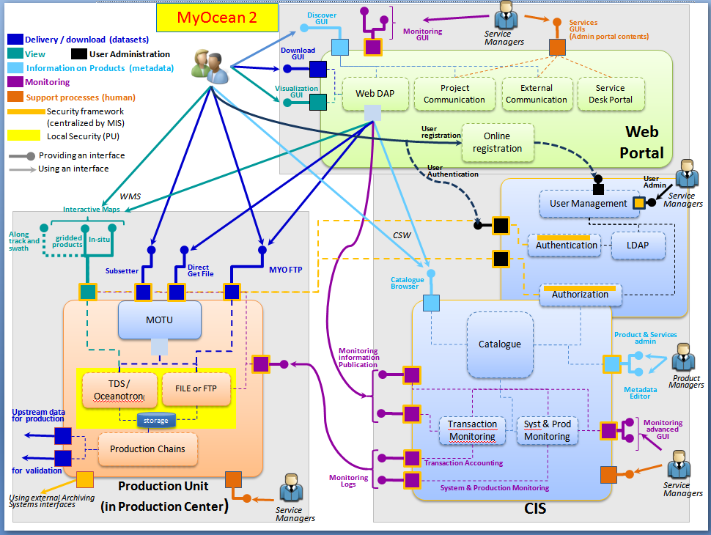

Figure 1: Candidate functional architecture, showing interfaces and anticipating sub systems main components

# Physical architecture

Physical architecture View:

Physical components (software and hardware components) that implement the logical architecture, and their relationships (physical interfaces)

A multi-level configuration used that identifies the physical components of the system, how they interconnect, and contribute to produce behaviour, products, by-products and services to fulfil the system's mission and accomplish its objectives. [WASSON 2006]

## Logical and software architecture

### General architecture

The following diagram presents the logical architecture of the MIS system.

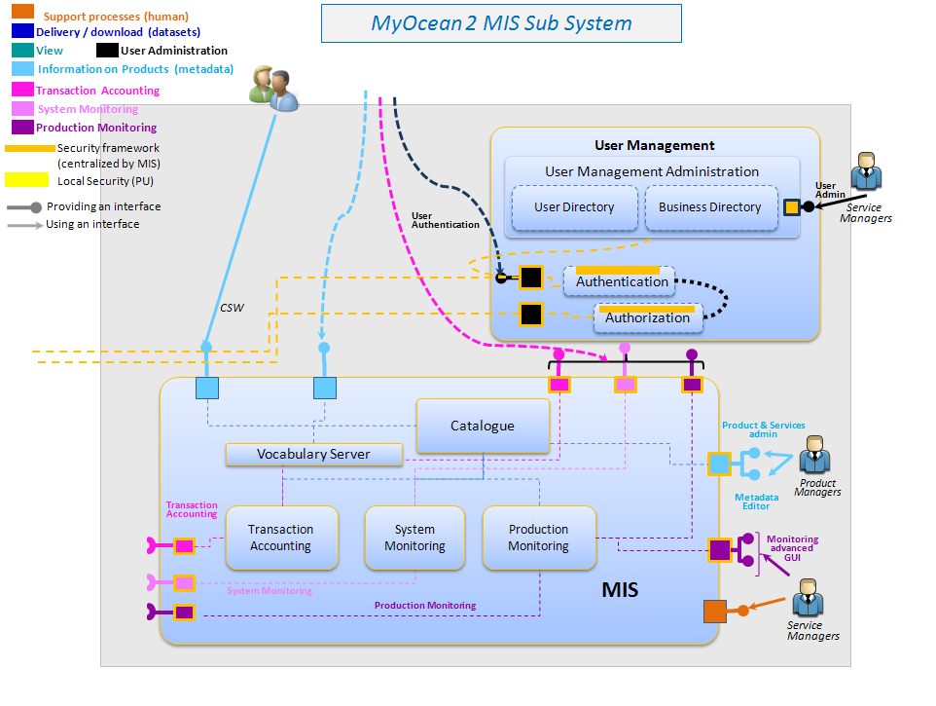

Figure 2 - Preview of V4 MIS functional sub packages and their interface types

The following logical component will be further described in the next chapters:

* User Management Administration
* Authentication
* Authorization
* Catalogue
* Vocabulary Server
* Transaction accounting
* System Monitoring
* Production Monitoring

On a software point of view, MyOcean is a modular web application based on distributed architecture. Each component provides its functionalities/interfaces and can be hosted on separate servers.

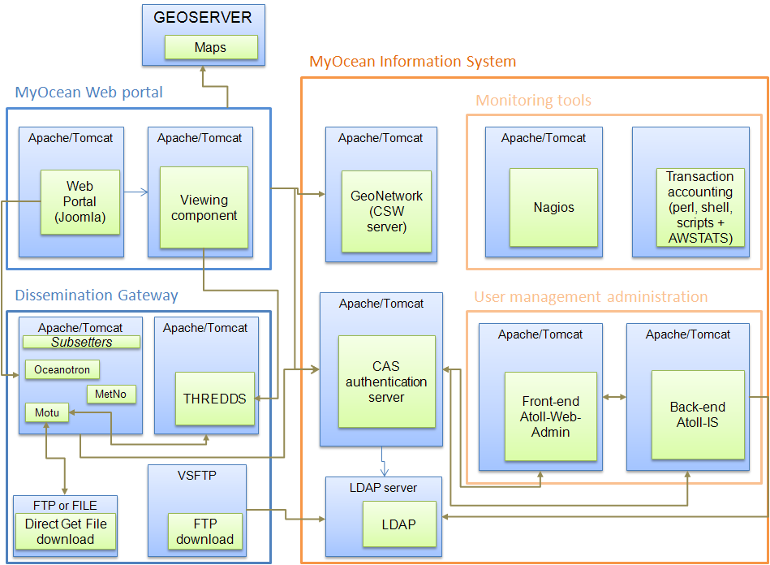

Figure 3: Software architecture global view

Relationships between sub system components

These schemas describe the dataflow from a use case to the component involved in the use case from the user and the administrator point of view.

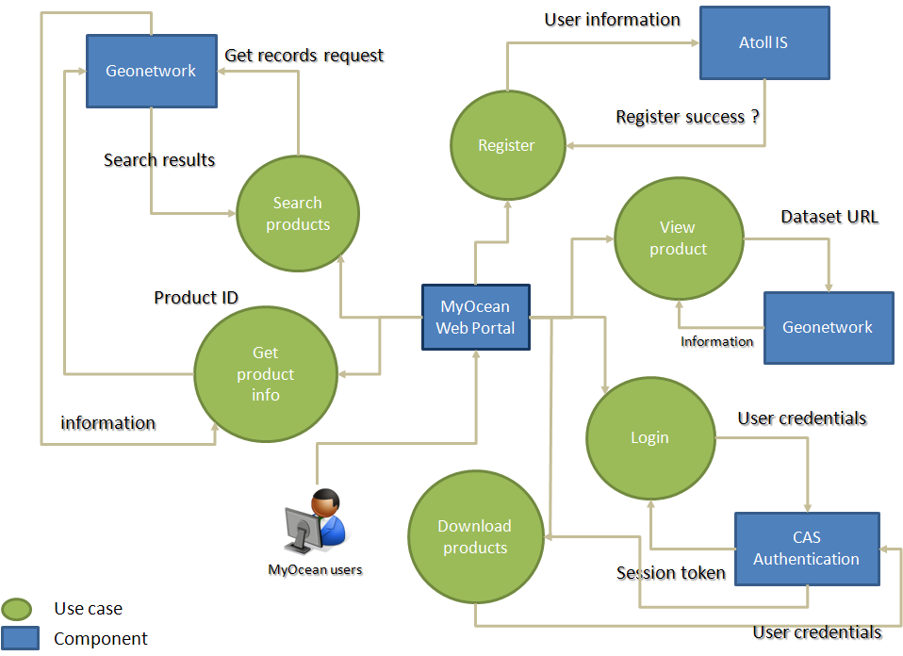

Figure 4: User point of view dataflow

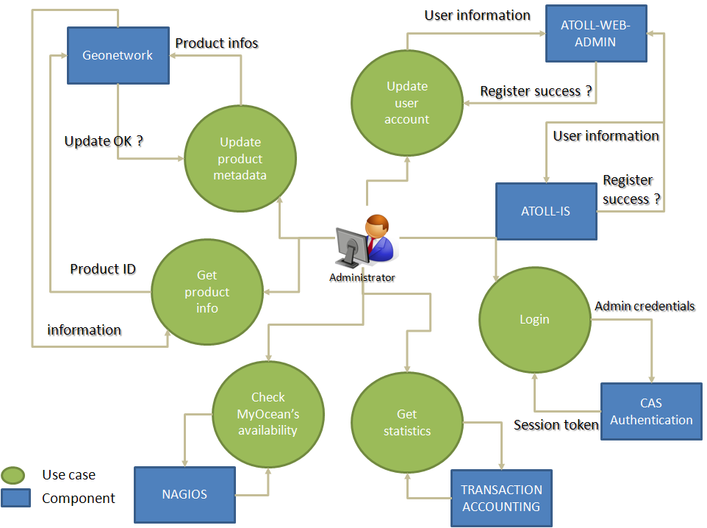

Figure 5: Administrator point of view dataflow

Detailed inventory of elements and reuse policy

Multiple technologies are used in the MIS projects:

Atoll: J2EE, Spring, ExtJS, Hibernate, PostgreSQL, LDAP, XML, XLST

CAS: J2EE, XML.

Nagios: PHP

Transaction accounting: Perl, shell scripts, XML, XSLT

Geonetwork: J2EE, CS-W, XML

Each component is open source software, based on JAVA or PHP technologies that are portable and very widely used. It ensures that it will be maintained and updated easily and the deployment is standard.

External interfaces

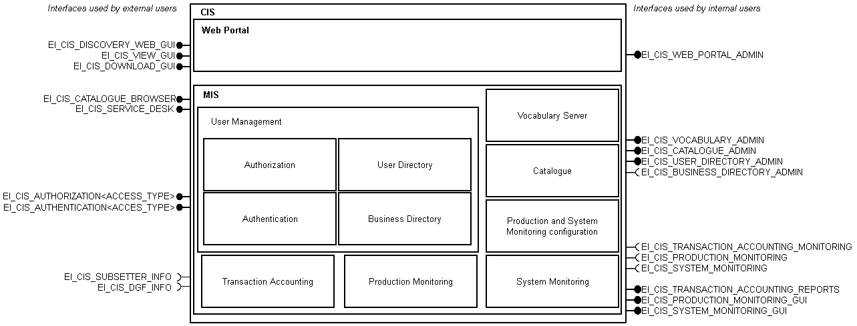

Figure 6 - V4 CIS external interfaces

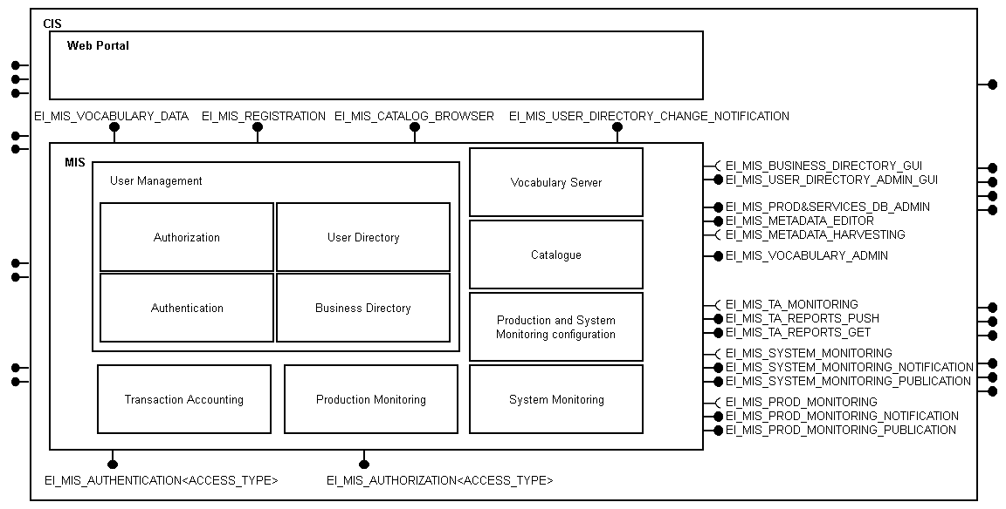

Figure 7 - V4 MIS external interfaces

|  |  |  |
| --- | --- | --- |
| Name | Description | Interface provided / use an external interface |
| EI_MIS_VOCABULARY_DATA | Interface used by Web Portal for vocabulary | provided |
| EI_MIS_REGISTRATION | Interface used by Web Portal for registration | provided |
| EI_MIS_CATALOG_BROWSER | Interface used for browsing the catalogue | provided |
| EI_MIS_USER_DIRECTORY_CHANGE_NOTIFICATION | Send e-mail when a change on user directory occurs | provided |
| EI_MIS_BUSINESS_DIRECTORY_GUI | Interface used for management of the business directory | external |
| EI_MIS_USER_DIRECTORY_ADMIN_GUI | Authentication, authorization, user & right management interface | provided |
| EI_MIS_PROD&SERVICES_DB_ADMIN | Catalogue product and service administration interface | provided |
| EI_MIS_METADATA_EDITOR | Metadata editor interface | provided |
| EI_MIS_METADATA_HARVESTING | Harvest access services of DUs for products metadata | external |
| EI_MIS_VOCABULARY_ADMIN | Interface used for vocabulary management | provided |
| EI_MIS_TA_MONITORING | Transaction accounting monitoring input interface | external |
| EI_MIS_TA_REPORTS_PUSH | Transaction accounting monitoring interface that sends reports to users | provided |
| EI_MIS_TA_REPORTS_GET | Transaction accounting monitoring interface to get reports | provided |
| EI_MIS_SYSTEM_MONITORING | System monitoring input interface | external |
| EI_MIS_SYSTEM_MONITORING_NOTIFICATION | System monitoring interface that send notifications when a system status changes | provided |
| Name | Description | Interface provided / use an external interface |
| EI_MIS_SYSTEM_MONITORING_PUBLICATION | System monitoring interface used by the web portal for publication to users | provided |
| EI_MIS_PROD_MONITORING | Production monitoring input interface | external |
| EI_MIS_PROD_MONITORING_NOTIFICATION | Production monitoring interface that send notifications when a production status changes | provided |
| EI_MIS_PROD_MONITORING_PUBLICATION | Production monitoring interface used by the web portal for publication to users | provided |
| EI_MIS_AUTHENTICATION<ACCESS_TYPE> | Interface used for authentication. Today access types are:   * Oceanotron * Motu * Metno Subsetter * MyOcean FTP * (MetOfficeUK Subsetter) | provided |
| EI_MIS_AUTHORIZATION<ACCESS_TYPE> | Interface used for authorization. Today access types are:   * Oceanotron * Motu * Metno Subsetter * MyOcean FTP * (MetOfficeUK Subsetter | provided |

Table 1 - MIS external interfaces

### Authentication

#### CAS (Central Authentication Service)

CAS is a Jasig product

Detailed information at <https://wiki.jasig.org/display/CASUM/Home>

##### Software used

Table

|  |  |  |  |  |
| --- | --- | --- | --- | --- |
| **Components** | **label** | **operator** | **support** | **Developer / maintainer** |
| LDAP | LDAP | CLS | CLS | ? |
| CAS Server | Authentication server | CLS | CLS | EXT (Jasig) |
| CAS Client | Authentication client | CLS | CLS | EXT (Jasig) |
|  |  |  |  |  |

Description

###### Functions provided, requirements

The Central Authentication Service (CAS) is a single sign-on protocol for the web. Its purpose is to permit a user to access multiple applications while providing their credentials (such as login and password) only once. It also allows web applications to authenticate users without gaining access to a user's security credentials, such as a password. The name CAS also refers to a software package that implements this protocol.

###### Architecture context

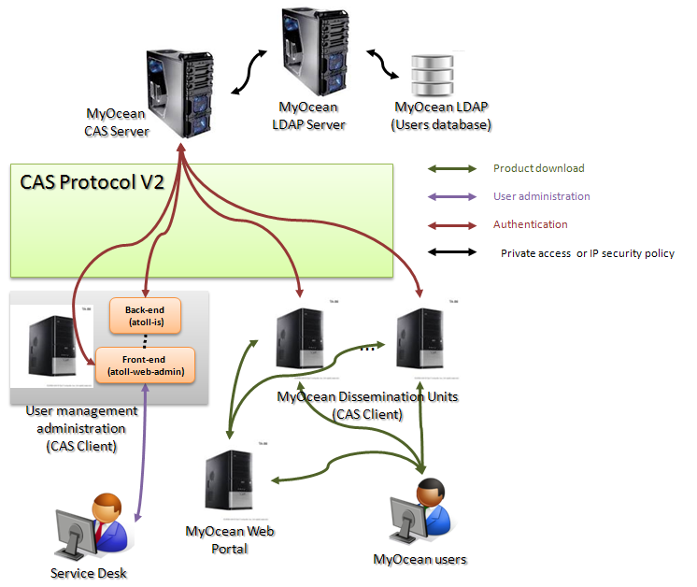

Figure 8 - CAS V2 architecture view

MyOcean authentication relies on the CAS 2 architecture (see <http://www.jasig.org/cas/cas2-architecture>).

CAS system architecture has two physical components: CAS Server and CAS client. They communicate through an https protocol.

CAS Authentication is involved in:

* User administration by Service Desk
* Dissemination units by MyOcean users
* Dissemination units by MyOcean Web Portal, in the downloading flow

**Note**: From MyOcean Web Portal, in the user registration flow doesn’t use CAS Authentication, but HTTP Basic Authentication (the login/password pair is a generic administrator one).

* CAS Server

The CAS server application is Java servlet whose primary responsibility is to authenticate users and grant access to CAS-enabled services (i.e. CAS Clients), by issuing and validating tickets.

An SSO session is created when the server issues a ticket-granting ticket (TGT) to the user upon successful login.

A service ticket (ST) is issued to a service at the user's request via browser redirects using the TGT as a token.

The ST is subsequently validated at the CAS server via back-channel communication.

In MyOcean, CAS Server uses the LDAP Authentication Handler to authenticate the credentials. The MyOcean users are stored in LDAP database.

In MyOcean, it is necessary to pull additional LDAP attributes (i.e. profile, status) into the CAS principal (i.e. user object). In order to populate LDAP attributes through the authentication, the CAS server files must be fit (see <https://wiki.jasig.org/display/CASUM/End-to-end+Windows+Example#End-to-endWindowsExample-ConfiguringtheSSOServer>).

LDAP component is implemented by an **OpenLDAP**, version 2.4.22, running on CentOS 5.3

CAS Server release is **3.3.5.** CAS Server must be configured to with optional package “cas-server-integration-restlet” to provide CAS RESTful interface for client applications which need to programmatically access CAS (see <https://wiki.jasig.org/display/CASUM/RESTful+API>).

Important information on TGT/PGT expiration could be found at <https://wiki.jasig.org/display/CASUM/Ticket+Expiration+Policy>.

* CAS Client

A CAS client is any CAS-enabled application (e.g. Dissemination Subsetter, User Management Administration) that can communicate with the CAS server. A CAS client is also a software package that can be integrated with applications in order to communicate with the CAS server.

CAS Client release is **3.1.11-PATCH-CLS.**

* CAS Protocol

The CAS protocol is a simple and powerful ticket-based protocol exclusively for CAS. The CAS protocol **version 2** is used in MyOcean; it is an XML-based protocol. A complete protocol specification may be found at <http://www.jasig.org/cas/protocol>.

* CAS Attributes

CAS is able to provide attributes from the LDAP database. For instance, the CAS server is configured so as to retrieve user LDAP relevant attributes of the user access rights (authorization): “profiles” and “status” attributes.

See also “CAS and attributes”: <https://wiki.jasig.org/display/CASUM/Attributes>

A sequence diagram, showing how CAS Authentication works, is explained in section “5.1.3.2.1 EI_MIS_AUTHENTICATION_AUTHORIZATION<CAS_CLIENT>”, page 36.

##### Interfaces

Describe only interfaces of CAS Server. Interfaces of CAS Client are described in the appropriate section of this document or in other appropriate ADD documents (e.g. dissemination gateway ADD).

The CAS Server interfaces are described in Jasig documention at <https://wiki.jasig.org/display/CASUM/Home>.

#### HTTP Basic Authentication

When a user wants to register to MyOcean, he connect to MyOcean Web Portal, fill and validate the registration form. Then MyOcean Web Portal requests the User Management Back-end (atoll-is) to register the user. The connection uses an HTTP basic authentication, using an HTTP user agent to provide a user name and password when sending a request.

**Note**: The user registration confirmation doesn’t need any authentication.

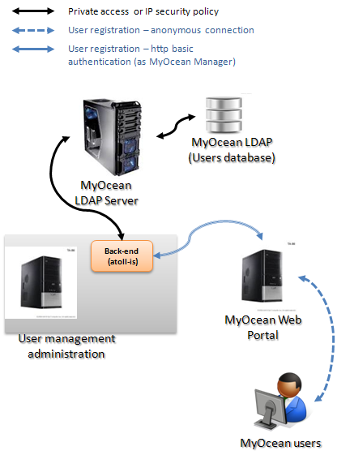

Figure 9 – HTTP Basic Authentication overview

#### VSFTP Authentication

Authentication for VSFTP Server is describe in the Dissemination Gateway ADD document

### User management administration

The Business directory contains all data associated to the users. Incidents, Problems, Events, Transaction accounting data are available from this business directory.

From a CIS point of view, the Business directory is not exactly in the perimeter of the MIS. It is an external Customer Relationship Management (CRM) tool managed directly by the Service Desk. However, CIS must manage a dedicated interface to exchange info with it. The format and the content of the file exported by the User Directory should be compatible with the Service Desk CRM tool.

Only interfaces with this CRM tool need to be described.

The authorization logical component is in charge of the rights attributed to a user. Rights are defined by the profile of the user. Here is a list of access according to the profiles:

* Guest : discovering features
* External : discovering features and download “Core Product”
* Major Account : discovering features and download “Core Product” and “Specific Core Product”

Internal: discovering features, download “Intermediate Product” and access to internal interfaces (contributor role).

#### Software used

Table

|  |  |  |  |  |
| --- | --- | --- | --- | --- |
| **Components** | **label** | **operator** | **support** | **Developer / maintainer** |
| Atoll-is | User management back-end web services | CLS | CLS | CLS |
| Atoll-web-admin | User management font-end interface | CLS | CLS | CLS |
| LDAP | LDAP | CLS | CLS | ? |
| CRM Tool | Customer Relationship Management tool | Mercator Ocean | ? | ? |
| CAS Client | Authentication Client | CLS | CLS | EXT (Jasig) |
| PostgreSQL | Relational DBMS | CLS | CLS | ? |
| Sendmail | Mail delivery agent/Mail system. It implements a Simple Mail Transfer Protocol (SMTP) for transmitting e-mail. | CLS | CLS | ? |

Description

User Management Administration is a modular application designed to manage Oceanic data catalogue, user account, profile authorization.

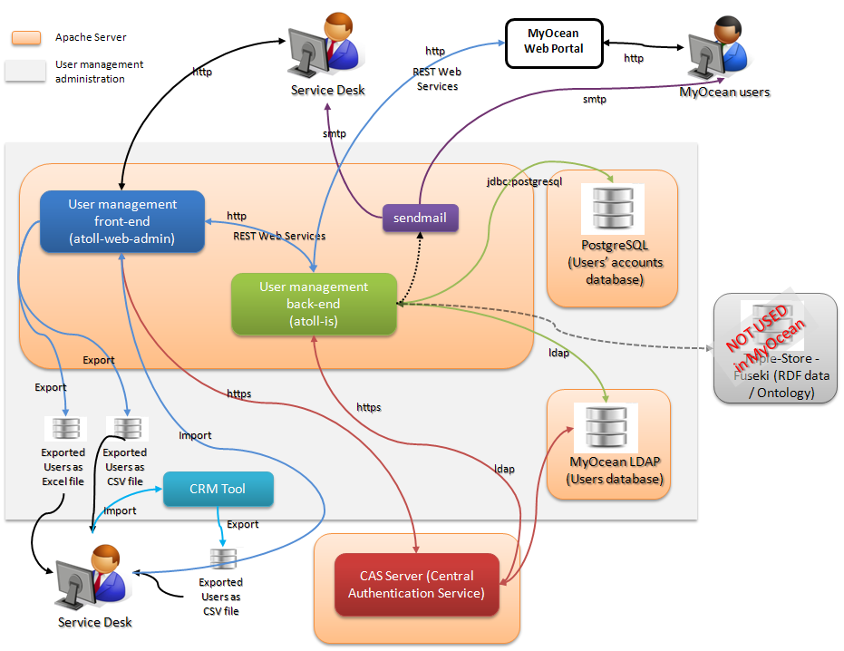

Figure 10 - User Management Administration Overview

The **MyOcean Information system currently uses only the user account management from Atoll**. It requires 2 components:

Atoll-is: Centralized business component (back-end)

Atoll-web-admin: Administration web interface (front-end)

**The user interface is ensured by the MyOcean web portal component.**

The user related Information are spread over the LDAP database and a PostgreSQL database (tables: account, account_profile_topic, profile).

The LDAP and PostgreSQL databases store the following user information:

|  |  |  |  |
| --- | --- | --- | --- |
|  | LDAP | PostgreSQL | Mandatory |
| First Name |  |  | **X** |
| Family Name |  |  | **X** |
| Organisation |  |  |  |
| Address line 1 |  |  |  |
| Address line 2 |  |  |  |
| City |  |  |  |
| Postal/Zip code |  |  |  |
| State/province |  |  |  |
| Country |  |  | **X** |
| E-mail address |  |  | **X** |
| Phone |  |  |  |
| Organisation type |  |  |  |
| Data usage intended |  |  |  |
| End user and/or service provider |  |  |  |
| Areas of relevance |  |  |  |
| Acceptance date |  |  |  |
| SLA agreement (pdf file) |  |  |  |
| Last update date |  |  |  |
| Creation date THIS DATE IS CURRENTLY NOT DISPLAYED – IT MUST BE ADDED IN THE GUI |  |  |  |
| Start validity date |  |  |  |
| End validity date |  |  |  |
| Last connexion date |  |  | **Computed (Read only)** |
| Last IP address |  |  | **Computed (Read only)** |
| Login |  |  | **X** |
| Profiles (e.g. internal, external, intermediate...) |  |  | **X** |
| Status (pending, registering, active, suspended, closed ) TBC |  |  | **X** |
| Password |  |  | **X** |
| Internal user id |  |  | **Computed (Read only)** |

##### Atoll-Is

###### Functions provided, requirements

Atoll-is is the business and persistence module of the User Management Administration system. It is the only component having read/write interactions with LDAP and PostgreSQL the databases.

It provides REST web services. All web services provided are not used in MyOcean; the only ones used are to manage Users:

* register user
* confirm user registration
* create, update, delete user
* get user information
* list users
* export users

It provides a J2EE application with a basic Web interface to see the list of available services.

###### Technical design

This component is a JEE application based on open-source software components.

In MyOcean, Atoll-Is ensures the user registration workflow and the update of users.

##### Atoll-web-admin

###### Functions provided, requirements

Atoll-web-admin is a Rich Internet Application providing a web interface to manage the data stored in Atoll-is.

In the MyOcean project, the only part currently used is the user management to allow the service desk to manage user information, status and profiles (create, update, delete).

User information on SLA is stored in the LDAP database. They are acceded from Atoll web admin. They appear as an “Extended Properties” tab in the user detail panel.

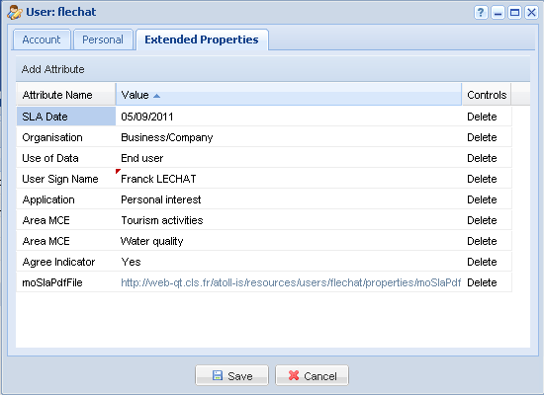

Figure 11 - Extended properties tab

###### Technical design

Atoll-web-admin is a J2EE application using Ext-JS to create the rich interface and make synchronous services call to Atoll-is web services.

It provides a user-friendly GUI to Service Desk for the daily management and monitoring of MyOcean users.

##### LDAP

###### Scope

LDAP component is in charge of authenticating users (both internal and external). In order to reduce dependency between sub-systems (WebPortal and MIS) or sub sub systems (MIS-GW and MIS CENTRAL)

LDAP component is implemented by an **OpenLDAP**, version 2.4.22, running on CentOS 5.3

###### Maturity

LDAP is very widely used and mature.

###### Protocol

LDAP is a protocol for accessing and maintaining distributed directory information services over an Internet Protocol (IP) network.

All information is available on the internet. See the OpenLDAP documentation here <http://www.openldap.org/>

###### Configuration

For the VSFTPD authorization, the following attributes must be filled for the user in the LDAP database:

* **objectClass: posixAccount**
* **gidNumber: 1000**, should be an existing one
* **homeDirectory: *user_home_directory*,** the chroot will be a folder dedicated to the profile (e.g. **/home/misgw/internal/)**
* **uidNumber: 1000,** should be an existing one
* **uid:** the user’s login (this Ldap uid attributes is mandatory with objectClass:posixAccount)

Giving the same gidNumber/uidNumber, all users have the same access rights under the homeDirectory.

The profile inclusion is implemented by a duplication of folders to mount automatically through the Auto FS mechanism. Ex: let’s say product A can be accessed by ‘standard’ and ‘internal’ users, product B can be accessed by ‘internal’ users only. Under the ‘standard’ chroot only A folder is accessible. Under ‘internal’ chroot, auto-FS is configured to mount products A and B.

To be authorized, the user’s **status** must also be ‘active’. This is check by the PAM_LDAP by configuring the pam_filter setting (e.g. pam_filter status=active) in the ldap.conf file. (see <http://ldapwiki.willeke.com/wiki/PAM%20LDAP%20-%20Host%20Based%20Authorization>).

##### PostgreSQL

###### Scope

PostgreSQL is the relational database management system used by Atoll-is to manage users accounts and profiles

###### Maturity

PostgreSQL is “Open Source”, widely used and secure.

###### Protocol

jdbc;postgresql is the protocol used for accessing is a protocol for accessing (read/write) the database objects.

All information is available on the internet. See the PostgreSQL documentation at <http://www.postgresql.org/>.

##### Sendmail

Sendmail is an “Open Source” mail delivery agent/Mail system. It implements a Simple Mail Transfer Protocol (SMTP) for transmitting e-mail.

More information and documentation are available at <http://www.linux.com/learn/docs/ldp/619-mail-administrator-howto#ss5.1> and <http://www.sendmail.com/sm/open_source/>.

#### Interfaces

Table

|  |  |  |  |  |
| --- | --- | --- | --- | --- |
| Name | Description | Interface provided / use an external interface | Format | Protocol |
| EI_MIS_AUTHENTICATION_AUTHORIZATION<CAS_CLIENT> | It provides CAS authenticationand authorization service. | provided |  |  |
| EI_MIS_AUTHENTICATION<BASIC> | It provides HTTP BASIC authentication service. | provided |  |  |
| EI_MIS_ADM_LIST_DELETE_USERS | It provides a list of available of users and allows deleting users from this list (atoll-web-admin). | provided |  |  |
| EI_MIS_ADM_CREATE_UPDATE_USERS | It provides a way to create or update a user (atoll-web-admin). | provided |  |  |
| EI_MIS_ADM_EXPORT_USERS | It allows exporting MyOcean users (atoll-web-admin). | provided |  |  |
| EI_MIS_ADM_IMPORT_USERS | It allows importing users to MyOcean (atoll-web-admin). | provided |  |  |
| EI_MIS_CRM_EXPORT_USERS | It allows exporting users from MyOcean CRM (CRM Tool). | provided |  |  |
| EI_MIS_CRM_EXPORT_USERS | It allows importing users into MyOcean CRM (CRM Tool). | provided |  |  |
| EI_MIS_IS_CAPABILITIES | It provides a list of available web services (atoll-is). | provided |  |  |
| EI_MIS_IS_REGISTER_USER | It allow registering a user (atoll-is). | provided |  |  |
| EI_MIS_IS_CREATE_USER | It allow creating a user (atoll-is). | provided |  |  |
| EI_MIS_IS_UPDATE_USER | It allow updating a user (atoll-is). | provided |  |  |
| EI_MIS_IS_LIST_USERS | It allows listing/exporting users (atoll-is). | provided |  |  |
| EI_MIS_IS_DELETE_USER | It allow deleting a user (atoll-is). | provided |  |  |
| EI_MIS_IS_RESET_PASSWORD | It allow resetting the user password (atoll-is). | provided |  |  |
| EI_MIS_IS_CHECK_NEW_LOGIN | It allow checking the validity of a new login (atoll-is). | provided |  |  |
| EI_MIS_IS_MAIL_NOTIFICATIONS | Send mail to a recipient (atoll-is). | provided |  |  |
| EI_MIS_ADM_LIST_DELETE_PROFILES | It provides a list of available of profiles and allows deleting profiles from this list (atoll-web-admin). | provided |  |  |
| EI_MIS_ADM_CREATE_UPDATE_PROFILES | It provides a way to create or update a profile (atoll-web-admin). | provided |  |  |
| EI_MIS_IS_CREATE_PROFILE | It allow creating a profile (atoll-is). | provided |  |  |
| EI_MIS_IS_UPDATE_PROFILE | It allow updating a profile (atoll-is). | provided |  |  |
| EI_MIS_IS_LIST_PROFILES | It allows getting the list of profiles (atoll-is). | provided |  |  |
| EI_MIS_IS_DELETE_PROFILE | It allows deleting a profile (atoll-is). | provided |  |  |
| EI_MIS_ADM_UPDATE_CONTEXT_MANAGER | It allows updating managers and administration settings (atoll-web-admin). | provided |  |  |
| EI_MIS_IS_ UPDATE_CONTEXT_MANAGER | It allows updating managers and administration settings (atoll-is). | provided |  |  |
| EI_MIS_ADM_CAS_LOGIN | It allows a user a CAS authentication on MyOcean (atoll-web-admin). | provided |  |  |
| EI_MIS_CAS_SERVER_LOGIN | To request a CAS authentication on MyOcean (CAS Server). | provided |  |  |
| EI_MIS_ADM_CAS_LOGOUT | It allows a user to logout from MyOcean (atoll-web-admin). | provided |  |  |
| EI_MIS_CAS_SERVER_LOGOUT | To request a logout from MyOcean (CAS Server). | provided |  |  |
| EI_MIS_USER_DIRECTORY_ADMIN_GUI | Service Managers use this interface to send and receive data to/from the user directory via the web portal user management interface. | provided |  |  |
| EI_MIS_BUSINESS_DIRECTORY_GUI | This is the interface used to see business directory data | external |  |  |

Table 2 - User management administration interfaces

Figure

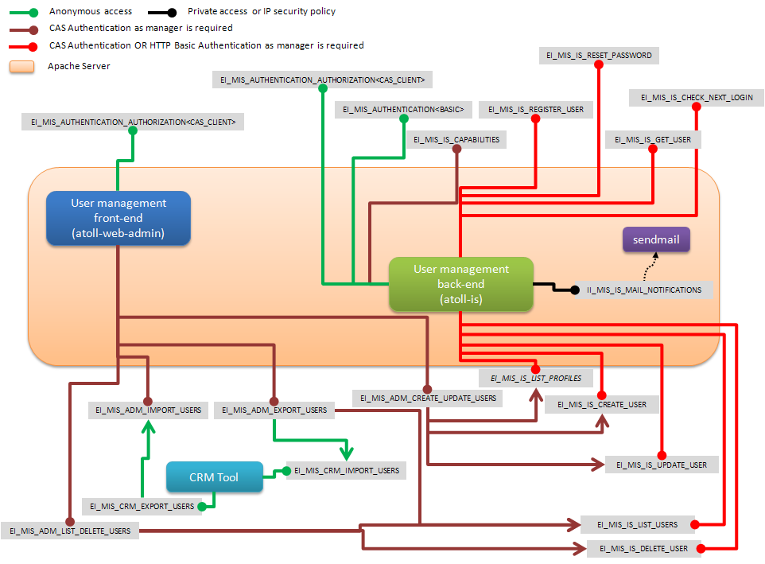

Figure 12 - User interfaces diagram

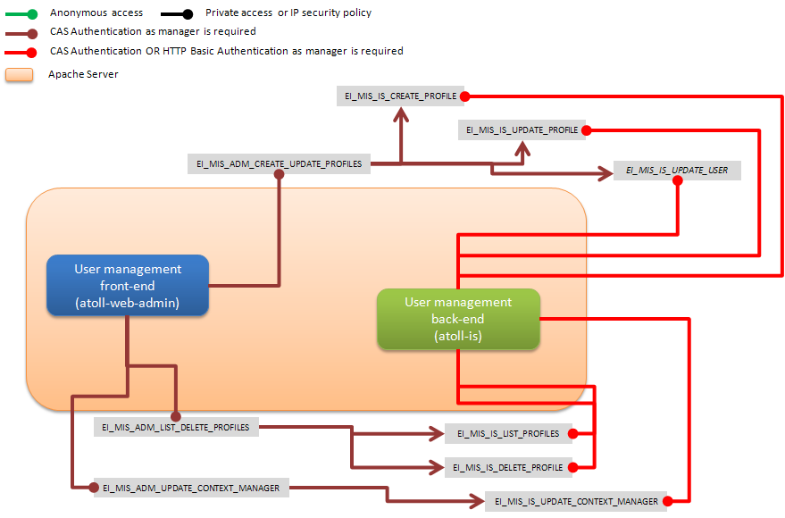

Figure 13 - Profiles and context/manager interfaces diagram

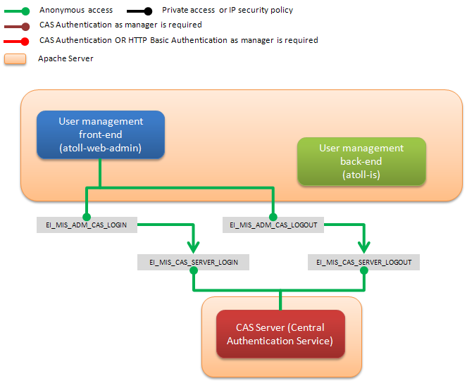

Figure 14 – CAS Login/Logout interfaces diagram

Detailed description of interfaces

##### EI_MIS_AUTHENTICATION_AUTHORIZATION<CAS_CLIENT>

The purpose of this interface is dual:

1. Authentication

This interface is used to protect application with a Central Authentication Service (CAS). It relies on a LDAP User management database

This interface follows the “JASIG CAS Client for Java 3.1” interface (see <https://wiki.jasig.org/display/CASC/CAS+Client+for+Java+3.1>)

See also “CAS Protocol” documentation at <http://www.jasig.org/cas/protocol> and “RESTful API” documentation at <https://wiki.jasig.org/display/CASUM/RESTful+API>.

1. Authorization

This interface allows authorization filter for “CASified” application based on the user profile. It relies on CAS with LDAP User management database.

The CAS server is configured so as to retrieve a user LADP relevant attributes of the user access rights (authorization): “profiles” and “status” attributes.

See also “CAS and attributes”: <https://wiki.jasig.org/display/CASUM/Attributes>

Notes:

1. Authentication and authorization are closely linked to the CAS (through LDAP attributes). This is why these two functions are merged into a single interface.
2. CAS RESTful interface is not used in the User management Administration.
3. Authorization is not applicable in the User management Administration. So it is not explicitly described in this section.

###### CAS authentication - User Management Administration

This section describes how CAS Authentication works for User Management Administration through a Web Browser (IE, Firefox, Chrome…).

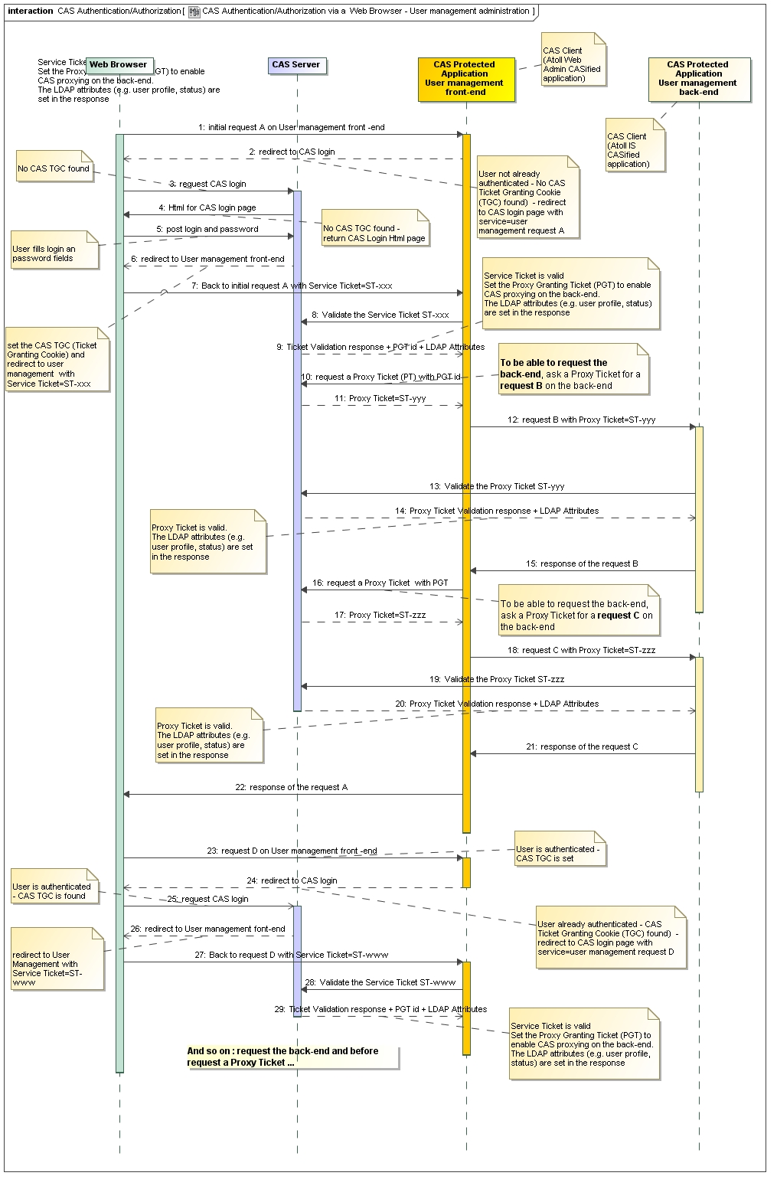

Figure 15 - Sequence diagram - User Management Administration - CAS authentication

1. Initial request A: the Web Browser accesses the Front-end that requires authentication.
2. The Web Browser does not already have a session on the Font-end. The CAS Authentication filter of the Front-end doesn’t see a ticket parameter in the request.
3. A redirection to the CAS login is done. CAS server checks for its CAS TGC (Ticket Granting Cookie).
4. No TGC is found, the CAS login HTML page is served.
5. User fills the login and password, the Web Browser posts login/password to CAS Server.
6. CAS server redirects back to Front-end. A Ticket Granting Ticket (TGT) is stored on the CAS server, and set as a CAS Ticket Granting Cookie (TGC). A Service Ticket (ST) is issued for the request A.
7. Initial request A is sent back to the Front-end with additional ST parameter. CAS client takes control:
   1. CAS client sees a Service Ticket parameter in the request, that can be checked with the CAS server
   2. CAS Service Ticket is only valid one time and expires after a short time (see CAS Server configuration)
8. Front-end checks CAS Service Ticket (CAS Validation filter).
9. CAS server responds to Service Ticket validation and returns also a Proxy Granting Ticket id. (PGT). The response contains also the **LDAP attributes** to retrieve (CAS server configuration setting).
10. With the PGT id, Front-end requests a Proxy Ticket (technically same as a Service Ticket) to be able to request the Back-end (request B).
11. CAS server returns a Proxy Ticket for request B.
12. Front-end send request B to the Back-end with additional PT parameter: ST-yyy:
13. Back-end checks CAS Proxy Ticket (CAS Validation filter).
14. CAS server responds to Proxy Ticket validation. The response contains also the **LDAP attributes** to retrieve (CAS server configuration setting).
15. Back-end sends response to Front-end for the request B.
16. Let’s say Front-end needs to request Back-end (request C). With the PGT id, Front-end requests a Proxy Ticket to be able to request the Back-end (request C).
17. CAS server returns a Proxy Ticket for request C.
18. Front-end send request C to the Back-end with additional PT parameter: ST-zzz:
19. Back-end checks CAS Proxy Ticket (CAS Validation filter).
20. CAS server responds to Proxy Ticket validation. The response contains also the **LDAP attributes** to retrieve (CAS server configuration setting).
21. Back-end sends response to Front-end for the request C
22. Front-end sends response to the initial request A.
23. A request D: the Web Browser accesses the Front-end that requires authentication.
24. The Web Browser already has a session on the Front-end. The CAS Authentication filter of the Front-end doesn’t see a ticket parameter in the request.
25. A redirection to the CAS login is done. CAS server checks for its CAS TGC (Ticket Granting Cookie). TGC is found and valid
26. CAS server redirects back to Front-end. A Service Ticket (ST) is issued for the request D.
27. Request B is sent back to the Front-end with additional ST parameter (ST-www). CAS client takes control:
    1. CAS client sees a Service Ticket parameter in the request, that can be checked with the CAS server
    2. CAS Service Ticket is only valid one time and expires after a short time (see CAS Server configuration)
28. Front-end checks CAS Service Ticket (CAS Validation filter).
29. CAS server responds to Service Ticket validation and returns also a Proxy Granting Ticket id. (PGT). The response contains also the **LDAP attributes** to retrieve (CAS server configuration setting).

And so on: Front-end requests the Back-end and before requests a Proxy Ticket...

##### EI_MIS_AUTHENTICATION<BASIC>

This interface is allows to access applications with a HTTP basic authentication, using an HTTP user agent to provide a user name and password when sending a request.

In MyOcean, it relies on a LDAP User management database and the PostgreSQL Atoll-is database (Tables: account, account_profile_manager).

This interface is used by MyOcean Web Portal in the user registration workflow. The credentials provided to Atoll-Is for basic authentication must be a user with a manager role. The user must exist in the LDAP database and in the account and account_profile_manager PostgreSQL database.

The user registration confirmation doesn’t need any authentication.

##### EI_MIS_ADM_LIST_DELETE_USERS

This interface provides a list of the registered users in MyOcean.

This interface allows deleting a user.

The interface is a web GUI using the HTTP protocol and secured with the CAS authentication (manager/administrator access).

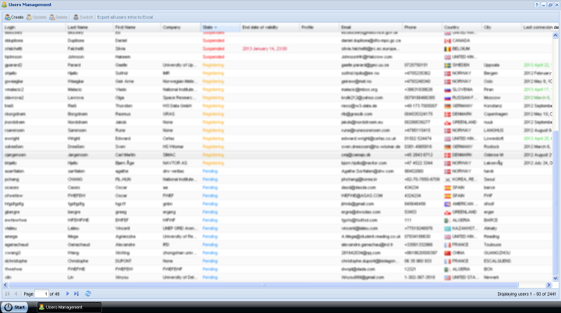

Figure 16 - List of MyOcean users

The users are displayed in a list (pagination), one user per line. The list is initially sorted by user’s status.

The creation date is currently not displayed. It must be added

The entire user’s data are (or can be) displayed in the line except extended properties. All the columns can be sorted and/or filtered. Columns can be hidden or displayed.

This interface is the input to create, update a user and export all users.

##### EI_MIS_ADM_CREATE_UPDATE_USERS

This interface allows creating (manually registering) and updating a user.

The interface is a web GUI using the HTTP protocol and secured with the CAS authentication (manager/administrator access).

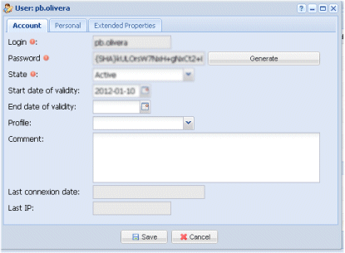

Figure 17 – Browse, create, update user - account

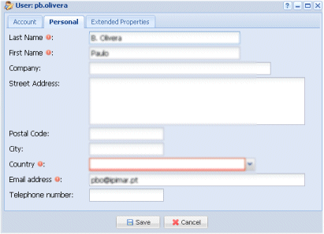

Figure 18 – Browse, create, update user - personal data

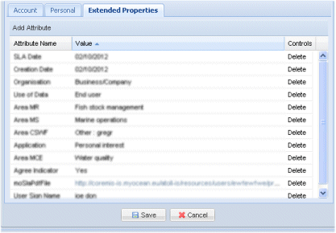

Figure 19 – Browse, create, update user - extended properties

**Create a user**

Mandatory fields are described in section “The LDAP and PostgreSQL databases store the following user information”, page 28.

Internal Id, last connection date and last IP fields are computed and can’t be fill.

**Update a user**

All fields mentioned on page 28 can be changed except login, last connection date, last IP.

##### EI_MIS_ADM_EXPORT_USERS

This interface allows exporting users from MyOcean database (LDAP+PostgreSQL) as an Excel file or a CSV file (not yet implemented).

The interface is a web GUI using the HTTP protocol and secured with the CAS authentication (manager/administrator access).

The output Excel file format is as follow:











The output CVS file format is TO BE DEFINED.

##### EI_MIS_ADM_IMPORT_USERS

This interface allows importing users to MyOcean database (LDAP+PostgreSQL) from an input CSV file or ??? (TO BE DEFINED).

The interface is a web GUI using the HTTP protocol and secured with the CAS authentication (manager/administrator access).

The input file must contains at least the mandatory user data: login, password (encrypted or not ???), status, last name, first name, country, email.

If the user’s profile is filled, it must exists (must be declared) in the MyOcean available profiles (or should the import process automatically create it in MyOcean?).

##### EI_MIS_CRM_EXPORT_USERS

This interface allows exporting users from MyOcean CRM as a CSV file or ??? (TO BE DEFINED).

Exported fields must be defined.

##### EI_MIS_CRM_IMPORT_USERS

This interface allows importing users to MyOcean CRM from a CSV file or ??? (TO BE DEFINED).

Imported fields must be defined.

##### EI_MIS_IS_CAPABILITIES

This interface provides a list of the available web services (atoll-is).

The interface uses the HTTP protocol and CAS authentication

###### Input

URL: <Atoll-IS URL>/resources/services

Method: HTTP GET

Parameter:

_mimetype: the response format (optional). Available values: application/xml, application/json. If the parameter is missing the response is in html format.

###### Output

The HTTP response returns the list of the web services. The format depends on the input _mimetype setting.

##### EI_MIS_IS_REGISTER_USER

This interface allows registering a user in MyOcean (atoll-is web service).

The interface uses the HTTP protocol and CAS authentication or HTTP Basic authentication access.

When a user is registered, his status is PENDING and he has no profile.

The user is created in the LDAP database and in the PostgreSQL database (Account)

###### Input

URL: <Atoll-IS URL>/resources/user

Method: HTTP POST as multipart/form-data

Parameters:

login: user login.

password: user password (no encryption or SHA encrypted). The password is always stored in the LDAP database with SHA encryption. From MyOcean Web Portal, the password is currently never filled (V3). It has to be filled (V4) if the user chooses or resets the password himself.

Important notes:

1. Because the password is stored with SHA encryption, it is impossible to get the value of the password in plain text (no encryption). This is important because if the user has not filled (or changed) his password himself, you must be able to transmit to the user the value in plain text, and this, before, the password is encrypted and stored. Otherwise, anyone will be able to find the value of the password.
2. Depending on whether the password is encrypted or not, the behaviour is:
   1. The password is not encrypted: an email is sent to the user to transmit the value of his password.
   2. The password is encrypted: no email is sent to the user.
3. Applications that use this interface must consider these notes and fill this interface with a encrypted password or not depending on whether they want an email to be sent or not.

address: user address.

city: user city.

company: user organisation.

country: user country.

email: user email address.

phone: user phone number.

zip: user zip code.

lastname: user last name.

firstname: user first name.

comment: comment about user.

extendedProperties: user extended properties : extended properties have multiple values for the same key (Ex: moApplication, moProviding, etc). It use a multipart formdata mime format sending format request (anyway we should use this format to send the SLA pdf binary file).

_mimetype: the response format (optional). Available values: application/xml, application/json. If the parameter is missing the response is in xml format.

###### Output

The HTTP response returns the internal ID of the registered user. The format depends on the input _mimetype setting.

##### EI_MIS_IS_CREATE_USER

This interface allows creating a user in MyOcean (atoll-is web service).

The interface uses the HTTP protocol and CAS authentication or HTTP Basic authentication access.

The user is created in the LDAP database and in the PostgreSQL database (account table)

###### Input

URL: <Atoll-IS URL>/resources/useraccounts

Method: HTTP POST as application/x-www-form-urlencoded

Parameters:

login: user login.

password: user password (no encryption or SHA encrypted). The password is always stored in the LDAP database with SHA encryption.

See also “Important notes”, page 45.

startValidityDate: user start validity date.

endValidityDate: user end validity date.

status: user status (PENDING, REGISTERING, ACTIVE, SUSPENDED, CLOSED). If not filled, default value is PENDING. **Warning** updating LDAP database for the status is not yet implemented.

city: user city.

company: user organisation.

country: user country.

email: user email address.

phone: user phone number.

zip: user zip code.

lastname: user last name.

firstname: user first name.

comment: comment about user.

profiles: users profile(s) id as a list of numeric ids. Each id is a valid id corresponding to existing profile in the PostgreSQL database (profile table). **Warning** updating LDAP database for the profiles is not yet implemented.

extendedProperties: user extended properties : extended properties have multiple values for the same key (Ex: moApplication, moProviding, etc). It use a multipart formdata mime format sending format request (anyway we should use this format to send the SLA pdf binary file).

_mimetype: the response format (optional). Available values: application/xml, application/json. If the parameter is missing the response is in xml format.

###### Output

The HTTP response returns the internal ID of the created user. The format depends on the input _mimetype setting.

##### EI_MIS_IS_UPDATE_USER

This interface allows updating a user in MyOcean (atoll-is web service).

The interface uses the HTTP protocol and CAS authentication or HTTP Basic authentication access.

The user is updated in the LDAP database and in the PostgreSQL database (account table)

Notice the login can’t be updated.

###### Input

URL: <Atoll-IS URL>/resources/useraccounts/*{id}*

*{id}* user internal ID*.*

Method: HTTP PUT as application/x-www-form-urlencoded

Parameters:

id: internal user id (must be an existing one).

password: user password (no encryption or SHA encrypted). The password is always stored in the LDAP database with SHA encryption.

See also “Important notes”, page 45.

startValidityDate: user start validity date.

endValidityDate: user end validity date.

status: user status (PENDING, REGISTERING, ACTIVE, SUSPENDED, CLOSED). If not filled, default value is PENDING

city: user city.

company: user organisation.

country: user country.

email: user email address.

phone: user phone number.

zip: user zip code.

lastname: user last name.

firstname: user first name.

comment: comment about user.

profiles: users profile(s) id as a list of numeric ids. Each id is a valid id corresponding to existing profile in the PostgreSQL database (profile table).

extendedProperties: user extended properties : extended properties have multiple values for the same key (Ex: moApplication, moProviding, etc). It use a multipart formdata mime format sending format request (anyway we should use this format to send the SLA pdf binary file).

_mimetype: the response format (optional). Available values: application/xml, application/json. If the parameter is missing the response is in xml format.

###### Output

The HTTP response returns the internal ID of the updated user. The format depends on the input _mimetype setting.

##### EI_MIS_IS_GET_USER

This interface allows getting a specific users’ information (atoll-is web service).

The interface uses the HTTP protocol and CAS authentication or HTTP Basic authentication access.

The user information are retrieved from the LDAP database and the PostgreSQL database (account table).

###### Input

URL: <Atoll-IS URL>/resources/useraccounts*/{login}*

*{login}* user login ID*.*

Method: HTTP GET

Parameters:

login: user login (must be an existing one).

###### Output

The output format depends on the input _mimetype setting.

The HTTP response returns:

id: internal user id (must be an existing one).

login: user login.

password: user password (SHA encrypted).

startValidityDate: user start validity date.

endValidityDate: user end validity date.

status: user status (PENDING, REGISTERING, ACTIVE, SUSPENDED, CLOSED).

city: user city.

company: user organisation.

country: user country.

email: user email address.

phone: user phone number.

zip: user zip code.

lastname: user last name.

firstname: user first name.

comment: comment about user.

profiles: users profile (id and label). This is the top level profile, this profile can include others profiles. This profile comes from the PostgreSQL database, not from the LDAP database (a comma separated list of profiles).

extendedProperties: user extended properties. NOT YET IMPLEMENTED – TODO IN V4

##### EI_MIS_IS_LIST_USERS

This interface allows getting users’ information (atoll-is web service).

The interface uses the HTTP protocol and CAS authentication or HTTP Basic authentication access.

The user information are retrieved from the LDAP database and the PostgreSQL database (account table).

**This interface produces 2 different outputs, depending on the request HTTP header "Accept” parameter:**

* Accept: **application/json**
* Accept: **application/vnd.openxmlformats-officedocument.spreadsheetml.sheet**

**By default the request doesn’t return all users, depending on the start, limit and filter parameters. The start and limit parameters allow to paginate the result.**

###### Input

URL: <Atoll-IS URL>/resources/useraccounts/report

Method: HTTP GET

Parameters:

start: the start user range to retrieve. Default value is 0.

limit: the limit number of user to retrieve. 0 for no limit. Default value is 50.

sort: to allow sorting the result on a user data fields. Default value is “login”.

dir: the sort direction: ACS or DESC. Default value is ASC.

filter: JSOn format filter as : {"*field_name*":[{"t":"*type*","v":"*value_to_filter*"}]}. Default value is no filter:

###### Output

If “Accept” parameter is **application/json,** the response returns users data as JSON format

If “Accept” parameter is **application/vnd.openxmlformats-officedocument.spreadsheetml.sheet,** the response returns users data as an Excel file. See section “5.1.3.2.5 EI_MIS_ADM_EXPORT_USERS”, page 43.

##### EI_MIS_IS_RESET_PASSWORD

This interface allows resetting the password of a user. The interface is not yet implemented.

The interface uses the HTTP protocol and CAS authentication or HTTP Basic authentication access.

The user’s password is updated in the LDAP database.

###### Input

URL: <Atoll-IS URL>/resources/useraccounts/*{id}*/resetpwd

*{id}* user internal ID*.*

Method: HTTP PUT

Parameters:

id: internal user id (must be an existing one).

password: user (new) password (no encryption or SHA encrypted). The password is always stored in the LDAP database with SHA encryption.

See also “Important notes”, page 45.

###### Output

The HTTP response returns the internal ID of the updated user. The format depends on the input _mimetype setting.

##### EI_MIS_IS_CHECK_NEW_LOGIN

This interface allows checking a login (to use when a user registers or is created) :

1. Check the syntax :
   1. the login must have at least 2 characters
   2. the login must be different from ‘system’
   3. the login must not contain extended ascii characters: login value must be normalized

For information, currently the code to normalize login (in MyOcean registration flow) is:

// JDK1.5

// use sun.text.Normalizer.normalize(s, Normalizer.DECOMP, 0);

//

def temp = Normalizer.normalize(s, Normalizer.Form.NFD);

def pattern = Pattern.compile("(\\W|\\p{InCombiningDiacriticalMarks}+)");

return pattern.matcher(temp).replaceAll("");

1. Check if the normalized login already exist or not.

The interface is not yet implemented.

The interface uses the HTTP protocol and CAS authentication or HTTP Basic authentication access.

###### Input

URL: <Atoll-IS URL>/resources/TO BE DEFINED

*{id}* user internal ID*.*

Method: HTTP GET

Parameters:

login: user login to check (before creation).

###### Output

The HTTP response returns a message and code (OK or not, an explicit message if not OK). TO BE CONFIRMED. The format depends on the input _mimetype setting.

##### EI_MIS_IS_DELETE_USER

This interface allows deleting a user in MyOcean (atoll-is web service).

The interface uses the HTTP protocol and CAS authentication or HTTP Basic authentication access.

The user is deleted from the LDAP database and the PostgreSQL database (account table)

###### Input

URL: <Atoll-IS URL>/resources/useraccounts/*{id}*

*{id}* user internal ID*.*

Method: HTTP DELETE

Parameters:

id: internal user id to delete (must be an existing one).

###### Output

None

##### II_MIS_IS_MAIL_NOTIFICATIONS

Mails are sent to the user when registering, validating account, when the account is suspended or suppressed, when the user’s password is initialized or changed.

These notifications are managed by atoll-is component.

List and description of the template used in MyOcean to generate emails:

Registration:

*Template*: to-user-need-confirmation.xml.ftl

This template is used to generate an email when a new user registers to MyOcean. By this email, the user has to confirm his registration.

*Content*:

<!--

Context:

user: the user

account: the account

catalogContext: the context

hostName: the hostname of the atoll-is application

contextPath: the context path of the atoll-is application

-->

<mail>

<subject>Activate your MyOcean membership</subject>

<html>

<content><![CDATA[

<p>Dear ${user.firstName} ${user.lastName},</p>

<p>Thank you for registering with MyOcean.</p>

<p>Your registration is nearly complete. We just need to confirm your identity. Please follow the link below to finalize your registration.</p>

<a href="${hostName}${contextPath}/resources/users/${user.login}/confirmation/${account.credentialKey}?_context=${catalogContext.name}&amp;redirectUrl=${redirectUrl}">Complete the registration process</a>

<p>Please note that without confirmation within 15 days, your registration will be cancelled.</p>

]]></content>

<signature>

<![CDATA[

<br/>

<p><#include "signature.html"></p>

]]>

</signature>

</html>

</mail>

Registration confirmation

*Template*: to-user-thanks-confirmation.xml.ftl

This template is used to generate an email when a new user has confirmed his registration to MyOcean. By this email, the user receives confirmation of his registration.

*Content*:

<mail>

<subject>Thank you for registering with MyOcean</subject>

<plaintext>

<content>Dear ${user.firstName} ${user.lastName},

Your request is being processed.

You will be notified very shortly about the activation of your account.

</content>

<signature>

<#include "signature.html">

</signature>

</plaintext>

</mail>

*Template*: to-manager-activate-user.xml.ftl

This template is used to generate an email sent to the manager (service desk) when a new user has confirmed his registration to MyOcean. By this email, the manager (service desk) user receives confirmation of user’s registration. Then it is expected the manager checks the account and decides whether to enable or not (change status to ‘active’ or not).

*Content*:

<mail>

<subject>Activation requested for user ${user.login} </subject>

<plaintext>

<content>Please,

Be informed that the following user has successfully confirmed his registration on the system.

Login: ${user.login}

First name:${user.firstName!"N/A"}

Last name: ${user.lastName!"N/A"}

Mail: ${user.email!"N/A"}

Address: ${user.address!"N/A"}

City: ${user.city!"N/A"}

Company: ${user.company!"N/A"}

The activation of this account needs attention.

</content>

<signature>

<#include "signature.html">

</signature>

</plaintext>

</mail>

Account activation

*Template*: to-user-activated.xml.ftl

This template is used to generate an email when the status of the user account has been changed to ‘active’. By this email, the user receives confirmation that his account his now activated.

*Content*:

<mail>

<subject>Welcome to MyOcean</subject>

<html>

<content><![CDATA[

<p>Dear ${user.firstName} ${user.lastName},</p>

<p>Thank you for your interest in MyOcean and our products.</p>

<p>Your account has been activated and you may now log in to <a href="${catalogContext.uriContext}">the Web Portal</a>.</p>.</p>

<p>Your login details are sent in a dedicated mail.</p>

<p>Your Service Level Agreement is attached to this mail.</p>

<p>To obtain information about products and services, you have different possibilities :

<ul>

<li>If you do wish to receive all notifications about incidents, faults and outages

please tell us by replying to this email, putting "OPT-IN" in the subject line,</li>

<li>If you do not wish to receive emails notifications from the service desk you need to do nothing,</li>

<li>Alternatively, if you would like to sign up to receive an RSS feed please go to

http://www.myocean.eu/web/25-news-flash.php and click on the RSS icon,

following instructions.</li>

</ul>

</p>

]]></content>

<signature>

<![CDATA[

<br/>

<p><#include "signature.html"></p>

]]>

</signature>

</html>

<attachment>

<filename>MyOcean_SLA_${user.firstName}_${user.lastName}_${user.login}.pdf</filename>

<path>user-properties:moSlaPdfFile/0</path>

</attachment>

</mail>

Set or reset user’s password

*Template*: to-user-set-password.xml.ftl

This template is used to generate an email when the user’s password has been changed (set for the first time or reset) by the manager (service desk): By this email, the user receives his (new) password to connect (authenticate) to MyOcean.

*Content*:

<mail>

<subject>Your login details for ${catalogContext.titleContext}</subject>

<html>

<content><![CDATA[

<p>Dear ${user.firstName} ${user.lastName},</p>

<p>We have set (or reset) your password. You may log in to <a href="${catalogContext.uriContext}">the Web Portal</a>

<#if account??>

<#if account.IsActiveState() = false>

when your account will be activated

</#if>

</#if>

.</p>

<p>Below are your login details, please keep them safe:</p>

<ul>

<li>Username: <tt>${user.login}</tt></li>

<li>Password: <tt>${user.password}</tt></li>

</ul>

Please note that your password is case sensitive.

]]></content>

<signature>

<![CDATA[

<br/>

<p><#include "signature.html"></p>

]]>

</signature>

</html>

</mail>

User’s account suspended

*Template*: to-user-suspended.xml.ftl

This template is used to generate an email when the status of the user account has been changed to ‘suspended. By this email, the user receives confirmation that his account his now suspended.

*Content*:

<mail>

<subject>Your user account has suspended</subject>

<html>

<content><![CDATA[

<p>Dear ${user.firstName} ${user.lastName},</p>

<p>Your user account ${account.login} and eventually your subscriptions have been suspended.</p>

<p>Thank you for your interest in ${catalogContext.titleContext}.</p>

<p>Please send an e-mail to your contact manager for more informations at ${contact.email}.</p>

]]></content>

<signature>

<![CDATA[

<br/>

<p><#include "signature.html"></p>

]]>

</signature>

</html>

</mail>

User’s account closed

*Template*: to-user-closed.xml.ftl : THIS TEMPLATE DOESN’T EXIST AND HAS TO BE BUILD

This template is used to generate an email when the status of the user account has been changed to ‘closed. By this email, the user receives confirmation that his account his now closed. The email generation and sent has to implemented

*Content*:

THIS TEMPLATE DOEsN’T EXIST AND HAS TO BE BUILD

User’s account deleted

*Template*: to-user-deleted.xml.ftl

This template is used to generate an email when the user account has been physically delete from MyOcean databases. By this email, the user receives confirmation that his account his definitely removed.

*Content*:

<mail>

<subject>Your user account has been deleted</subject>

<html>

<content><![CDATA[

<p>Dear ${user.firstName} ${user.lastName},</p>

<p>Your user account ${account.login} has been deleted from ${catalogContext.titleContext} database. </p>

<p>Thank you for your interest in ${catalogContext.titleContext}.</p>

<p>Please send an e-mail to your contact manager for more informations at ${contact.email}.</p>

]]></content>

<signature>

<![CDATA[

<br/>

<p><#include "signature.html"></p>

]]>

</signature>

</html>

</mail>

##### EI_MIS_ADM_LIST_DELETE_PROFILES

This interface provides a list of the profiles defined in MyOcean.

This interface allows deleting a profile.

The interface is a web GUI using the HTTP protocol and secured with the CAS authentication (manager/administrator access).

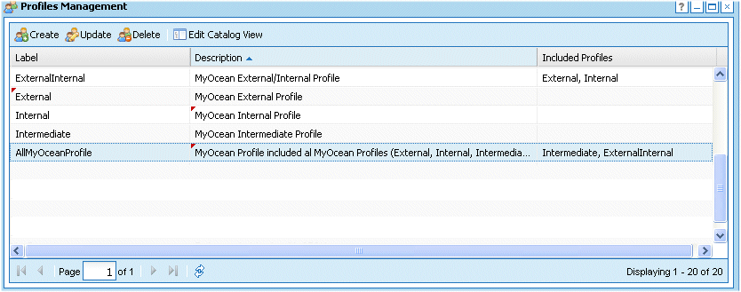

Figure 20 - List of MyOcean profiles example

The profiles are displayed in a list (pagination), one user per line. The list is initially sorted by profile’s label.

The entire user’s data are (or can be) displayed in the line except extended properties. All the columns can be sorted. Columns can be hidden or displayed.

A profile can include one or more profiles: e.g.

* “ExternalInternal” profile includes “External” and “Internal” profiles.
* “AllMyOceanProfile” profile includes “Intermediate” and “ExternalInternal” profiles; so, “AllMyOceanProfile” includes “Intermediate”, “External” and “Internal” profiles.

This interface is the input to create, update a profile.

Notes:

1. The manager should take care not to create two profiles with the same label. The identifier of the profile is an internal ID. Or shall we implement control to check there is no label with the same label (name) ?
2. The “Edit Catalog View” option .is not used in MyOcean.

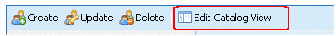

1. Only one profile is assigned to a user. A user may have more than one profile, by creating a “root” profile and include into this “root” profile the desired profiles
2. If a profile includes other profiles and this profile is assigned to a user, the profiles stored in the LDAP database for the users (memberUid fields) are all the profiles: root profile and included profiles, e.g. if “AllMyOceanProfile” is assigned to a user, the LDAP fields shall contain the following string “AllMyOceanProfile, ExternalInternal,Intermediate,External,Internal”. This is not yet implemented.
3. A profile can be deleted if it’s assigned to at least one user. To be able to delete the profile, .the profile assigned to this user has to be removed. It could be done:
   1. From the “update profile dialog box – tab “members”: select users and then click remove button – See section “5.1.3.2.20 EI_MIS_ADM_CREATE_UPDATE_PROFILES”, page 59. Then perhaps manager have to assign a new profile to those users.
   2. Per user, change the profile assigned to him, from the user edit dilog box – See section “5.1.3.2.4 EI_MIS_ADM_CREATE_UPDATE_USERS”, page 41.
4. A profile can be deleted if it’s included in another profile. The inclusion can be removed from the “update profile dialog box – tab “members”: – See section “5.1.3.2.20 EI_MIS_ADM_CREATE_UPDATE_PROFILES”, page 59.

##### EI_MIS_ADM_CREATE_UPDATE_PROFILES

This interface allows creating and updating a profile.

The interface is a web GUI using the HTTP protocol and secured with the CAS authentication (manager/administrator access).

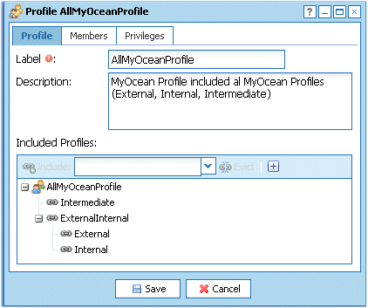

Figure 21 – Browse, create, update a profile

The label of the profile is mandatory. The description is optional. A profile can include one or more profiles. To include a profile, select an existing one in the combo box an click “Include”:

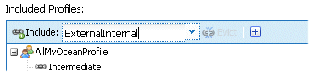

Figure 22 – Included profiles

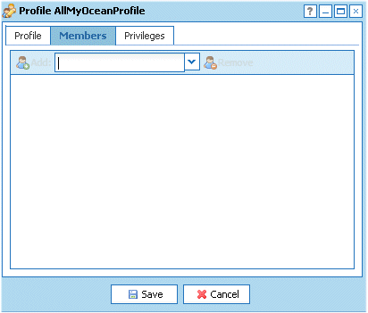

Figure 23 – Assign users to a profile

A profile can be assigned to users from the dialog box above: select a user from the combo box and then click Add button. This is optional. The profile can be also assigned to a user from the “Create/Update User Account” dialog box (see section “5.1.3.2.4 EI_MIS_ADM_CREATE_UPDATE_USERS”, page 41).

A profile can be dismissed from users from the dialog box above: select users and then click Remove button. The profile can be also dismissed from a user from the “Create/Update User Account” dialog box (see section “5.1.3.2.4 EI_MIS_ADM_CREATE_UPDATE_USERS”, page 41).

Notes: (see also “5.1.3.2.19 EI_MIS_ADM_LIST_DELETE_PROFILES”, page 58)

1. shall we implement control to check there is no label with the same name (label)?
2. the profile’s label is case-sensitive : e.g. “External” and “external” are two distinct profiles (TO BE CONFIRMED)
3. The opportunity to have included profiles may be necessary in the future for MyOcean or other applications.
4. Updating the LDAP with all profiles (‘flatten’ root profile and included profiles) is not yet implemented.

Example of the benefits of included profiles:

Let say we want to add Seadatanet users as users of MyOcean:

1. Create a profile “seadatanet” in MyOcean.
2. Import Seadatanet users (with profile “seadatanet”) into the MyOcean database (see “5.1.3.2.6 EI_MIS_ADM_IMPORT_USERS”, page 44).
3. Update profile “seadatanet” in MyOcean: include a MyOcean profile (external, internal ...), then all the Seadatanet users will inherit automatically of the MyOcean profile.

Or vice versa, we are able to assign “seadatanet” profile to MyOcean users: add the “seadatanet” profile to the MyOcean profile.

However, both are not possible you shall not include “seadatanet” profile into MyOcean profile and include MyOcean profile into “seadatanet” profile; this would result in an infinite recursive loop.

Notes:

1. The “Privileges” tab is not used in MyOcean. This tab doesn’t appear in the creation mode (only in the updating mode). The “Privileges” item offers the ability to assign rights to users on products and datasets.

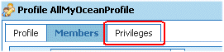

##### EI_MIS_IS_CREATE_PROFILE

This interface allows creating a profile in MyOcean (atoll-is web service).

The interface uses the HTTP protocol and CAS authentication or HTTP Basic authentication access.

The profile is created in the PostgreSQL database (profile, profile_included tables)

If the profile is assigned to users, the LDAP database is updated for these users (user‘s profiles updated). **Warning** updating LDAP database for the profiles is not yet implemented.

###### Input

URL: <Atoll-IS URL>/resources/profiles

Method: HTTP POST as application/x-www-form-urlencoded

Parameters:

label: the label of the profile.

description: the description of the profile.

included: included profile(s) id as a list of numeric ids. Each id is a valid id corresponding to existing profile in the PostgreSQL database (profile table).

members: users to assign to the profile id as a list of string corresponding to users’ login. Each string is a valid login corresponding to existing login in the PostgreSQL database (account table).

_mimetype: the response format (optional). Available values: application/xml, application/json. If the parameter is missing the response is in xml format.

###### Output

The HTTP response returns the internal ID of the created profile. The format depends on the input _mimetype setting.

##### EI_MIS_IS_UPDATE_PROFILE

This interface allows updating a profile in MyOcean (atoll-is web service).

The interface uses the HTTP protocol and CAS authentication or HTTP Basic authentication access.

The profile is updated in the PostgreSQL database (profile, profile_included tables)

If the profile is assigned to users or dismissed from users, the LDAP database is updated for these users (user‘s profiles updated). **Warning** updating LDAP database for the profiles is not yet implemented.

###### Input

URL: <Atoll-IS URL>/resources/profiles

Method: HTTP PUT as application/x-www-form-urlencoded

Parameters:

id: internal profile id (must be an existing one).

label: the label of the profile.

description: the description of the profile.

included: included profile(s) id as a list of numeric ids. Each id is a valid id corresponding to existing profile in the PostgreSQL database (profile table).

members: users to assign to the profile id as a list of string corresponding to users’ login. Each string is a valid login corresponding to existing login in the PostgreSQL database (account table).

_mimetype: the response format (optional). Available values: application/xml, application/json. If the parameter is missing the response is in xml format.

###### Output

The HTTP response returns the internal ID of the updated profile. The format depends on the input _mimetype setting.

##### EI_MIS_IS_LIST_PROFILES

This interface allows getting profiles’ data (atoll-is web service).

The interface uses the HTTP protocol and CAS authentication or HTTP Basic authentication access.

The profiles data are retrieved from the PostgreSQL database (profile, profile_included table).

**By default the request doesn’t return all profiles, but depending on the start, limit and filter parameters, the result can be partial The start and limit parameters allow to paginate the result.**

###### Input

URL: <Atoll-IS URL>/resources/catalogcontexts/*{context}*/profiles

*{context}* for MyOcean is *default.*

Method: HTTP GET

Parameters:

start: the start user range to retrieve. Default value is 0.

limit: the limit number of user to retrieve. 0 for no limit. Default value is 50.

sort: to allow sorting the result on a user data fields. Default value is “id”.

dir: the sort direction: ACS or DESC. Default value is ASC.

filter: JSOn format filter as : {"*field_name*":[{"t":"*type*","v":"*value_to_filter*"}]}. Default value is no filter:

###### Output

The HTTP response returns the profiles’ data (the format depends on the input _mimetype setting):

* catalog context (*default* for MyOcean)
* profile’s id
* profile’s description
* included profile(s)

##### EI_MIS_IS_DELETE_PROFILE

This interface allows deleting a profile (atoll-is web service).

The interface uses the HTTP protocol and CAS authentication or HTTP Basic authentication access.

The profile is deleted in the PostgreSQL database (profile, profile_included tables)

Notes:

1. A profile can be deleted if it’s assigned to at least one user. In this case, a HTTP error code and an exception will be raised.

###### Input

URL: <Atoll-IS URL>/resources/profiles/*{id}*

Method: HTTP DELETE

Parameters:

id: internal profile id to delete (must be an existing one).

###### Output

None

##### EI_MIS_ADM_UPDATE_CONTEXT_MANAGER

This interface allows updating managers and administration settings.

The interface is a web GUI using the HTTP protocol and secured with the CAS authentication (manager/administrator access).

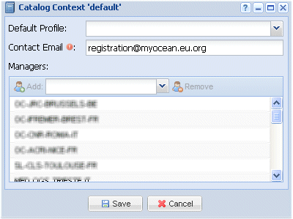

Figure 24 – Browse, update managers and administration settings

The contact email is mandatory. This email address is:

* the email address set as the sender of each email sent automatically to users (e.g. registration email,...)
* the contact which may be included in the email content.

Default profile is not used in MyOcean (it is to the default profile that is automatically assigned to the anonymous users in other applications).

Managers can be defined here. From the dialog box above: select a user from the combo box and then click Add button. This is optional.

A manager can be dismissed. From the dialog box above: select manager(s) and then click Remove button.

Notes:

1. When the atoll-is PostgreSQL is created, a manager (e.g. ‘adminweb’) is automatically declared as user and manager in the:
   * account table
   * profile table
   * profile_manager table
   * catalog_context_table
   * secure_resource table
   * privilege table

**This user (e.g. ‘adminweb’) is not automatically added in the LDAP database. This should be done manually by the administrator/operating system of MyOcean.**

**Without created at least on user as manager (e.g. ‘adminweb’), It would be impossible to connect to atoll that requires authentication as manager**

##### EI_MIS_IS_UPDATE_CONTEXT_MANAGER

This interface allows updating managers and administration settings (atoll-is web service).

The interface uses the HTTP protocol and CAS authentication or HTTP Basic authentication access.

The profile is updated in the PostgreSQL database (profile, profile_included tables)

If the profile is assigned to users or dismissed from users, the LDAP database is updated for these users (user‘s profiles updated). **Warning** updating LDAP database for the profiles is not yet implemented.

###### Input

URL: <Atoll-IS URL>/resources/catalogcontexts/*{context}*

*{context}* for MyOcean is *default.*

Method: HTTP PUT as application/x-www-form-urlencoded

Parameters:

id: internal context id (must be an existing one – context is initialized when the PostgreSQL database is created).

anonymousProfile: the default profile – not used in MyOcean.

description: the description of the profile.

contact: email address set as the sender and included a contact in emails sent to users.

managers: users to assign as managers, as a list of numeric ids. Each id is a valid id corresponding to existing users in the PostgreSQL database.

###### Output

None.

##### EI_MIS_ADM_CAS_LOGIN

This interface allows a user a CAS authentication on MyOcean

The interface is a web GUI using the HTTP protocol.

Notes:

1. When a user authenticates (logs in), he logs in for all MyOcean CASified applications for a specific browser instance: this means if a user authenticates on MyOcean on a specific browser instance, if he accesses the same or another MyOcean application from a new browser instance, he will be not authenticated on the new browser instances. He will have to authenticate on this new browser instance.

##### EI_MIS_CAS_SERVER_LOGIN

This interface allows requesting an authentication to the CAS Server. This interface is mentioned here for clarification purposes. It is described in the CAS protocol at <http://www.jasig.org/cas/protocol>. See also section “5.1.2.1 CAS (Central Authentication Service)”, page 22.

##### EI_MIS_ADM_CAS_LOGOUT

This interface allows a user to logout from MyOcean

The interface is a web GUI using the HTTP protocol.

Notes:

1. When a user logs out, he logs out for all MyOcean CASified applications for a specific browser instance: this means if a user is authenticated on MyOcean with several browser instances, when he logs out from one browser instance, he is still authenticated on the other browser instances.

##### EI_MIS_CAS_SERVER_LOGOUT

This interface allows requesting a logout to the CAS Server. This interface is mentioned here for clarification purposes. It is described in the CAS protocol at <http://www.jasig.org/cas/protocol>. See also section “5.1.2.1 CAS (Central Authentication Service)”, page 22.

##### EI_MIS_USER_DIRECTORY_ADMIN_GUI

TO BE DEFINED

##### EI_MIS_BUSINESS_DIRECTORY_ADMIN_GUI

TO BE DEFINED

#### (UC) Browse the users

Identification

(UC) Browse the users

Description

This use case describes the sequence to get user displayed on screen.

Preconditions

Only users authenticated as Manager or Service Desk can browse users.

The user must be authenticated as Manager or Service Desk.

Inputs

|  |  |
| --- | --- |
| Variables | Mandatory / Optional |
|  |  |

Post conditions

Outputs

|  |  |
| --- | --- |
| Variables | Mandatory / Optional |
|  |  |

Normal flow

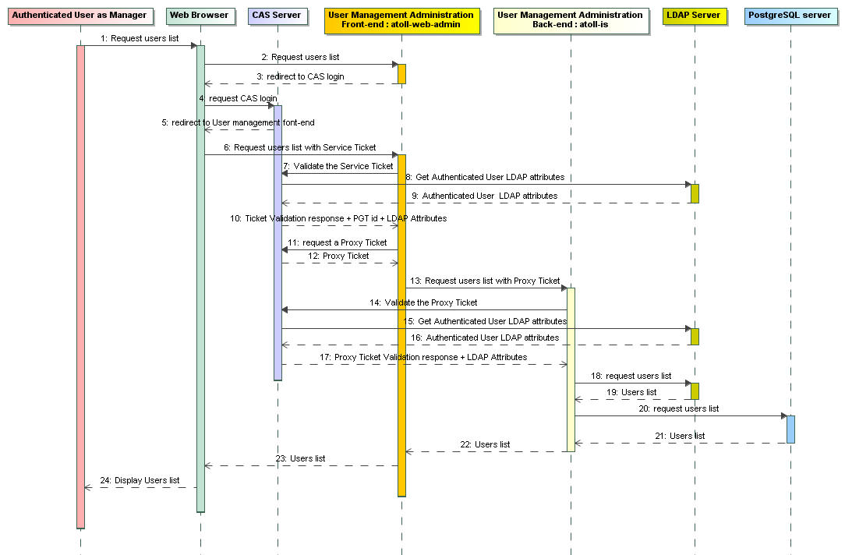

Figure 25 - (UC) Browse the users - Sequence diagram

Alternative flows

Exceptions

The CAS Proxy Ticket Granting id (PGT) can expire after a time. This time is set in the CAS Server configuration. If PGT is expired, the CAS authenticated connexion between atoll-web-admin and atoll-is can be established, the list is then empty and no error message is displayed. The user have to logout then login again. See section “CAS Server”, page 24. Currently there is no automatic “login again” process in this specific case, because this would require a significant work to implement such a mechanism.

#### (UC) Consult a user

Identification

(UC) Consult a user

Description

This use case describes the sequence to get specific user’s information displayed on screen.

Preconditions

Only users authenticated as Manager or Service Desk can consult all users. In this case, this use case can be accessed only from the users’ information screen: a navigation list of all MyOcean users. See use case “5.1.3.3 (UC) Browse the users”, page 69. The GUI is described in section “5.1.3.2.4 EI_MIS_ADM_CREATE_UPDATE_USERS”, page 41.

An authenticated user can consult his own information. In this case, this use case can be accessed only from MyOcean Web Portal.

Inputs

|  |  |
| --- | --- |
| Variables | Mandatory / Optional |
|  |  |

Post conditions

Outputs

|  |  |
| --- | --- |
| Variables | Mandatory / Optional |
|  |  |

Normal flow

Sequence diagram to consult a user as as Manager or Service Desk:

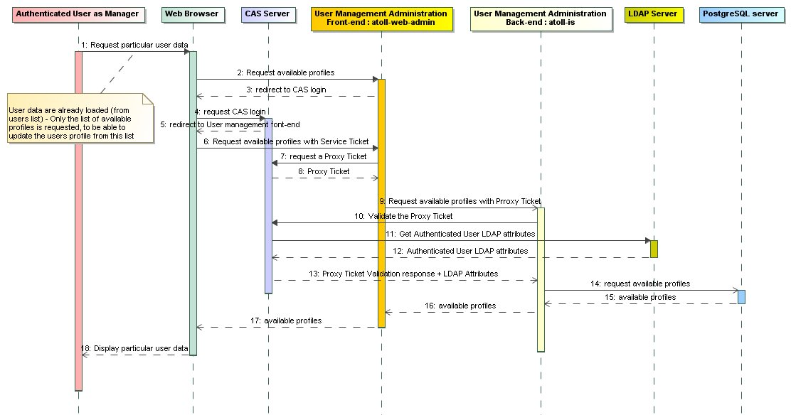

Figure 26 - (UC) Consult a user as Manager - Sequence diagram

Sequence diagram for a user (A) to consult his own information:

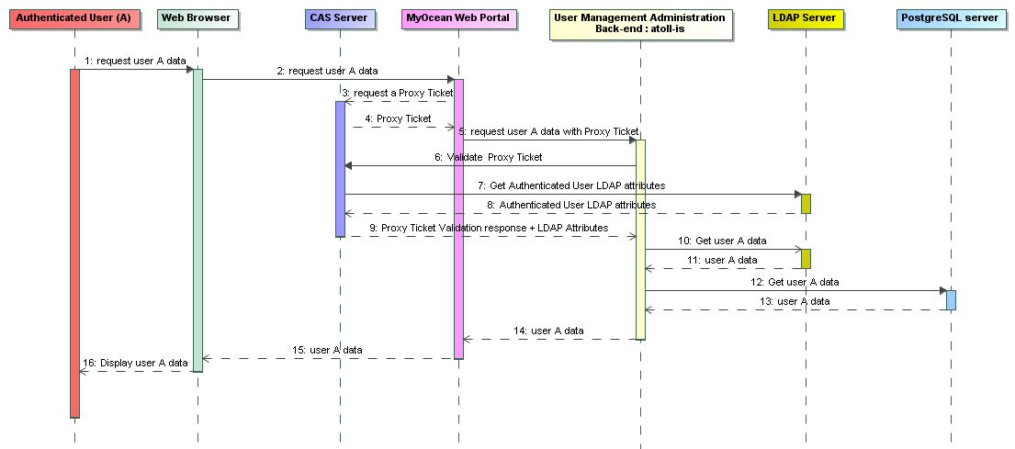

Figure 27 - (UC) User consults his own information - Sequence diagram

Alternative flows

Exceptions

The CAS Proxy Ticket Granting id (PGT) can expire after a time. This time is set in the CAS Server configuration. If PGT is expired, the CAS authenticated connexion between atoll-web-admin and atoll-is can be established, the list is then empty and no error message is displayed. The user have to logout then login again. See section “CAS Server”, page 24. Currently there is no automatic “login again” process in this specific case, because this would require a significant work to implement such a mechanism.

#### (UC) Declare a new user

Identification

(UC) Declare a new user

Description

This use case allows adding manually a new user in MyOcean. A user can be added automatically if a guest user registers online, but the Service Desk can also add a user manually.

Preconditions

Only users authenticated as Manager or Service Desk can add a user. This use case can be accessed directly from a menu “New User” or from the “create” button in the users’ information screen (see use case “5.1.3.3 (UC) Browse the users”, page 69).

The user login must not exist in the user directory.

The creation form is the same as the one described in the use case “5.1.3.4 (UC) Consult a user”, page 70.

Inputs

|  |  |
| --- | --- |
| Variables | Mandatory / Optional |
|  |  |

Post conditions

The user is created in the LDAP and PostgreSQL databases.

Outputs

|  |  |
| --- | --- |
| Variables | Mandatory / Optional |
|  |  |

Normal flow

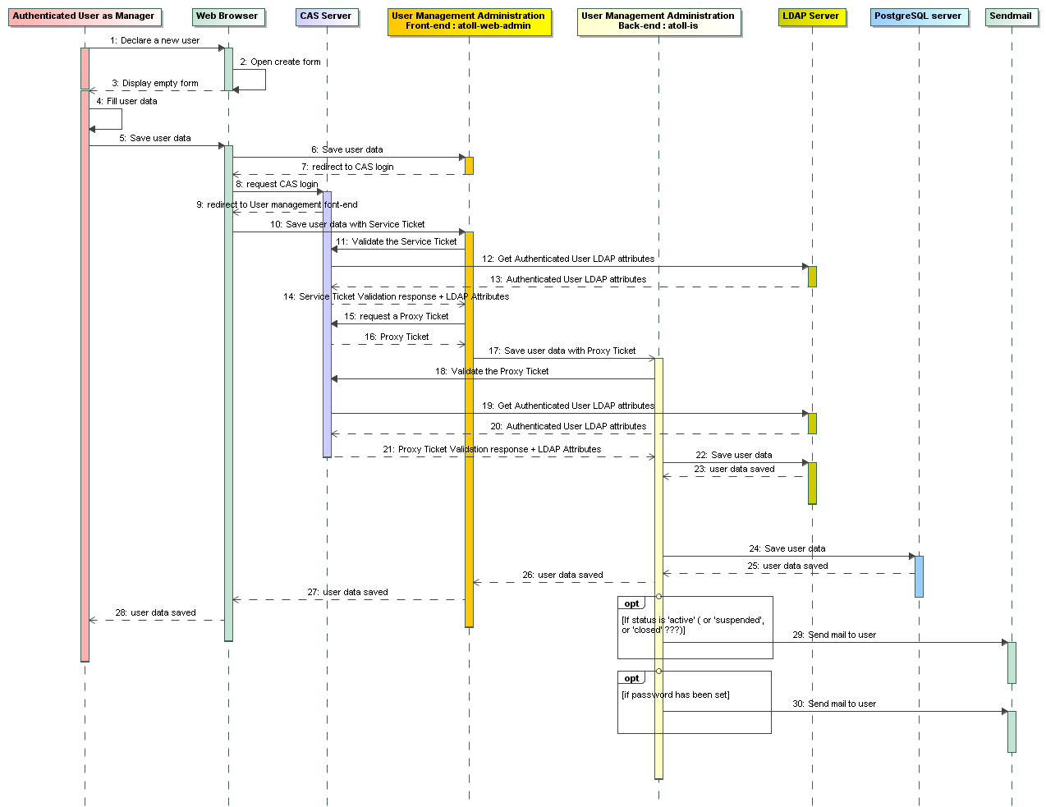

Figure 28 - (UC) Declare a new user - Sequence diagram

Alternative flows

The use case “5.1.3.16 (UC) Register to MyOcean process”, page 93 is an alternative to declare a new user.

Exceptions

If the user login already exists, an error message is displayed (duplicate login).

The CAS Proxy Ticket Granting id (PGT) can expire after a time. This time is set in the CAS Server configuration. If PGT is expired, the CAS authenticated connexion between atoll-web-admin and atoll-is can be established, the list is then empty and no error message is displayed. The user have to logout then login again. See section “CAS Server”, page 24. Currently there is no automatic “login again” process in this specific case, because this would require a significant work to implement such a mechanism.

#### (UC) Edit a user

Identification

(UC) Edit a user

Description

This use case allows updating an existing user in MyOcean.

Preconditions

Only users authenticated as Manager or Service Desk can edit and update a user. This use case can be accessed from the “update” button in the users’ information screen (see use case “5.1.3.3 (UC) Browse the users”, page 69).

The update form is the same as the one described in the use case “5.1.3.4 (UC) Consult a user”, page 70.

Inputs

|  |  |
| --- | --- |
| Variables | Mandatory / Optional |
|  |  |

Post conditions

The user is updated in the LDAP and PostgreSQL databases.

Outputs

|  |  |
| --- | --- |
| Variables | Mandatory / Optional |
|  |  |

Normal flow

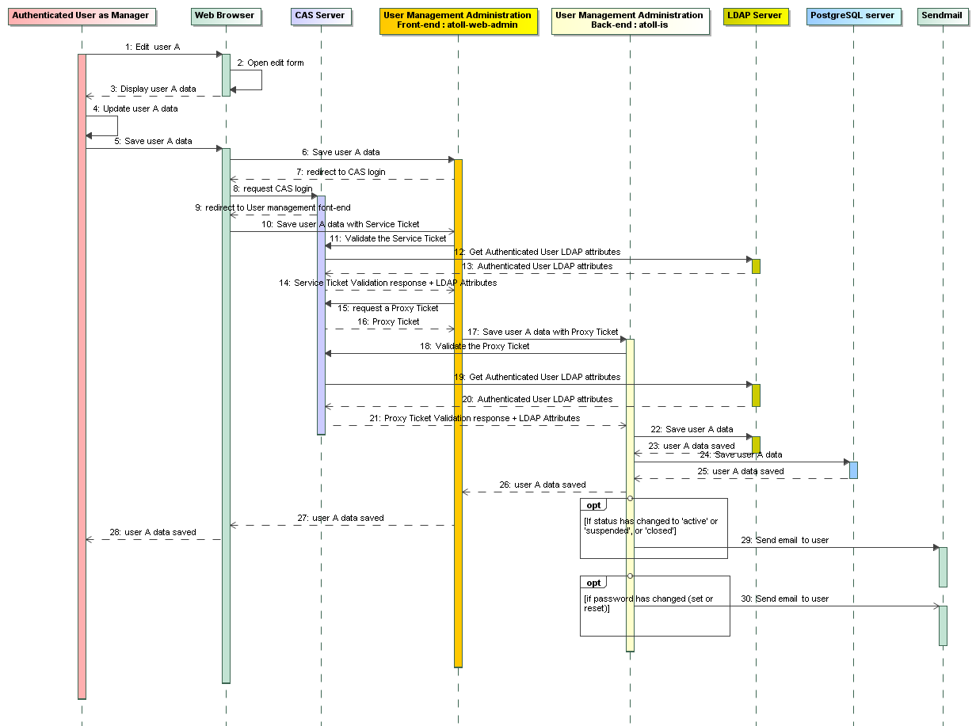

Figure 29 - (UC) Edit a user - Sequence diagram

Alternative flows

Exceptions

The CAS Proxy Ticket Granting id (PGT) can expire after a time. This time is set in the CAS Server configuration. If PGT is expired, the CAS authenticated connexion between atoll-web-admin and atoll-is can be established, the list is then empty and no error message is displayed. The user have to logout then login again. See section “CAS Server”, page 24. Currently there is no automatic “login again” process in this specific case, because this would require a significant work to implement such a mechanism.

#### (UC) Suspend a user

Identification

(UC) Suspend a user

Description

This use case permits to suspend a user. It is a temporary closure of the account for technical or relationship reasons.

This use cases consists in edit a user and change his status. It is similar to use case “5.1.3.6 (UC) Edit a user”, page 75.

Preconditions

See “5.1.3.6 (UC) Edit a user”, page 75.

Inputs

|  |  |
| --- | --- |
| Variables | Mandatory / Optional |
|  |  |

Post conditions

See “5.1.3.6 (UC) Edit a user”, page 75.

Outputs

|  |  |
| --- | --- |
| Variables | Mandatory / Optional |
|  |  |

Normal flow

The flow is described in use case “5.1.3.6 (UC) Edit a user”, page 75.

Alternative flows

Exceptions

See “5.1.3.6 (UC) Edit a user”, page 75.

#### (UC) Close a user account

Identification

(UC) Close a user account

Description

This use case happens when a user is wrongly created (initiated by the Service Desk in this case) or when a user unregisters from MyOcean services (see “5.1.3.17 (UC) Unregister from MyOcean”, page 96).

Preconditions

See “5.1.3.6 (UC) Edit a user”, page 75.

Inputs

|  |  |
| --- | --- |
| Variables | Mandatory / Optional |
|  |  |

Post conditions

See “5.1.3.6 (UC) Edit a user”, page 75.

Outputs

|  |  |
| --- | --- |
| Variables | Mandatory / Optional |
|  |  |

Normal flow

The flow is described in use case “5.1.3.6 (UC) Edit a user”, page 75.

Alternative flows

A user unregisters from MyOcean: see “5.1.3.17 (UC) Unregister from MyOcean”, page 96.

Exceptions

See “5.1.3.6 (UC) Edit a user”, page 75.

#### (UC) Delete a user

Identification

(UC) Delete a user

Description

This use case happens when a user is wrongly created and when the Service Desk wants to physically remove the user definitely from MyOcean.

Preconditions

Only users authenticated as Manager or Service Desk can delete a user. This use case can be accessed from the “delete” button in the users’ information screen (see use case “5.1.3.3 (UC) Browse the users”, page 69).

Inputs

|  |  |
| --- | --- |
| Variables | Mandatory / Optional |
|  |  |

Post conditions

All user’s information are deleted from the LDAP and PostgreSQL databases.

Outputs

|  |  |
| --- | --- |
| Variables | Mandatory / Optional |
|  |  |

Normal flow

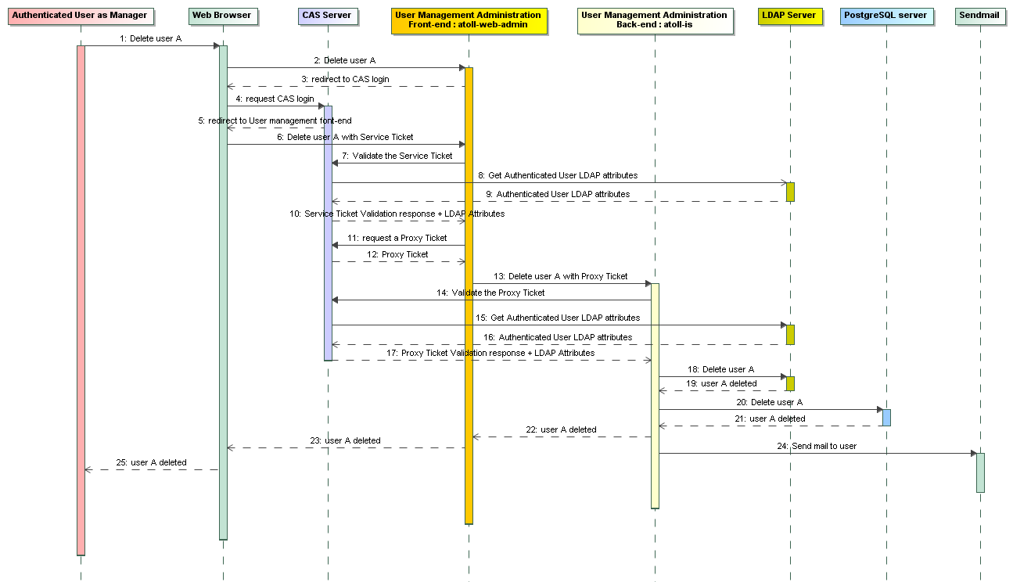

Figure 30 - (UC) Delete a user - Sequence diagram

Alternative flows

Exceptions

The CAS Proxy Ticket Granting id (PGT) can expire after a time. This time is set in the CAS Server configuration. If PGT is expired, the CAS authenticated connexion between atoll-web-admin and atoll-is can be established, the list is then empty and no error message is displayed. The user have to logout then login again. See section “CAS Server”, page 24. Currently there is no automatic “login again” process in this specific case, because this would require a significant work to implement such a mechanism.

#### (UC) Export user’s information

Identification

(UC) Export user’s information

Description

This use case permits to export user’s information to a file in Excel format or a CSV file (not yet implemented), By default all users in the users are exported. The export could be applied only on users displayed (filtered) on the display. To be confirmed and to be implemented.

The format of the export as Excel file is described in section “5.1.3.2.5 EI_MIS_ADM_EXPORT_USERS”, page 43.

Preconditions

Only users authenticated as Manager or Service Desk can export users’ information. This use case can be accessed from the “export users” button in the users’ information screen (see use case “5.1.3.3 (UC) Browse the users”, page 69).

Inputs

|  |  |
| --- | --- |
| Variables | Mandatory / Optional |
|  |  |

Post conditions

Users’ information are exported to a file.

Outputs

|  |  |
| --- | --- |
| Variables | Mandatory / Optional |
|  |  |

Normal flow

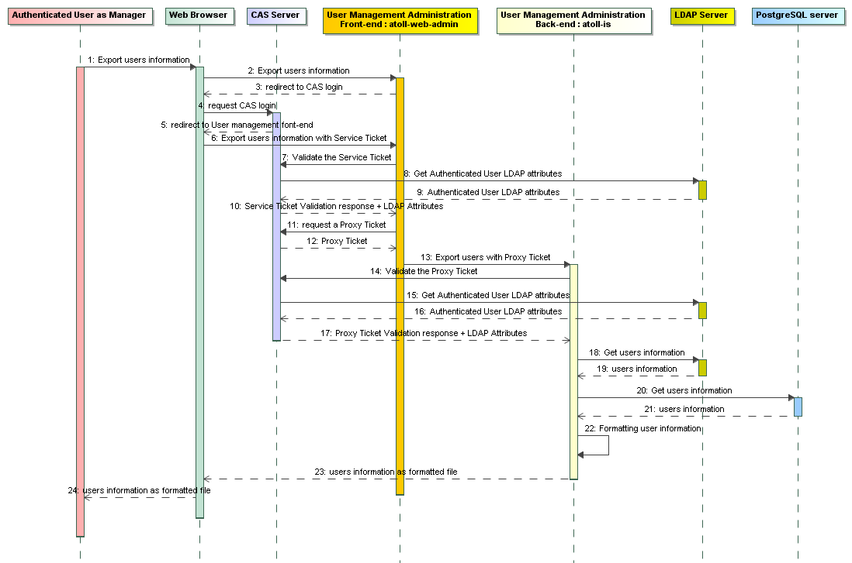

Figure 31 - (UC) Export users - Sequence diagram

Alternative flows

Exceptions

The CAS Proxy Ticket Granting id (PGT) can expire after a time. This time is set in the CAS Server configuration. If PGT is expired, the CAS authenticated connexion between atoll-web-admin and atoll-is can be established, the list is then empty and no error message is displayed. The user have to logout then login again. See section “CAS Server”, page 24. Currently there is no automatic “login again” process in this specific case, because this would require a significant work to implement such a mechanism.

#### (UC) Import users

Identification

(UC) Import users

Description

This use case is not yet implemented.

This use case permits to import user’s information from a XML or CSV file (To be confirmed).

The CSV file must contain at least the mandatory fields (see “The LDAP and PostgreSQL databases store the following user information”, page 28) except for the login field which could be optional (see below). The XML or CSV format be must be designed.

A dialog box is displayed to be able to select the file to import. Then a confirmation dialog box is displayed to allow accepting or cancelling the import process.

The import process logs for each user contained in the file, the import process result (successful or in error).

One of the above rules have to be chosen:

Option 1:

The login is the user identifier.

If the login field is set, the user has to be updated. It must exist in the LDAP and PostgreSQL database, otherwise an error is logged.

If the login field is not set, the user has to be created. The login field is computed from the first name and last name in the same way as the user registration process (normalized string and add range number for duplicated login). The process does not care whether a user with the same first name and last name already exists.

Option 2:

The login is the user identifier

If the login field is always set, the user is updated if he already exists in the database. The user is created if he doesn’t exist in the database. This is dangerous if the login does not really match to the same user (but you may want to change the first name or last name of the user due to a typo).

Option 3:

The login is the user identifier

If the login field is never set, the user is created if he already exists in the database The login field is computed from the first name and last name in the same way as the user registration process (normalized string and add range number for duplicated login). The process does not care whether a user with the same first name and last name already exists.

At the end of the import, a report is built as a PDF file (to be confirmed) and a dialog box is displayed to be able to get the file (download and view).

Preconditions

Only users authenticated as Manager or Service Desk can import users’ information. This use case can be accessed from the “import users” button in the users’ information screen (see use case “5.1.3.3 (UC) Browse the users”, page 69).These button and function are not yet implemented.

Inputs

|  |  |
| --- | --- |
| Variables | Mandatory / Optional |
|  |  |

Post conditions

Users are imported in the LDAP and PostgreSQL database.

Outputs

|  |  |
| --- | --- |
| Variables | Mandatory / Optional |
|  |  |

Normal flow

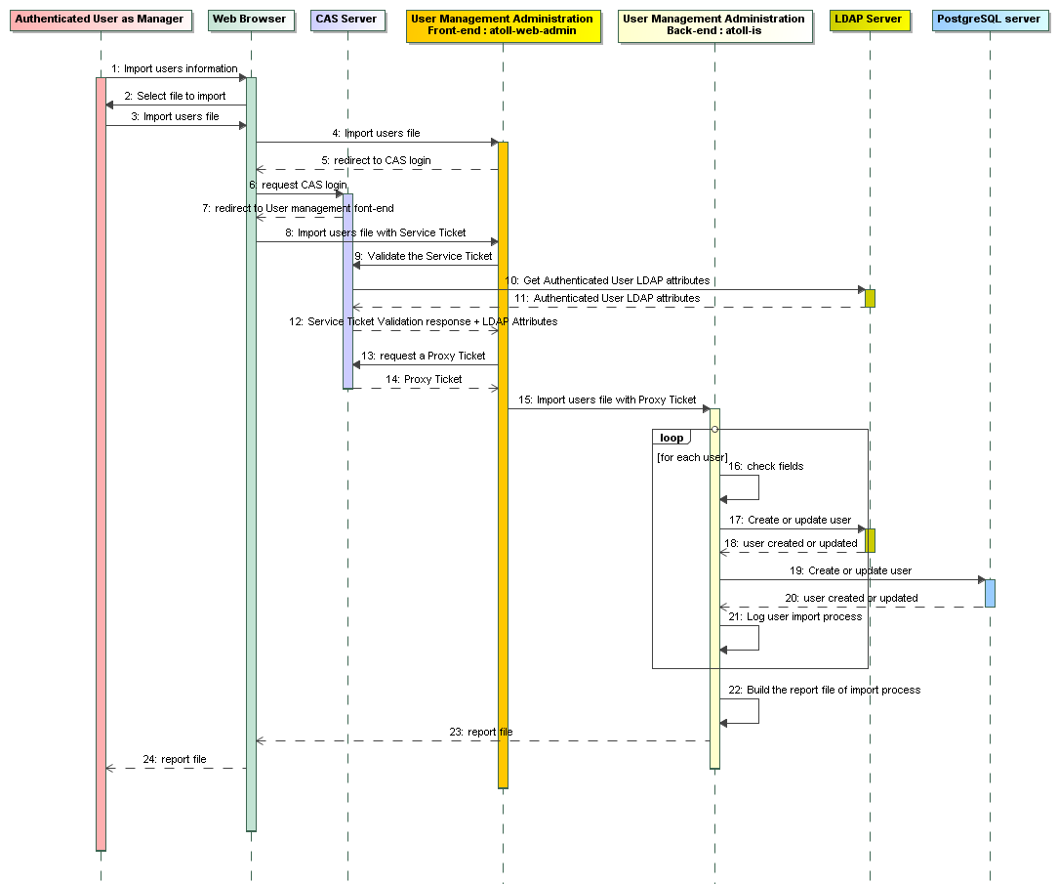

Figure 32 - (UC) Import users - Sequence diagram

Alternative flows

Exceptions

The CAS Proxy Ticket Granting id (PGT) can expire after a time. This time is set in the CAS Server configuration. If PGT is expired, the CAS authenticated connexion between atoll-web-admin and atoll-is can be established, the list is then empty and no error message is displayed. The user have to logout then login again. See section “CAS Server”, page 24. Currently there is no automatic “login again” process in this specific case, because this would require a significant work to implement such a mechanism.

#### (UC) Browse the profiles

Identification

(UC) Browse the profiles

Description

Preconditions

Only users authenticated as Manager or Service Desk can browse profiles.

The user must be authenticated as Manager or Service Desk.

Inputs

|  |  |
| --- | --- |
| Variables | Mandatory / Optional |
|  |  |

Post conditions

List of post conditions

Outputs

|  |  |
| --- | --- |
| Variables | Mandatory / Optional |
|  |  |

Normal flow

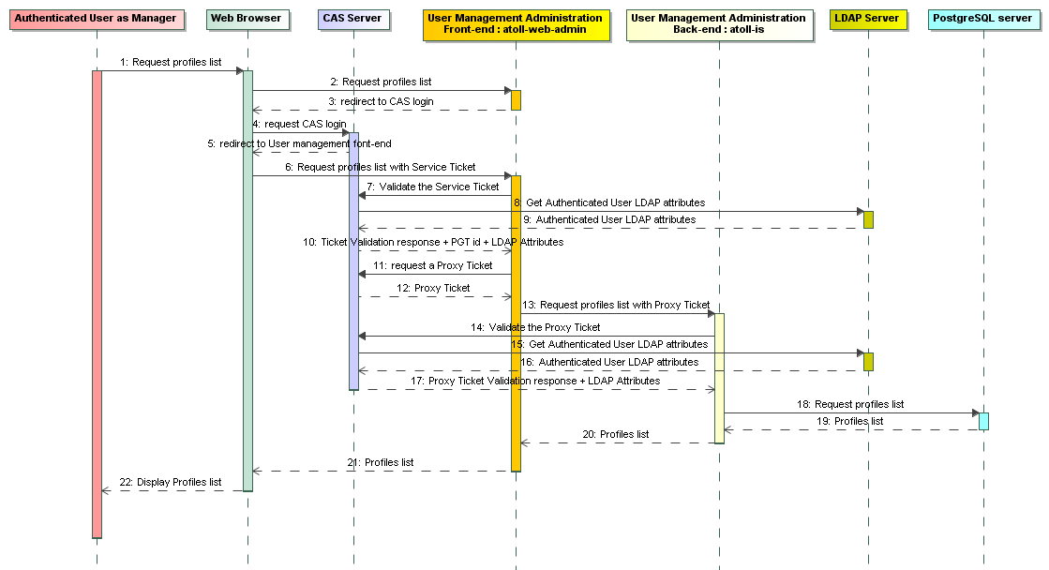

Figure 33 - (UC) Browse the profiles - Sequence diagram

Alternative flows

Exceptions

The CAS Proxy Ticket Granting id (PGT) can expire after a time. This time is set in the CAS Server configuration. If PGT is expired, the CAS authenticated connexion between atoll-web-admin and atoll-is can be established, the list is then empty and no error message is displayed. The user have to logout then login again. See section “CAS Server”, page 24. Currently there is no automatic “login again” process in this specific case, because this would require a significant work to implement such a mechanism.

#### (UC) Consult/Edit profile

Identification

(UC) Consult/Edit profile

Description

This use case allows consulting/updating an existing profile in MyOcean.

A profile can include one or more profiles, and each included profile cans include also one or more profiles, and so on.

Preconditions

Only users authenticated as Manager or Service Desk can consult, edit and update a profile. This use case can be accessed from the “update” button in the profiles’ information screen (see use case “5.1.3.12 (UC) Browse the profiles, page 86). The GUI is described in section “5.1.3.2.20 EI_MIS_ADM_CREATE_UPDATE_PROFILES”, page 59.

Inputs

|  |  |
| --- | --- |
| Variables | Mandatory / Optional |
|  |  |

Post conditions

The profile and its included profiles are updated in the PostgreSQL database.

Outputs

|  |  |
| --- | --- |
| Variables | Mandatory / Optional |
|  |  |

Normal flow

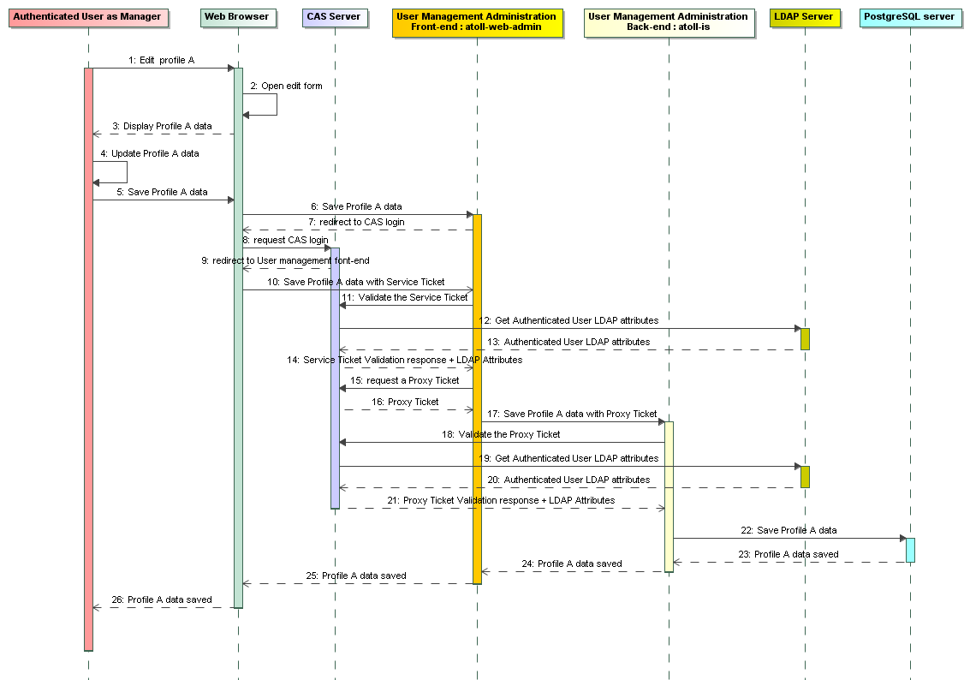

Figure 34 - (UC) Consult/edit a profile - Sequence diagram

Alternative flows

Exceptions

The CAS Proxy Ticket Granting id (PGT) can expire after a time. This time is set in the CAS Server configuration. If PGT is expired, the CAS authenticated connexion between atoll-web-admin and atoll-is can be established, the list is then empty and no error message is displayed. The user have to logout then login again. See section “CAS Server”, page 24. Currently there is no automatic “login again” process in this specific case, because this would require a significant work to implement such a mechanism.

#### (UC) Delete a profile

Identification

(UC) Delete a profile

Description

This use case permits to delete a profile.

Deleting a profile doesn’t delete its included profiles.

A profile can’t be deleted if this profile is assigned at least to one user. Service Desk must unassigned this profile for all involved users

Preconditions

Only users authenticated as Manager or Service Desk can delete a profile. This use case can be accessed from the “delete” button in the profiles’ information screen (see use case “5.1.3.12 (UC) Browse the profiles, page 86).

Inputs

|  |  |
| --- | --- |
| Variables | Mandatory / Optional |
|  |  |

Post conditions

The profile is deleted from PostgreSQL databases.

Outputs

|  |  |
| --- | --- |
| Variables | Mandatory / Optional |
|  |  |

Normal flow

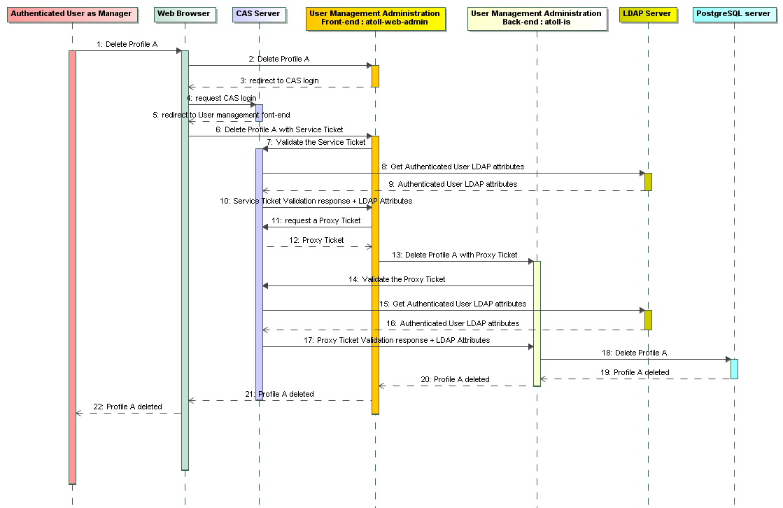

Figure 35 - (UC) Delete a profile - Sequence diagram

Alternative flows

Exceptions

The CAS Proxy Ticket Granting id (PGT) can expire after a time. This time is set in the CAS Server configuration. If PGT is expired, the CAS authenticated connexion between atoll-web-admin and atoll-is can be established, the list is then empty and no error message is displayed. The user have to logout then login again. See section “CAS Server”, page 24. Currently there is no automatic “login again” process in this specific case, because this would require a significant work to implement such a mechanism.

#### (UC) Declare a new profile

Identification

(UC) Declare a new profile

Description

This use case offers the possibility to declare a new profile in MyOcean.

Preconditions

Only users authenticated as Manager or Service Desk can add a profile. This use case can be accessed directly from a menu “New Profile” or from the “create” button in the profile’s information screen (see use case “5.1.3.12 (UC) Browse the profiles, page 86).).

The profile must not exist in the user directory.

The creation form is the same as the one described in the use case “5.1.3.13 (UC) Consult/Edit profile”, page 87.

See also “5.1.3.2.19 EI_MIS_ADM_LIST_DELETE_PROFILES”, page 58 and “5.1.3.2.20 EI_MIS_ADM_CREATE_UPDATE_PROFILES”, page 59.

Inputs

|  |  |
| --- | --- |
| Variables | Mandatory / Optional |
|  |  |

Post conditions

The profile and its included profiles are created in the PostgreSQL database.

Outputs

|  |  |
| --- | --- |
| Variables | Mandatory / Optional |
|  |  |

Normal flow

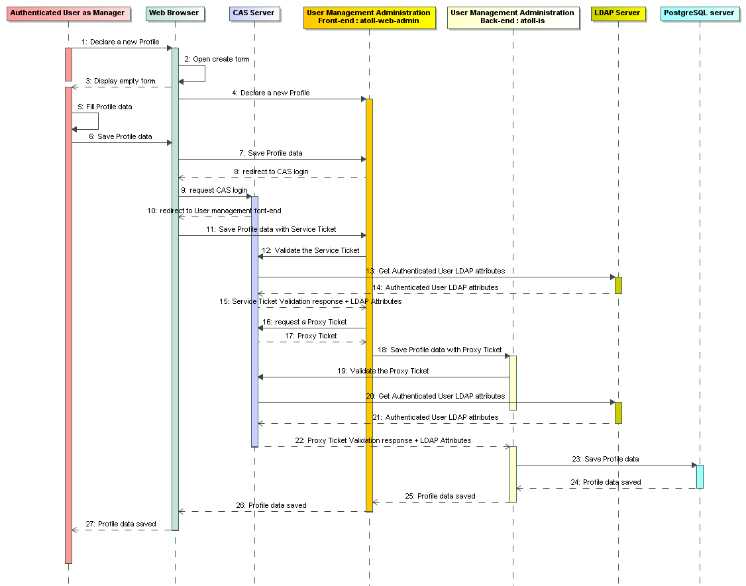

Figure 36 - (UC) Declare a new profile - Sequence diagram

Alternative flows

Exceptions

The CAS Proxy Ticket Granting id (PGT) can expire after a time. This time is set in the CAS Server configuration. If PGT is expired, the CAS authenticated connexion between atoll-web-admin and atoll-is can be established, the list is then empty and no error message is displayed. The user have to logout then login again. See section “CAS Server”, page 24. Currently there is no automatic “login again” process in this specific case, because this would require a significant work to implement such a mechanism.

#### (UC) Register to MyOcean process

Identification

(UC) Register to MyOcean process

Description

Some services of MyOcean, such as “Download product” are reserved to registered users. This use case describes the process done by the MIS for a registration.

Preconditions

Inputs

|  |  |
| --- | --- |
| Variables | Mandatory / Optional |
|  |  |

Post conditions

List of post conditions

Outputs

|  |  |
| --- | --- |
| Variables | Mandatory / Optional |
|  |  |

Normal flow

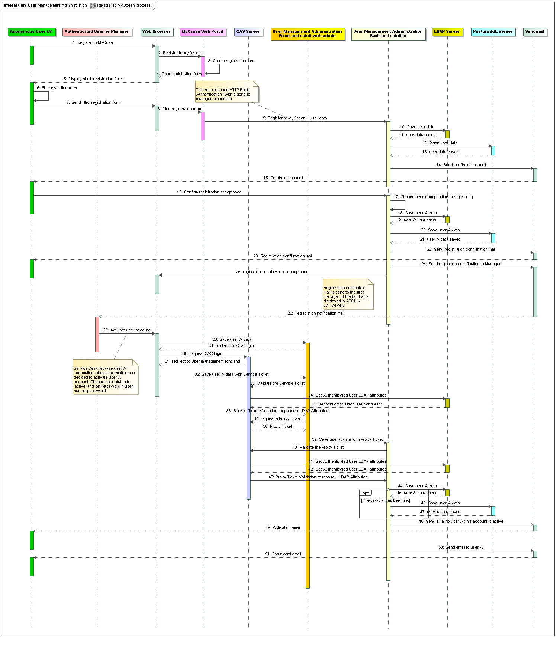

Figure 37 - (UC) Register to MyOcean process - Sequence diagram

Alternative flows

The use case “5.1.3.5 (UC) Declare a new user”, page 73 is an alternative to declare a new user.

Exceptions

The CAS Proxy Ticket Granting id (PGT) can expire after a time. This time is set in the CAS Server configuration. If PGT is expired, the CAS authenticated connexion between atoll-web-admin and atoll-is can be established, the list is then empty and no error message is displayed. The user have to logout then login again. See section “CAS Server”, page 24. Currently there is no automatic “login again” process in this specific case, because this would require a significant work to implement such a mechanism.

#### (UC) Unregister from MyOcean

Identification

(UC) Unregister from MyOcean

Description

To unregister, the user sends an email to the Service Desk. Then the Service Desk closes the account manually.

Same as “5.1.3.8 (UC) Close a user account”, page 78.

Preconditions

See “5.1.3.8 (UC) Close a user account”, page 78.

Inputs

|  |  |
| --- | --- |
| Variables | Mandatory / Optional |
|  |  |

Post conditions

See “5.1.3.8 (UC) Close a user account”, page 78.

Outputs

|  |  |
| --- | --- |
| Variables | Mandatory / Optional |
|  |  |

Normal flow

See “5.1.3.8 (UC) Close a user account”, page 78.

Alternative flows

See “5.1.3.8 (UC) Close a user account”, page 78.

Exceptions

See “5.1.3.8 (UC) Close a user account”, page 78.

#### (UC) Log in

Identification

(UC) Log in

Description

This use case permits to open an authenticated session on MyOcean

Preconditions

User must not be already authenticated on MyOcean

Inputs

|  |  |
| --- | --- |
| Variables | Mandatory / Optional |
|  |  |

Post conditions

User is authenticated on MyOcean

Outputs

|  |  |
| --- | --- |
| Variables | Mandatory / Optional |
|  |  |

Normal flow

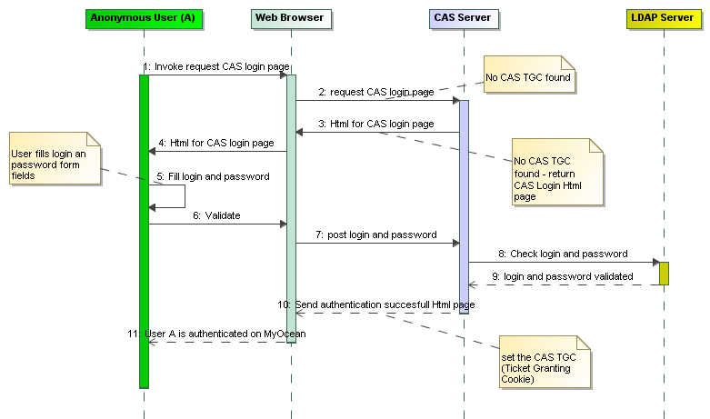

Figure 38 - (UC) Log in - Sequence diagram

Alternative flows

When anonymous user tries to access a secured MyOcean service (service requiring authentication), he has first to authenticate on MyOcean. Then he is automatically redirected to the secured service.

Exceptions

#### (UC) Log-out

Identification

(UC) Log-out

Description

This use case allow disabling authentication on MyOcean

Preconditions

It does not matter whether or not the user is already authenticated on MyOcean.

Inputs

|  |  |
| --- | --- |
| Variables | Mandatory / Optional |
|  |  |

Post conditions

User is no longer authenticated on MyOcean.

Outputs

|  |  |
| --- | --- |
| Variables | Mandatory / Optional |
|  |  |

Normal flow

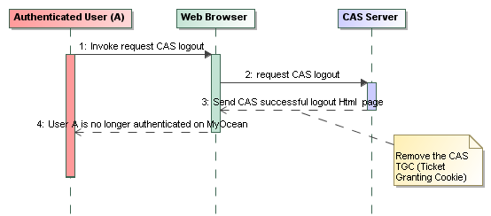

Figure 39 - (UC) Log out - Sequence diagram

Alternative flows

User is automatically log out if his browser’s session expires due to inactivity for longer than the predetermined inactivity duration.

Exceptions

### Catalogue

The catalogue component is responsible of the product management and product browsing. It is also involved for the production monitoring and the transaction accounting.

#### Software used

Table

|  |  |  |  |  |
| --- | --- | --- | --- | --- |
| **Components** | **label** | **operator** | **support** | **developer/maintainer** |
| GEONETWORK  GEONETWORK-RO | CSW catalogue server  Read-Only CSW catalogue server | IFR  IFR | IFR  IFR | IFR  IFR |

Description

##### Geonetwork (CS-W server)

More information about how to use Geonetwork at Ifremer:

You can refer to Product and Services Manual [DA 11], Product manager manual [DA 13] or Quickstart [DA 16].

###### Functions provided, requirements

Geonetwork in an open source project from <http://geonetwork-opensource.org/>

GeoNetwork opensource is a standardized and decentralized spatial information management environment, designed to enable access to geo-referenced databases, cartographic products and related metadata from a variety of sources.

The OGC Catalog Web Service (CS-W) is the discovery service which allows editing, indexing, publishing and searching in customized metadata profiles.

Geonetwork is INSPIRE compliant.

###### Architecture context

Geonetwork is written in JAVA language and runs on a Tomcat server.

It can be interfaced with Oracle, Postgre or MySQL databases. At Ifremer the database management system PostgresSQL have been chosen.

It offers a metadata update interface and a user interface to browse the catalogue.

The application is deployed at Ifremer infrastructure. See more information about the physical environment hosting Geonetwork at Ifremer, see (5.2.4 Physical architecture deployed at IFREMER )

###### Role

Ifremer hosts the central facility to manage the product and access service descriptions with product managers.

From this component the discovery service is provided to search and get product and access service descriptions.

At last, the system monitoring engine configuration is provided from this database and a monitoring engine runs at Ifremer.

#### Interfaces

Table

|  |  |  |  |  |
| --- | --- | --- | --- | --- |
| Name | Description | Interface provided / use an external interface | Format | Protocol |
| EI_MIS_CATALOG_BROWSER | This interface is used for browsing the catalogue. It can be used by the Web Portal or any external systems. It must be OGC-CSW compliant. | Provided |  | OGC/CSW |
| EI_MIS_PS_ADMIN | Interface for administration and configuration of the catalogue. Also provides monitoring configuration files. | Provided |  | HTTP |
| j_EDITOR | This interface is graphical and used by product managers. From this one, products, data access and documents are managed. | Provided |  | HTTP |
| II_I_CATALOGUE_DATABASE_MIS | This interface is used for storage and extraction of the metadata sheets |  |  |  |
| II_I_GEONETWORK_HARVESTING_MIS | This interface is used for harvest catalogue from a geonetwork to another geonetwork | Provided |  |  |

Figure

EI_MIS_PS_ADMIN

EI_MIS_METADATA_EDITOR

EI_MIS_PS_ADMIN

II_I_GEONETWORK_HARVESTING_MIS

EI_MIS_CATALOG_BROWSER

Catalogue

Geonetwork

Database

Catalogue

Geonetwork-RO

Embedded Database

Figure 40 – Geonetwork interfaces

Detailed operation

There are two instances geonetwork: an edition instance and a read-only instance.

The first one is used to manage and edit products (from admin, product managers…). The second one is a read-only instance where the product edition is not allowed. She is used to create a copy of the edition instance. She harvest all MyOcean catalogues of the edition instance. Thereby, the external components (web portal…) directly request (via CSW) the read-only instance.

The harvesting on the read-only instance are made after each MyOcean update campaign (V4, V4.1 …).

The read-only instance is necessary to make available data 24 hours a day. Indeed, edition instance is constantly evolving and some reboots and redeployments may occur. The read-only instance has his own embedded database (postgres H2).

Note that you can also use the interface EI_MIS_CATALOG_BROWSER directly from the edition instance. This is useful in some cases.

Detailed description of interfaces

##### EI_MIS_PS_ADMIN: Product and services administration

###### Scope

The product and services administration interface provides functionalities to manage Geonetwork functionalities at system or metadata level.

Those functionalities are provided for the administrator of the system and the administrator of the product and services metadata

More information are available in the Product and Services Manual [DA 11]

###### Maturity

Geonetwork is an open source component version 2.6.

###### Protocol(s)

This interface is a GUI provided by a web server (no installation required at user level).

The interface is available on internet through HTTP.

GUI

HTTP

##### EI_MIS_METADATA_EDITOR: Metadata editor

###### Scope

The metadata editor interface is provided by Geonetwork and allows managing the metadata for the catalogue.

It is a web interface.

To get more information, refer to the official documentation:

<http://www.geonetwork-opensource.org/manuals/trunk/eng/users/quickstartguide/new_metadata/index.html>

Documentation is also provided by Ifremer in the particular case of MyOcean. You can refer to [DA 13] for product manager manual.

###### Maturity

Geonetwork is an open source component version 2.6.

###### Protocol(s)

This interface is a GUI provided by a web server (no installation required at user level).

The interface is available on internet through HTTP.

GUI

HTTP

##### EI_MIS_CATALOG_BROWSER: metadata discovery interface

###### Scope

The metadata discovery interface provides a service to search and get information from the catalogue.

###### Maturity

The interface is advanced as it allows:

To search items with many criteria.

To navigate across items categories by following the relationship between them (e.g. one access service disseminate one product) thanks to foreign key identifiers.

###### Protocol

The interface implements the OGC/WC-S protocol in version 2.0.2.

REST

HTTP

OGC/CS-W

###### Operations

The operations which are provided by this interface are:

**GetCapabilities**:

<http://geonetwork-opensource.org/manuals/trunk/eng/developers/xml_services/csw_services.html#getcapabilities>

**DescribeRecord**:

<http://geonetwork-opensource.org/manuals/trunk/eng/developers/xml_services/csw_services.html#describerecord>

**GetRecordById**:

<http://geonetwork-opensource.org/manuals/trunk/eng/developers/xml_services/csw_services.html#getrecordbyid>

**GetRecords**:

<http://geonetwork-opensource.org/manuals/trunk/eng/developers/xml_services/csw_services.html#getrecords>

**Transaction**:

<http://geonetwork-opensource.org/manuals/trunk/eng/developers/xml_services/csw_services.html#transaction>

All operations are described in the [DA 12]

##### II_I_CATALOGUE_DATABASE_MIS

This internal interface links the Geonetwork application to the pgSQL Database at Ifremer hosting the catalogue content.

You can check the official Geonetwork open source documentation at <http://geonetwork-opensource.org/>

##### II_I_GEONETWORK_HARVESTING_MIS

This internal interface is used for harvest catalogues from a geonetwork to another geonetwork

For more information, you can check the following URL: <http://www.geonetwork-opensource.org/manuals/trunk/eng/users/managing_metadata/harvesting/gn/index.html#harvesting-gn>

#### (UC) Manage metadata sheets

Identification

(UC) Manage data products

Description

This use case details how and under which conditions the data products attributes and states are managed, enabling data products to be shown in the Catalogue or not. As a result, MyOcean users will access those data depending on their rights

Preconditions

The user is connected to the Catalogue with sufficient rights.

The product metadata describing the data product exists in the Products Database

Inputs

|  |  |
| --- | --- |
| Variables | Mandatory / Optional |
|  |  |

Post conditions

N/A

Outputs

|  |  |
| --- | --- |
| Variables | Mandatory / Optional |
|  |  |

Normal flow

In Geonetwork, all data are stored in metadata sheets. Those sheets can have several format and templates. Those metadata sheets are stored in one or several “groups”.

**Visibility and Categories**

According to product manager manual §IV.7 [DR 13], the visibility and the belonging of a metadata sheet to a MyOcean Category (MyOcean Core products, MyOcean Intermediate products...) is handled as follow:

For V4.1, 7 “groups” exists in the Product Database:

* MYOCEAN-ALL-PRODUCTS
* MYOCEAN-CORE-PRODUCTS
* MYOCEAN-DOCUMENTS
* MYOCEAN-INTERMEDIATE-PRODUCTS
* MYOCEAN-SERVICES-AND-DATASETS
* MYOCEAN-SPECIFIC-CORE
* MYOCEAN-UPSTREAM-PRODUCTS

Please consult the CATALOGUES user manual [DA 14] for more details about these catalogues.

**Progress code for product teasing**

The product Manager can set a status to a metadata sheet that is used by the web portal for product teasing. The procedure is described here below:

**completed**: production of the data has been completed  
**historicalArchive**: data has been stored in an offline storage facility  
**obsolete**: data is no longer relevant  
**onGoing**: data is continually being updated  
**planned**: fixed date has been established upon or by which the data will be created or updated  
**required**: data needs to be generated or updated  
**underDevelopment**: data is currently in the process of being created.

**Validation flow**

The Catalogue Manager and the Product Manager have to follow a validation flow which is handled by the Product Database. The procedure to modify a metadata sheet status according to the validation flow is described here below:

**Unknown**: Workflow not enables

**Draft**: Product manager edits the description product

**Submitted**: Product manager submit product to the reviewer. He can’t modify description anymore.

**Approved**: Reviewer validates the product descriptions. Product may become public. Product manager can't modify description anymore.  
**Rejected**: Reviewer rejects product descriptions. Product manager need to correct it and submit it again.

**Retired**: Product becomes obsolete and should be retired from the catalogue. He still exists but only reviewers can see him.

**Manage different types of metadata sheets**

In MyOcean Geonetwork, metadata sheets can have 2 formats:

* Dublin Core for documents
* MyOcean Template (ISO19139) for datasets, products, intermediate products and upstream products

Document metadata are stored in the MYOCEAN-DOCUMENTS group.

Intermediate products metadata are stored in the MYOCEAN-INTERMEDIATE-PRODUCTS group.

Upstream products metadata are stored in the MYOCEAN-UPSTREAM-PRODUCTS group.

MyOcean Core Product metadata are stored in the MYOCEAN-CORE-PRODUCTS group.

Harvested dataset metadata are stored in the MYOCEAN-SERVICES-AND-DATASETS group.

Specific core products metadata are stored in the MYOCEAN-SPECIFIC-CORE group.

Alternative flows

N/A

Exceptions

None

#### (UC) Create a metadata sheet

Identification

(UC) Create a product metadata

Description

The CIS provides an interface allowing the user to create and declare a new product in the Products Database via a metadata

Preconditions

The product specification defining the data product is specified in the FTSS

You are logged as a Product manager, a Catalogue Manager or an Administrator.

Inputs

|  |  |
| --- | --- |
| Variables | Mandatory / Optional |
|  |  |

Post conditions

The new product metadata is registered in the catalogue

A unique ID has been attributed to the metadata.

Outputs

|  |  |
| --- | --- |
| Variables | Mandatory / Optional |
|  |  |

Normal flow

There is several ways to add metadata sheets in the Catalogue:

* Create a metadata sheet using the metadata editor
* Duplicate a metadata sheet using the metadata editor
* Import a XML file containing metadata
* Use the Geonetwork batch import tool

**Create a document metadata**

Documents are a bit special to handle because they are stored in Dublin-core format. Thus, creating a document metadata sheet is different from creating a MyOcean product metadata sheet.

As explained in the Product and Service Database Administration document [DA 11] (Procedures -> add documents), 3 methods are available to the user:

* Import a valid XML file describing the document
* Use the Geonetwork batch import tool to create document metadata (requires administrator rights). This feature is useful when importing several documents at a time.
* Duplicate a document via the user interface

For the first and second option, more details are available in the Geonetwork documentation.

For the third option, you need to have the rights to duplicate a metadata sheet in MYOCEAN-DOCUMENTS. Then, click on the “Manage” button of a document metadata sheet. Select “Duplicate”.

**Creating a product metadata sheet using the metadata editor**

Follow the procedure in the Product Manager Manual [DA 13] (Procedures -> Add, edit and delete a metadata -> create a new metadata)

**Importing a XML file containing metadata**

To import a XML file containing the metadata, you need to have administration rights. For more details about this feature, please consult the Geonetwork documentation.

**Use Geonetwork batch import tool**

More details about the batch import tool is available in the Geonetwork documentation.

The batch import tool is used by automatic harvesting of metadata. Harvesting is detailed in a dedicated use case.

Alternative flows

N/A

Exceptions

N/A

#### (UC) Update a metadata sheet

Identification

(UC) Update a product metadata

Description

This use case describes the way to edit metadata

Preconditions

You are logged as a Product Manager, Catalogue Manager or an Administrator

Inputs

|  |  |
| --- | --- |
| Variables | Mandatory / Optional |
|  |  |

Post conditions

The metadata is updated

Outputs

|  |  |
| --- | --- |
| Variables | Mandatory / Optional |
|  |  |

Normal flow

Follow the procedure described in the Product Manager Manual [DA 13] to edit a metadata sheet (Procedure -> Edit a metadata) via the metadata editor.

Depending on the opened metadata sheet, 3 views are available through the metadata editor:

* Document view
* Full product specification view
* Short product specification view

**Document view**

It only contains:

* Title
* URL of the document
* Publication date

**Full product specification view**

The view is divided in parts containing fields related to the same area. For more details, please consult Product Manager Manual [DA 13]

*Product identification*

* Title
* Internal permanent shortname
* External shortname
* Overview
* Creation date/Update date
* Version (optional)

*Descriptive keywords*

* Mission type
* Feature type
* Area of benefit
* Ocean variables
* Display priority (optional)

*Spatio-temporal extent*

* Geographical bounding box
* Spatial resolution
* Coordinate reference system
* MyOcean reference areas
* Minimum vertical extent
* Maximum vertical extent
* Number of vertical levels
* Temporal extent start date
* Temporal extent end date
* Temporal resolution
* Temporal scale
* Processing level
* Update frequency
* Update time
* Sliding window of updates

*Organisations responsible for management and processing, point of contact*

MyOcean standards require three contacts for the product:

* A production centre (custodian)
* A product manager (originator)
* A local service desk (point of contact)

Each organisation is described by four mandatory fields:

* A name for the organisation
* A name for a personal point of contact
* An email contact
* A role (one of originator, custodian, or point of contact)

*Thumbnails*

* Image

*Access services*

There can be several of those in a product metadata sheet.

* URL
* Protocol
* Layer or dataset
* Description

*Documents, datasets and upstream products*

This part is made of links to already existing metadata sheets.

* Link
* Type (type can be document, validation upstream product, production upstream product or dataset)
  + If type is document, links are done with metadata sheets available in the MYOCEAN-DOCUMENTS group
  + If type is validation upstream product or production upstream product, links are done with metadata sheets available in the MYOCEAN-UPSTREAM-PRODUCTS group
  + If type is dataset, links are done with metadata sheets available in the MYOCEAN-DATASETS group.

**Short product specification view**

This view is mainly used for upstream products. Like the full product specification view, the view is divided in parts containing fields related to the same area. For more details, please consult Product Manager Manual [DA 13]

*Product identification*

* Title
* Internal permanent shortname
* Overview

*Geographical extent*

* Geographical bounding box

*Organisation responsible for management and processing, point of contact*

Manually define a contact for the product. Three fields need to be defined:

* The name of the organisation responsible for the product
* The name of the individual to contact
* The electronic mail address of the individual contact

Alternative flows

N/A

Exceptions

N/A

#### (UC) Delete a metadata sheet

Identification

(UC) Delete a product metadata

Description

This use case describes the way to delete a product metadata

Preconditions

You must be logged as product manager, catalogue manager or administrator.

Inputs

|  |  |
| --- | --- |
| Variables | Mandatory / Optional |
|  |  |

Post conditions

The metadata sheet is deleted.

Outputs

|  |  |
| --- | --- |
| Variables | Mandatory / Optional |
|  |  |

Normal flow

Follow the procedure described in the Product Manager Manual [DA 13] to edit a metadata sheet (Procedure -> Delete a metadata) via the metadata editor.

Alternative flows

N/A

Exceptions

N/A

#### (UC) Consult advanced product information

Identification

(UC) Consult advanced product information

Description

This use case describes the way to access the full metadata of a metadata sheet without using the metadata editor or the machine to machine CSW interface.

Preconditions

None

Inputs

|  |  |
| --- | --- |
| Variables | Mandatory / Optional |
|  |  |

Post conditions

None

Outputs

|  |  |
| --- | --- |
| Variables | Mandatory / Optional |
|  |  |

Normal flow

Go to the sextant interface and click on a metadata sheet.

Alternative flows

N/A

Exceptions

N/A

#### (UC) Metadata Harvesting

Identification

(UC) Metadata Harvesting

Description

This use case describes the way the Catalogue harvest metadata from Dissemination Units and populates the Geonetwork groups.

Preconditions

Dissemination units have configured their interfaces to allow the harvester to gather metadata.

Inputs

|  |  |
| --- | --- |
| Variables | Mandatory / Optional |
|  |  |

Post conditions

Datasets metadata sheets are created in the Catalogue

Outputs

|  |  |
| --- | --- |
| Variables | Mandatory / Optional |
|  |  |

Normal flow

Please consult the PRODUCT AND SERVICE DATABASE user manual [DA 11] for more details about harvesting (Procedures -> Harvest Datasets from dissemination unit server).

Alternative flows

N/A

Exceptions

N/A

#### (UC) Export Catalogue in CSV

Identification

(UC) Export Catalogue in CSV

Description

This use case describes the way the Catalogue can be exported in CSV format

Preconditions

None

Inputs

|  |  |
| --- | --- |
| Variables | Mandatory / Optional |
|  |  |

Post conditions

The Catalogue is exported in CSV format

Outputs

|  |  |
| --- | --- |
| Variables | Mandatory / Optional |
|  |  |

Normal flow

Please consult the PRODUCT AND SERVICE DATABASE user manual [DA 11] for more details about export in CSV (Procedure -> Export Catalogue metadata in CSV).

Alternative flows

N/A

Exceptions

N/A

#### (UC) Deploy read only instance

Identification

(UC) Deploy read only instance

Description

This use case describes the way the Catalogue can deploy an additional read-only Geonetwork instance.

Preconditions

None

Inputs

|  |  |
| --- | --- |
| Variables | Mandatory / Optional |
|  |  |

Post conditions

The Catalogue has now two instances. One of them is read only.

Outputs

|  |  |
| --- | --- |
| Variables | Mandatory / Optional |
|  |  |

Normal flow

The read-only Geonetwork instance retrieves all myocean catalogues from the edition Geonetwork instance via CSW requests. It ensures better stability and availability than edition instance (because edition instance may be updated and/or restarted).

Please consult the PRODUCT AND SERVICE DATABASE user manual [DA 11] for more details about Geonetwork read only instance (Procedure -> Geonetwork read only).

Alternative flows

N/A

Exceptions

N/A

### Vocabulary Server

Design

The Vocabulary Server provides reference vocabularies that are compliant with the MyOcean policy. The web portal and the catalogue share the same need of vocabulary. In order to avoid discrepancies in the parameters, names or definitions, the catalogue component and the web portal subsystem retrieve vocabulary from the Vocabulary Server.

#### Software used

Table

|  |  |  |  |  |
| --- | --- | --- | --- | --- |
| **Components** | **label** | **operator** | **support** | **developer/maintainer** |
| Geonetwork | Geonetwork | IFREMER | IFREMER | ? |

Description

The Geonetwork allows managing thesauri. For more information about this feature, please consult the geonetwork documentation.

#### Interfaces

Table

|  |  |  |  |  |
| --- | --- | --- | --- | --- |
| Name | Description | Interface provided / use an external interface | Format | Protocol |
| EI_MIS_VOCABULARY_DATA | This interface is the one used by the catalogue and the web portal. |  |  |  |
| EI_MIS_VOCABULARY_ADMIN | This interface is used by Vocabulary managers for creation, update or deletion of data. |  |  | HTTP |

Figure

Figure 41 – Vocabulary Server

Detailed description of interfaces

#### EI_MIS_VOCABULARY_DATA

This interface is an exchange by any mean available of a sparql file between catalogue manager and web portal administrator.

#### EI_MIS_VOCABULARY_ADMIN

###### Scope

This is the same interface as 5.1.4.2.1 EI_MIS_PS_ADMIN: Product and services administration.

The product and services administration interface provides functionalities to manage Geonetwork functionalities at system or metadata level.

Those functionalities are provided for the administrator of the system and the administrator of the product and services metadata

More information are available in the Product and Services Manual [DR 11]

###### Maturity

Geonetwork is an open source component version 2.6.

###### Protocol(s)

This interface is a GUI provided by a web server (no installation required at user level).

The interface is available on internet through HTTP.

GUI

HTTP

#### (UC) Manage Vocabulary

Identification

(UC) Manage Vocabulary

Description

This use case describes how vocabulary is managed in Geonetwork.

Preconditions

The user is logged as Catalogue administrator.

System administrator rights are required for some operations.

Inputs

|  |  |
| --- | --- |
| Variables | Mandatory / Optional |
|  |  |

Post conditions

None

Outputs

|  |  |
| --- | --- |
| Variables | Mandatory / Optional |
|  |  |

Normal flow

Geonetwork administration interface is used for managing thesauri. MyOcean keywords are defined in those thesauri. This includes values available in the metadata editor.

For CF-parameters, MyOcean is synchronised with SeaDataNet vocabulary server. But because some MyOcean parameters have no definition in SeaDataNet vocabulary server, an additional file is used to complete the SeaDataNet vocabulary.

MyOcean web portal uses the CF parameters defined as previously explained. The only way to synchronise MyOcean Web Portal and the Geonetwork vocabulary server is to generate a sparql file that needs to be included in the Web Portal.

For more details about those operations, please consult the PRODUCT AND SERVICE DATABASE user manual [DA 11] (Procedure -> Add/update keyword).

Alternative flows

N/A

Exceptions

N/A

### MIS Gateway Transaction Accounting

The MIS Gateway (Motu) logs every extraction request as an XML file (own format). Initially, these logs were designed to help debugging.

#### Software used

Table

|  |  |  |  |  |
| --- | --- | --- | --- | --- |
| **Components** | **Label** | **operator** | **support** | **Developer / maintainer** |
| MISGW-TRANS-ACCOUNTING | MIS Gateway extraction requests report | CLS | CLS | CLS |

#### MIS Gateway Transaction accounting logical view

###### Functions provided, requirements

The MIS Gateway Transaction Accounting XML files are downloaded by the Layout Tool from MIS-Gateway Server of the Dissemination Units (DU).

The downloaded files are processed by the Layout Tool and converted from the XML format to a more readable Microsoft Excel format (XLS).

A XML configuration file (one per DU) defines the runtime settings as the url of MIS-Gateway server, the name of the XML Transaction Accounting file, the recipients of the report of the execution and the recipients of the output XLS reports.

###### Architecture context

The transaction accounting is made using several technical components:

* Perl /Shell scripts

Scripts are written process XML files.

Perl offers powerful string and regular expression tools.

* XSLT 1.0

Finally, XSL transformation is applied on the XML MIS Gateway Transaction Accounting files to format the information and get XML Excel output file.

**xsltproc** is the tool used for applying XSLT 1.0 stylesheets to XML documents (see <http://linux.about.com/library/cmd/blcmdl1_xsltproc.htm>).

Note: XSLT 1.0 is used, not XSLT 2.0 although it offers more functionalities. XSLT 2.0 is not implemented in all XSL processors. XSLT 1.0 is sufficient for the CIS transaction accounting.

* Sendmail

Sendmail is an “Open Source” mail delivery agent/Mail system. It implements a Simple Mail Transfer Protocol (SMTP) for transmitting e-mail.

More information and documentation are available at <http://www.linux.com/learn/docs/ldp/619-mail-administrator-howto#ss5.1> and <http://www.sendmail.com/sm/open_source/>.

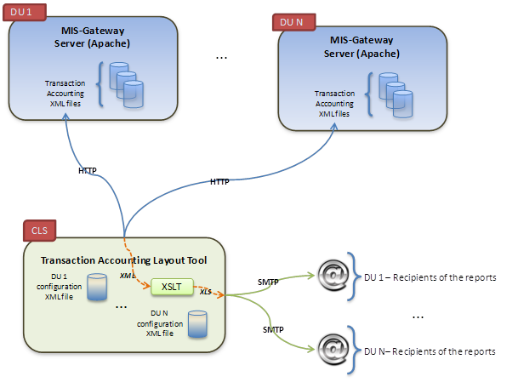

Figure 42 - MIS Gateway Transaction Accounting Layout Tool overview

###### The XML Transaction Accounting files

The settings are in the log4j.xml in the Motu configuration directory.

|  |
| --- |
| <log4j:configuration debug="false" xmlns:log4j="http://jakarta.apache.org/log4j/"> …  <appender class="org.apache.log4j.DailyRollingFileAppender" name="XMLFileInfo">  <param name="file" value="/opt/atoll/motu/publication/transactions/accounting-yourdu.xml"/>  <param name="Append" value="true"/>  <param name="DatePattern" value="'.'yyyy-MM"/>  <layout class="fr.cls.atoll.motu.library.misc.log4j.MotuXMLLayout"/>   </appender> … </log4j:configuration> |

A date marker (DatePattern setting) is added after the xml extension: e.g.: accounting-yourdu.xml.2013-05.

On next month, the file is automatically rotated. The file rotation is processed if the month has changed and a request has been processed by Motu. Therefore the rotation is not exactly at the end of the month.

The XML Transaction Accounting files must be available through HTTP protocol. They are store at the MyOcean Transaction Accounting url. The HTTP access can be anonymous or can use an HTTP Basic Authentication.

**Example of XML Transaction Accounting content:**

XML Transaction Accounting view – Succesfull requests:

|  |
| --- |
| <motuQueueServerLog queueId="queue1" queueDesc="light queue" requestId="1367487702195"  elapsedWaitQueueTime="1" elapsedRunTime="1895" elapsedTotalTime="1896"  inQueueTime="2013-05-02 09:41:42.260 UTC" startTime="2013-05-02 09:41:42.261 UTC"  endTime="2013-05-02 09:41:44.156 UTC" amountDataSize="0.04940032958984375" totalIOTime="1507"  preparingTime="0" readingTime="1504" writingTime="3" copyingTime="0" compressingTime="0"  downloadUrlPath="http://atoll.cls.fr/mfcglo-armor-gateway/deliveries/dataset-armor-3d-v1-myocean_1367487702306.nc"  extractLocationData="/datalocal/atoll/mfcglo-armor-gateway/deliveries/dataset-armor-3d-v1-myocean_1367487702306.nc">  <extractionParameters  serviceName="http://purl.org/myocean/ontology/service/database#GLOBAL_ANALYSIS_PHYS_001_003-TDS"  temporalCoverageInDays="64" productId="dataset-armor-3d-v1-myocean" userId="ksimensen"  userHost="46.34.88.155" anonymousUser="false" batchQueue="false">  <listVar>  <string>salinity</string>  <string>temperature</string>  </listVar>  <listTemporalCoverage>  <string>2012-05-30</string>  <string>2012-08-01</string>  </listTemporalCoverage>  <listLatLonCoverage>  <string>73</string>  <string>68</string>  <string>76</string>  <string>80</string>  </listLatLonCoverage>  <listDepthCoverage>  <string>Surface</string>  <string>Surface</string>  </listDepthCoverage>  <responseFormat>HTML</responseFormat>  </extractionParameters>  <priorities>  <priority priority="2" range="1" date="2013-05-02 09:41:42.260 UTC"/>  </priorities> </motuQueueServerLog> |

XML Transaction Accounting view – Unsuccesfull requests:

|  |
| --- |
| <motuQueueServerLogError requestId="1367477006084" elapsedWaitQueueTime="0" elapsedRunTime="0"  elapsedTotalTime="0" amountDataSize="0.0" totalIOTime="0" preparingTime="0" readingTime="0"  writingTime="0" copyingTime="0" compressingTime="0">  <queueLogError errorCode="INVALID_DATE_RANGE"  message="Invalid date range.Invalid range: [2088-06-18 00:00:00,2089-06-18 00:00:00]. Valid range is: [2011-01-05 00:00:00,2013-04-24 00:00:00]. "  dateError="2013-05-02 06:43:26.144 UTC"/>  <extractionParameters  serviceName="http://purl.org/myocean/ontology/service/database#GLOBAL_ANALYSIS_PHYS_001_003_a-TDS"  temporalCoverageInDays="366" productId="dataset-armor-3d-v1-myocean" userId="opemis"  userHost="vnagioscamioon.ifremer.fr" anonymousUser="false" batchQueue="false">  <listVar/>  <listTemporalCoverage>  <string>2088-06-18</string>  <string>2089-06-18</string>  </listTemporalCoverage>  <listLatLonCoverage>  <string>-90</string>  <string>-180</string>  <string>90</string>  <string>180</string>  </listLatLonCoverage>  <listDepthCoverage/>  <responseFormat>HTML</responseFormat>  </extractionParameters>  <priorities/> </motuQueueServerLogError> |

###### The MIS Gateway Transaction Accounting configuration files

The MIS Gateway Transaction Accounting configuration files are XML format. This file describes which XML Transaction Accounting files should be considered.

A configuration file is needed for each DU.

The full description and example of this configuration file are located in the document [DA 8]. The XML schema is *logFileConfig.xsd*.

Example:

|  |
| --- |
| <?xml version="1.0" encoding="UTF-8"?> <logFileConfig description="Logs Queue Server Motu - MyOcean - SLTAC"   remoteHost="http://atoll.cls.fr"   subDir="SLTAC"   name="transAccLogFile_SLTAC"   labelFileDate="%YYYY-0-%MM-0"  remoteProtocol="http"  fromRemote="true"  proxyHost="http://proxy-prod.cls.fr"  proxyPort="8080"  remoteUserHost="*your_hppt_basic_authentication_login*"  remotePwdHost="*your_hppt_basic_authentication_password*"  xmlns:xsi="http://www.w3.org/2001/XMLSchema-instance">  <logFile>  <include>/sltac-gateway/transactions/accounting-GLO-CLS-TOULOUSE-FR-SLTAC.xml</include>  </logFile>    <mailErrorDest>exploitation-atoll@cls.fr</mailErrorDest>  <mailDest>exploitation-atoll@cls.fr</mailDest>  <mailDest>servicedesk@mercator-ocean.fr</mailDest>  <mailDest>servicedesk.myocean@cls.fr</mailDest>    </logFileConfig> |

#### Sequence of commands

This section describes the commands to run for analysis achievement. There is one command per Dissemination Unit.

This process retrieves the XML Transaction Accounting file configured in the MIS Gateway Transaction Accounting configuration file.

The process copies the XML Transaction Accounting file on the local machine (the machine where the MIS Gateway transaction Accounting tool is installed).

The process builds (generates) the XML Excel report.

|  |
| --- |
| * ***# Run Transaction Accounting Reporting - MyOcean - Armor*** * perl /data2/atoll/awstats/logs/perl/**logQSMotu.pl** -conffilelog /data2/atoll/awstats/logs/xml/MyOcean/**transAccountConfFile_Armor.xml** $MONTH_SETTING $YEAR_SETTING * ***# Repeat the 'Run' command above for each DU*** |

**-conf filelog *MISGW_Transaction_Accounting_conf_file***: specifies the MIS Gateway Transaction Accounting configuration file to use.

**$YEAR_SETTING** can be empty or contain **-year *YYYY****:* this is the year of the log to process. If empty, the default is: year of the month preceding the current month

**$MONTH_SETTING** can be empty or contain **-month *MM***: this is the month of the log to process. If empty, the default is: previous month the current month)

$YEAR_SETTING, $MONTH_SETTING are usually empty, unless we want to replay the analysis for a specific period.

#### Statistics report in detail

The XML Excel report contains two sheets: one about successful extractions, on about errors.

The fields are explained in the [DA 7] document.

###### Succesfull extractions

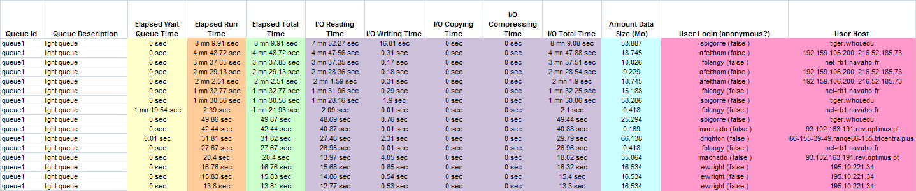

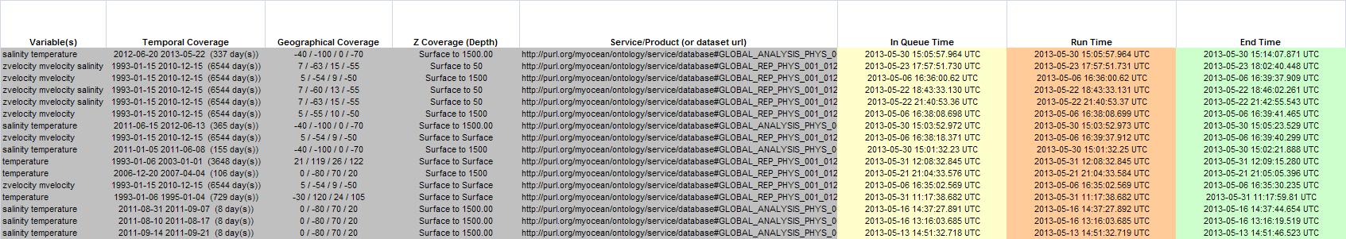

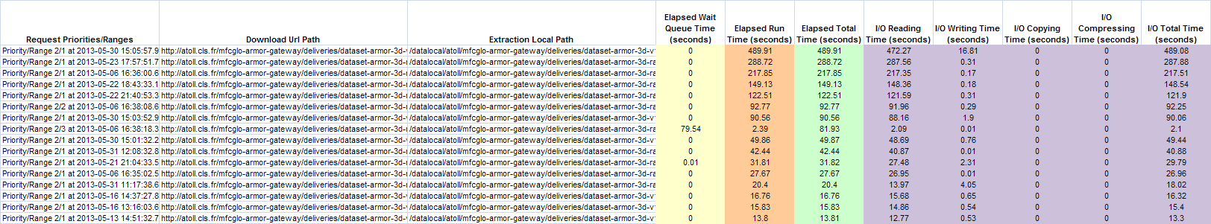

###### Unsuccesfull extractions

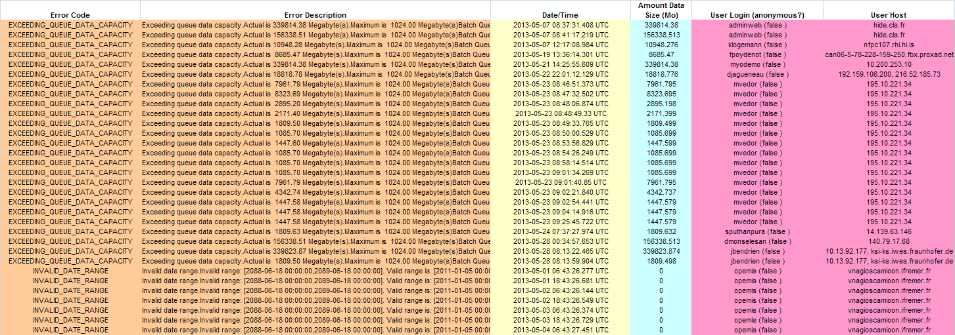

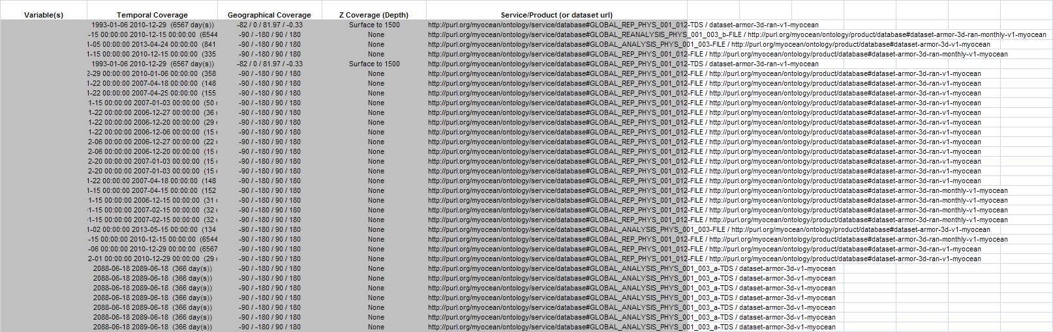

#### Interfaces

Interfaces are described in the [DA 7] document.

### CIS Transaction accounting

This CIS Transaction accounting provides assistance in log analysis in order to facilitate the preparation of statistical reports.

A log file is a file in which are written the web access (http, ftp ...). Information are raw data and difficult to use visually. The service gives the user the ability to analyze, synthesize the information and to provide a set of predefined statistical reports in HTML, Excel, CSV, XML, PDF formats (TBC).



Figure 43 – CIS Transaction accounting use cases

The transaction accounting component shall be able to retrieve logs from the dissemination units (download access services logs and viewing logs) and the web portal. From that point, it shall be able to aggregate the logs, analyse them and build raw statistics data. Then, reports are generated and send to the Service Desk and Service Managers.

#### Software used

Table

|  |  |  |  |  |
| --- | --- | --- | --- | --- |
| **Components** | **Label** | **operator** | **support** | **Developer / maintainer** |
| CIS-TRANS-ACCOUNTING | Logs analysis and report | CLS | CLS | CLS |

#### MyOcean XML Product Specification (EPST) file

Needed information for the CIS Transaction Accounting are provided by the EPST Product Specification file. This EPST file is an Excel file. This file has to be exported manually as XML file(s) from Excel (see Excel help or <http://office.microsoft.com/en-au/excel-help/export-xml-data-HP010206401.aspx>).

The needed information to get from EPST are:

* TAC_MFC (e.g. GLO, ARC, MED, OC, SST...): these are the first characters before the first “-“ character of the Dissemination Unit (e.g. Dissemination Unit = **GLO**-CLS-TOULOUSE-FR, then Production family = GLO)
* Dissemination Unit
* Product Specification
* Dataset
* Collection (e.g.: “model”, “observations”)
* Regions: a string with a list of regions (one or more regions with blank separator), e.g.:“BS BAL MED NWS IBI” or “MED”, “NWS IBI”:
  + “BS BAL MED NWS IBI”: this string is considered as one region which includes BS, BAL, MED, NWS and IBI.
  + “MED”
  + “NWS IBI”: this string is considered as a single region which includes NWS and IBI
* Product type: e.g.:
  + Near Real Time Product
  + Near Real Time Product; Forecast Product: this string is considered as a single product type which includes Near Real Time Product and Forecast Product
  + Forecast Product
  + Multi Year Product
* Old dataset: this is a previous dataset name (It may be helpful for the transition between the old and the new name). This information may be empty.

The XSD schema used to export to XML could be:

|  |
| --- |
| <?xml version="1.0" encoding="UTF-8"?> <xs:schema xmlns:xs="http://www.w3.org/2001/XMLSchema" elementFormDefault="qualified">  <xs:element name="products">  <xs:complexType>  <xs:sequence>  <xs:element ref="product" minOccurs="0" maxOccurs="unbounded"/>  </xs:sequence>  </xs:complexType>  </xs:element>  <xs:element name="product">  <xs:complexType>  <xs:sequence>  <xs:element name="tacmfc" type="xs:string"/>  <xs:element name="du" type="xs:string"/>  <xs:element name="product" type="xs:string"/>  <xs:element name="dataset" type="xs:string" />  <xs:element name="collection" type="xs:string" />  <xs:element name="regions" type="xs:string" />  <xs:element name="ptype" type="xs:string" />  <xs:element name="datasetold" type="xs:string" />  </xs:sequence>  </xs:complexType>  </xs:element>   </xs:schema> |

To export the information to XML file, the easier way is:

1. Make a copy of the EPST file.
2. Open this copy in Excel.
3. Create a new sheet.
4. Copy the needed columns to the new sheet in this order: Dissemination Unit, Product Specification, Dataset, Product type, Regions
5. Insert a new column, before Dissemination Unit and to extract the Product family enter the formula: =GAUCHE($B2;TROUVE("-";$B2;1)-1) (or =LEFT($B2;FIND("-";$B2;1)-1)). Report this formula on all lines.
6. Map XML with the XSD file above and export as XML as mentioned in the Excel documentation.

The Excel sheet to export looks like:

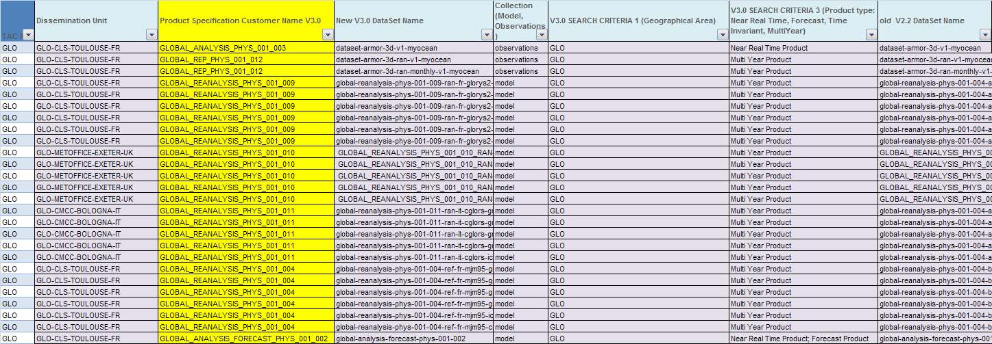

The exported XML file looks like:

|  |
| --- |
| <?xml version="1.0" encoding="UTF-8" standalone="yes"?> <products>  <product>  <tacmfc>GLO</tacmfc>  <du>GLO-CLS-TOULOUSE-FR</du>  <product>GLOBAL_ANALYSIS_PHYS_001_003</product>  <dataset>dataset-armor-3d-v1-myocean</dataset>  <collection>observations</collection>  <regions>GLO</regions>  <ptype>Near Real Time Product</ptype>  <datasetold>dataset-armor-3d-v1-myocean</datasetold>  </product>  <product>  <tacmfc>GLO</tacmfc>  <du>GLO-CLS-TOULOUSE-FR</du>  <product>GLOBAL_REP_PHYS_001_012</product>  <dataset>dataset-armor-3d-ran-v1-myocean</dataset>  <collection>observations</collection>  <regions>GLO</regions>  <ptype>Multi Year Product</ptype>  <datasetold>dataset-armor-3d-ran-v1-myocean</datasetold>  </product>  <product>  <tacmfc>SL</tacmfc>  <du>SL-CLS-TOULOUSE-FR</du>  <product>SEALEVEL_GLO_SLA_L3_REP_OBSERVATIONS_008_001_b</product>  <dataset>dataset-duacs-rep-global-e2-sla-l3</dataset>  <collection>observations</collection>  <regions>ARC BAL GLO IBI NWS</regions>  <ptype>Multi Year Product</ptype>  <datasetold>dataset-duacs-ran-global-e2-sla-l3</datasetold>  </product>  <product>  <tacmfc>GLO</tacmfc>  <du>GLO-CLS-TOULOUSE-FR</du>  <product>GLOBAL_ANALYSIS_FORECAST_PHYS_001_002</product>  <dataset>global-analysis-forecast-phys-001-002</dataset>  <collection>model</collection>  <regions>GLO</regions>  <ptype>Near Real Time Product; Forecast Product</ptype>  <datasetold>global-analysis-forecast-phys-001-001-c-glo</datasetold>  </product>  <product>  <tacmfc>MED</tacmfc>  <du>MED-INGV-BOLOGNA-IT</du>  <product>MEDSEA_REANALYSIS_PHYS_006_004</product>  <dataset>myov03-med-ingv-ssh-rean-dy</dataset>  <collection>model</collection>  <regions>MED</regions>  <ptype>Multi Year Product</ptype>  <datasetold/>  </product> … </products> |

#### CIS Transaction accounting logical view

###### Functions provided, requirements

The CIS transaction accounting is a logs analyzer and push system. Several server logs will be analyzed, filtered and formatted (HTML, XML, CSV, Excel, PDF…). The result can be sent by mail to anyone who needs information from the logs.

###### Architecture context

The transaction accounting is made using several technical components:

* AWSTATS

AWStats offers useful functionalities:

Statistic database with xml format and the log archive system.

Configurable

Personalized analysis

Portability: AWStats is an open source project under GPL licence.

See Awstat documentation at <http://awstats.sourceforge.net/>.

* GeoIP plug-in

GeoIP uses IP address to find the country by using IP databases (binary files).

The GeoIP plug-in is Awstats compliant. See Awstats configuration documentation to enable the GeoIP plug-in in Awstats.

The GeoIP plug-in is downloadable : see <http://dev.maxmind.com/geoip/legacy/downloadable>:

wget -N http://geolite.maxmind.com/download/geoip/database/GeoLiteCountry/GeoIP.dat.gz

GeoIP supplies APIs for many programming languages. Currently, the GeoIP C API is used. This API needs a C compiler to be installed.

The GeoIP Perl API could be used (see GeoIP documentation), but it uses a wrapper to the GeoIP C library. So, the Perl module is not relevant.

The “country database” and “city database” are free and are available at <http://dev.maxmind.com/geoip/legacy/geolite> (download the binary databases).

Currently, only statistics on countries are relevant in MyOcean. Statistics on cities are not needed.

Currently release 1.4.6 is used. The latest one is 1.5.1.

The “country database” is upgraded each month on the Maxmind site. A monthly cron could be used to automatically download the latest version.

* Perl /Shell scripts

Scripts are written to filter or process log files.

Perl offers powerful string and regular expression tools. This solution will be faster to develop than a C or C++ program.

In addition as AWStats is written in Perl language, it seems natural to complete with perl scripts.

* XSLT 1.0

Finally, XSL transformation is applied on the result to format the information and get an HTML, XML, CSV, etc… output file.

**xsltproc** is the tool used for applying XSLT 1.0 stylesheets to XML documents (see <http://linux.about.com/library/cmd/blcmdl1_xsltproc.htm>).

Note: XSLT 1.0 is used, not XSLT 2.0 although it offers more functionalities. XSLT 2.0 is not implemented in all XSL processors. XSLT 1.0 is sufficient for the CIS transaction accounting.

* Sendmail

Sendmail is an “Open Source” mail delivery agent/Mail system. It implements a Simple Mail Transfer Protocol (SMTP) for transmitting e-mail.

More information and documentation are available at <http://www.linux.com/learn/docs/ldp/619-mail-administrator-howto#ss5.1> and <http://www.sendmail.com/sm/open_source/>.

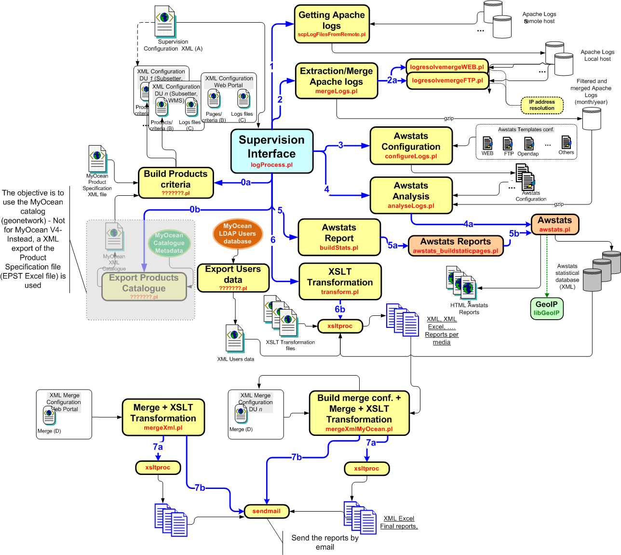

Figure 44 - CIS Transaction accounting logical architecture

###### The configuration files

The configuration files are XML format. They are used to define the settings of the transaction accounting such as:

* The log configuration file (tag as C in the diagram above): it specifies the log files (Apache, FTP) to use: the content of the analysis ("what"),
* The criteria configuration file (tag as B in the diagram above): it specifies the selection and/or exclusion criteria: the criteria for analysis ("how"),
* The process configuration file (tag as A in the diagram above): it specifies the CIS Transaction Accounting to process: the assembly of the analysis: "what" + "how"

Note:

1. When a date marker is set in the log configuration file (C) and criteria configuration file (B), it is replace par the date of the desired analysis:
   1. **%YYYY-0** for the year
   2. **%MM-0** for the month

E.g. : <include lineFilter="OK DOWNLOAD">/transaction_accounting/accounting-vsftpd.log.%YYYY-0-%MM-0</include> : transaction_accounting/accounting-vsftpd.log.**%YYYY-0**-%MM-0 setting will be replaced by transaction_accounting/accounting-vsftpd.log.2013-05 for CIS transaction accounting of the year/month 2013/05.

* The log configuration file (C)

This file describes which log files should be considered. It can be Apache or VSFTPD logs.

A configuration file is needed:

* For each pair [Dissemination Unit ; Media] (WMS, Subsetter, VSFTPD). Let’s say a Dissemination Unit offers WMS, Subsetter Motu, Subsetter Oceanotron and VSFTP services: there will be 4 configuration log files for this Dissemination unit.
* For all Dissemination Units (DU mixed up) pair [All Dissemination Unit ; Media] (WMS, Subsetter, VSFTPD). Let’s say MyOcean offers WMS, Subsetter Motu, Subsetter Oceanotron and VSFTP services: there will be 4 configuration log files for the Dissemination Units mixed up.
* For MyOcean Web Portal

The full description and example of this configuration file are located in the document [DA 8]. The XML schema is *logFileConfig.xsd*.

Notes:

1. The Apache log files can contain irrelevant log lines, e.g.
   1. In the WMS log file, only requests started by /thredds/wms/ are relevant for the MyOcean statistics. To filter this line use the ***lineFilter*** attribute of the ***include*** element:

<include **lineFilter="/thredds/wms/">**opendap.aviso.oceanobs.com-access_log</include>

* 1. In the Subsetter (i.e. log file, only the requests to download the result file are interested for the MyOcean statistics. To filter this line use the ***lineFilter*** attribute of the ***include*** element. Let’s say the source file to download in the motu-extract directory :

<include **lineFilter="/motu-extract">**opendap.aviso.oceanobs.com-access_log</include>

* 1. In MyOcean Web Portal (i.e. log file, only the requests to Joomla relevant for the MyOcean statistics. To filter this line use the ***lineFilter*** attribute of the ***include*** element. Let’s say the Joomla root is /web/ :

<include **lineFilter="/web/">** myocean-wp.cls.fr-access_log</include>

1. There is another way to filter lines by writing the log lines in a specific log file: use the *CustomLog Conditional Logs* Apache configuration (see <http://httpd.apache.org/docs/2.4/en/logs.html>):

Consider logging requests from /motu-extract directory to one log file, and the other ones to a different log file.

###-----------------------------------------------------------------  
### if Request_URI starts with /motu-extract, then set variable motu-extract  
###-----------------------------------------------------------------  
SetEnvIf Request_URI  ^/motu-extract motu-extract  
###-----------------------------------------------------------------  
### Log requests starting with /motu-extract in a specific log file, by using motu-extract variable  
###-----------------------------------------------------------------  
CustomLog logs/motu-aviso-extract.aviso.oceanobs.com-access_log common **env=motu-extract**###-----------------------------------------------------------------  
### Log requests that do not start with /motu-extract in a another log file, by using motu-extract variable  
###-----------------------------------------------------------------  
CustomLog logs/atoll-motu.aviso.oceanobs.com-access_log common **env=!motu-extract**

or for WMS :

###-----------------------------------------------------------------  
### if Request_URI starts with /thredds/wms, then set variable thredds-wms  
###-----------------------------------------------------------------  
SetEnvIf Request_URI  ^/thredds/wms thredds-wms  
###-----------------------------------------------------------------  
### Log requests starting with /thredds/wms in a specific log file, by using thredds-wms variable  
###-----------------------------------------------------------------  
CustomLog logs/wms.com-access_log common **env=**thredds-wms###-----------------------------------------------------------------  
### Log requests that do not start with /thredds/wms in a another log file, by using  
thredds-wms variable  
###-----------------------------------------------------------------  
CustomLog logs/other.com-access_log common **env=!**thredds-wms

1. **Regarding the Apache log file**, if the log format in not the recommended one in the document [DA 10], the ***logFormat*** attribute of the ***logFile*** element allows to specify the log format of the log file: e.g.:

<logFile **logFormat="%host %other %other %time1 %methodurl %code %bytesd"**>

The tags are explained in the Awstats configuration manual at <http://awstats.sourceforge.net/docs/awstats_config.html#LogFormat>.

BUT, this scenario is not workable because it will not be possible to merge the log files of each DU in the case of the analysis for all mixed DU. In this case, the log format of the Apache configuration MUST be changed or use a duplicate log file with the recommended format to avoid to break existing applications which use the log file: this is the case for, currently with DU CLS and SLTAC log format.

1. **Regarding the VSFTP log file**, the log format must be set to “**vsftpdextend**”. This option allows a specific process to compute the transfer/download time on downloaded data. In this case, the log file to set is the file that matches the ***vsftpd_log_file*** parameter of the VSFTPD configuration file (see document [DA 9]): e.g.:

<logFile **logFormat=”vsftpdextend"**>

1. For all Dissemination Units mixed up analysis, a ***include*** element must be set for each Dissemination Unit. A specific process must be run to configure and merge automatically the log configuration files of each DU per media (VSFTP, Motu, WMS...). **See section “The log configuration file (C) for all Dissemination Units”, page 142.**

* The log configuration file (C) for all Dissemination Units mixed up

As we can see, a log configuration file is configured to get one or more log files from a single source: *remoteHost* attribute (refer to document [DA 8]).

To analyze logs for all Dissemination Units we have to run the entire process by merging all log file of each DU. We can’t merge final analysis of each DU for the following reason:

Let’s say user John has downloaded data from FTP from DU1, DU2. The analysis for FTP and DU1 will show that John has downloaded data and will be recorded as a unique visitor for DU1. The analysis for FTP and DU2 will show that John has downloaded data and will be recorded as a unique visitor for DU2. The analysis for FTP and all DU has to show John has downloaded data and will be recorded as a unique visitor for all DU. If we merge the final FTP analysis for DU1 and DU2, we get the sum 1+1=2 unique visitors, that’s wrong, because it’s the same user.

A specific log configuration file has to be created for all Dissemination Unit (one file per media: VSFTPD, Motu, WMS...): e.g.:

WMS example:

|  |
| --- |
| <?xml version="1.0" encoding="UTF-8"?> <logFileConfig description="Configuration file – WMS – All Dissemination Unit"   siteDomain="none"   logType="W"   mediaType="WMS"   name="WMSAllDU"   subDir="**AllDU**" <!-- this is an example for the name of the DU --> fromRemote="false"   mergeLogs="false"   xmlns:xsi="http://www.w3.org/2001/XMLSchema-instance" xsi:noNamespaceSchemaLocation="../logFileConfig.xsd">  <logFile>  <include lineFilter="/thredds/wms/">*/transaction_accounting/WMSDU1.log*.%YYYY-0-%MM-0</include>  <include>*/transaction_accounting/WMSDU2.log*.%YYYY-0-%MM-0</include>  <include lineFilter="/thredds/wms/">*/transaction_accounting/WMSDU3.log*.%YYYY-0-%MM-0</include>  …  <include lineFilter="/thredds/wms/">*/transaction_accounting/WMSDUn.log*.%YYYY-0-%MM-0</include> </logFile> </logFileConfig> |

VSFTPD example:

|  |
| --- |
| <?xml version="1.0" encoding="UTF-8"?> <logFileConfig description="Configuration file - Vsftp sample"   siteDomain="none"   logType="F"   mediaType="VSFTPD"   name="VsftpAllDU"   subDir="AllDU" <!-- this is an example for the name of the DU -->  fromRemote="false"   mergeLogs="false"   xmlns:xsi="http://www.w3.org/2001/XMLSchema-instance" xsi:noNamespaceSchemaLocation="../logFileConfig.xsd">  <logFile logFormat="vsftpdextend">  <include lineFilter="OK DOWNLOAD">*/transaction_accounting/vsftpdDU1.log.*%YYYY-0-%MM-0</include>  <include lineFilter="OK DOWNLOAD">*/transaction_accounting/vsftpdDU2.log.*%YYYY-0-%MM-0</include>  <include lineFilter="OK DOWNLOAD">*/transaction_accounting/vsftpdDU3.log.*%YYYY-0-%MM-0</include>  …  <include lineFilter="OK DOWNLOAD">*/transaction_accounting/vsftpdDUn.log.*%YYYY-0-%MM-0</include>  </logFile> </logFileConfig> |

In the examples above, we can notice there are no remote host settings, because we assume the log files have already been downloaded previously (DU analysis process). This implies the Transaction Accounting for all DU mixed up have to be process after those for each DU (see more details in sections “

Note: for MyOcean Web Portal statistics the attribute **ignoreBuildprodconf** must be set to *true* (see example above)

The process configuration file (A) - All Dissemination Units mixed”, page 151 and “**Erreur ! Source du renvoi introuvable.** **Erreur ! Source du renvoi introuvable.**”, page **Erreur ! Signet non défini.**.

* The criteria configuration file (B)

This file describes the elements (criteria) to consider when analyzing logs:

* general parameters,
* an analysis by criteria or by category (subcategory) criteria,
* the selection criteria,
* exclusion criteria,
* daily statistics computation (see section “5.1.7.7 Per number of days raw statistics”, page 159),
* specific output formats (xslt transformations of data analyzed),
* recipients (email) of the monitoring

The full description of this configuration file is located in the document [DA 8]. The XML schema is *logProductConfig.xsd*.

1. **For MyOcean Web Portal Transaction Accounting**, this file has to be built and configured manually. It may match MyOcean Web Portal Site Map as shown below (but it is not mandatory).

Example file:

|  |
| --- |
| <logProductDescr description="MyOcean Web Portal" name="MyOceanWebPortal">  <products description="All pages" name="allPages">  <productConfig description="Home page" name="home">  <url>*/ *</url>  </productConfig>    <!-- begin About Pages -->  <products description="About Pages " name="aboutPages">  <productConfig description="About us" name="aboutus">  <url>*/web/6-about-us.php*</url>  </productConfig>  <products description="Project Pages" name="projectPages">  <productConfig description="The Project" name="theproject">  <url>*/web/2-the-project.php*</url>  </productConfig>   <productConfig description="Objective" name="objective">  <url>*/web/3-objective.php*</url>  </productConfig>   <productConfig description="Schedule" name="schedule">  <url>*/web/4-schedule.php*</url>  </productConfig>   <productConfig description="Organisation" name="organisation">  <url>*/web/5-organisation.php*</url>  </productConfig>   <productConfig description="Intranet" name="intranet">  <url>*/web/33-intranet.php*</url>  </productConfig>   </products>  <products description="Partners Pages" name="partnersPages">  <productConfig description="MyOcean2 Patners" name="myocean2partners">  <url>*/web/8-myocean2-partners.php*</url>  </productConfig>   <productConfig description="Partner list" name="partnerlist">  <url>*/web/10-partner-list.php*</url>  </productConfig>   </products>  <productConfig description="User-driven approach" name="userdrivenapproach">  <url>*/web/7-a-user-driven-approach.php*</url>  </productConfig>   </products>   <!-- end About Pages -->    <!-- begin Products and Services Pages -->  <products description="Products and Services Pages " name="productservicePages">  <productConfig description="Products and Services" name="productservice">  <url>*/web/19-products-and-services.php*</url>  </productConfig>   <products description="Services Pages " name="servicePages">  <productConfig description="Services" name="service">  <url>*/web/64-services.php*</url>  </productConfig>   <productConfig description="Catalogue of services" name="catalogueservice">  <url>*/web/26-catalogue-of-services.php*</url>  </productConfig>   <productConfig description="Register now" name="register">  <url>*/web/56-user-registration-form.php*</url>  </productConfig>   <productConfig description="Ask the service desk" name="askservicedesk">  <url>*/web66-ask-the-service-desk.php*</url>  </productConfig>   </products>  <products description="Products Pages " name="productPages">  <productConfig description="Products" name="product">  <url>*/web/65-products.php*</url>  </productConfig>   <products description="Catalogue Pages " name="cataloguePages">  <productConfig description="Access to catalogue" name="accesscatalogue">  <url>*/web/24-catalogue.php*</url>  <url>*/web/60-access-to-catalogue.php*</url>  </productConfig>   <productConfig description="Access full catalogue online" name="accessfullcatalogue">  <url>*/web/69-myocean-interactive-catalogue.php*</url>  </productConfig>   <productConfig description="Download MyOcean Catalogue" name="downloadcatalogue">  <url>*/web/69-myocean-interactive-catalogue.php*</url>  </productConfig>   </products>    <productConfig description="News Flash" name="newsflash">  <url>*/web/25-news-flash.php*</url>  </productConfig>   <productConfig description="Product improvements" name="productimprove">  <url>*/web/35-product-improvements.ph*</url>  </productConfig>   <productConfig description="Technical FAQ" name="technicalfaq">  <url>*/web/34-products-and-services-faq.php*</url>  </productConfig>   </products>  </products>  <!-- end Products and Services Pages -->    <!-- begin Area of benefits Pages -->  <products description="Area of benefits Pages " name="areabenefitsPages">  <productConfig description="Area of benefits" name="areabenefits">  <url>*/web/70-area-of-benefits.php*</url>  </productConfig>   <products description="Maritime safety Pages" name="maritimesafetyPages">  <productConfig description="Maritime safety" name="maritimesafety">  <url>*/web/71-maritime-safety.php*</url>  </productConfig>   <productConfig description="Maritime safety description" name="maritimesafetydesc">  <url>*/web/72-marine-safety-description.php*</url>  </productConfig>   <productConfig description="Maritime safety user feedback" name="maritimesafetyfeedback">  <url>*/web/79-marine-safety-user-feedback.php*</url>  </productConfig>   <productConfig description="Maritime safety downstream use cases" name="maritimesafetyusecases">  <url>*/web/87-downstream-use-cases.php*</url>  </productConfig>   </products>  <products description="Maritime resources Pages" name="maritimeresourcesPages">  <productConfig description="Maritime resources" name="maritimeresources">  <url>*/web/73-marine-resources.php*</url>  </productConfig>   <productConfig description="Maritime resources description" name="maritimeresourcesdesc">  <url>*/web/74-marine-resources-description.php*</url>  </productConfig>   <productConfig description="Maritime resources user feedback" name="maritimeresourcesfeedback">  <url>*/web/80-marine-resources-user-feedback.php*</url>  </productConfig>   <productConfig description="Maritime resources downstream use cases" name="maritimeresourcesusecases">  <url>*/web/88-downstream-use-cases.php*</url>  </productConfig>   </products>  <products description="Coastal and Marine environment Pages" name="coastalenvPages">  <productConfig description="Coastal and Marine environment" name="coastalenv">  <url>*/web/75-coastal-marine-environment.php*</url>  </productConfig>   <productConfig description="Coastal and Marine environment description" name="coastalenvdesc">  <url>*/web/76-coastal-marine-environment-description.php*</url>  </productConfig>   <productConfig description="Coastal and Marine environment user feedback" name="coastalenvfeedback">  <url>*/web/81-coastal-and-marine-environment-user-feedback.php*</url>  </productConfig>   <productConfig description="Coastal and Marine environment downstream use cases" name="coastalenvusecases">  <url>*/web/89-downstream-use-cases.php*</url>  </productConfig>   </products>   <products description="Weather, Climate and SF Pages" name="wheatherPages">  <productConfig description="Weather, Climate and SF" name="weather">  <url>*/web/77-weather-climate-seasonal-forecasting.php*</url>  </productConfig>   <productConfig description="Weather, Climate and SF description" name="weatherdesc">  <url>*/web/78-weather-climate-seasonal-forecasting-description.php*</url>  </productConfig>   <productConfig description="Weather, Climate and SF user feedback" name="weatherfeedback">  <url>*/web/82-weather-climate-seasonal-forecasting-user-feedback.php*</url>  </productConfig>   <productConfig description="Weather, Climate and SF downstream use cases" name="weatherusecases">  <url>*/web/90-downstream-use-cases.php*</url>  </productConfig>   </products>   </products>  <!-- end Area of benefits Pages -->    <productConfig description="News and Events" name="newsevents">  <url>*/web/16-news-events.php*</url>  </productConfig>   <productConfig description="Focus on" name="focuson">  <url>*/web//17-focus-on.php*</url>  </productConfig>   <productConfig description="User newsletter" name="usernewsletter">  <url>*/web/91-myocean-user-newsletter.php*</url>  </productConfig>   <productConfig description="Product Showcase" name="productshowcase">  <url>*/web/18-product-showcase.php*</url>  </productConfig>     <!-- begin Education Pages -->  <products description="Education Pages" name="educationPages">  <productConfig description="Education" name="education">  <url>*/web/22-education.php*</url>  </productConfig>  <products description="Observation Pages" name="observationPages">  <productConfig description="Observation" name="observation">  <url>*/web/37-observation.php*</url>  </productConfig>  <productConfig description="Satellites" name="obssatellites">  <url>*/web/40-satellites.php*</url>  </productConfig>  <productConfig description="In situ" name="obsinsitu">  <url>*/web/41-in-situ.php*</url>  </productConfig>  </products>  <productConfig description="Modelling" name="modelling">  <url>*/web/38-modelling.php*</url>  </productConfig>  <products description="Ocean parameters Pages" name="oceanparamsPages">  <productConfig description="Ocean parameters" name="oceanparams">  <url>*/web/39-ocean-parameters.php*</url>  </productConfig>  <productConfig description="Temperature" name="oceanparamstemperature">  <url>*/web/42-temperature.php*</url>  </productConfig>  <productConfig description="Salinity" name="oceanparamssalinity">  <url>*/web/43-salinity.php*</url>  </productConfig>  <productConfig description="Currents" name="oceanparamscurrents">  <url>*/web/44-currents.php*</url>  </productConfig>  <productConfig description="Sea ice" name="oceanparamsseaice">  <url>*/web/45-sea-ice.php*</url>  </productConfig>  <productConfig description="Sea level" name="oceanparamssealevel">  <url>*/web/46-sea-level.php*</url>  </productConfig>  <productConfig description="Wind" name="oceanparamswind">  <url>*/web/47-wind.php*</url>  </productConfig>  <productConfig description="Biogeochemistry" name="oceanparamsbiogeochemistry">  <url>*/web/48-biogeochemistry.php*</url>  </productConfig>  </products>  </products>  <!-- end Education Pages -->    <productConfig description="Press and Edition corner" name="presscorner">  <url>*/web/23-pressedition-corner.php*</url>  </productConfig>  <productConfig description="Scientific publications" name="scientificpublications">  <url>*/web/55-scientific-publications.php*</url>  </productConfig>  <productConfig description="GMES and FP7" name="gmes">  <url>*/web/20-gmes-fp7.php*</url>  </productConfig>  <productConfig description="Contact us" name="contactus">  <url>*/web/21-contact-us.php*</url>  </productConfig>    <products description="All FAQ Pages" name="allfaqPages">  <productConfig description="FAQ" name="faq">  <url>*/web/21-contact-us.php*</url>  </productConfig>  <productConfig description="Technical FAQ" name="technicalfaq">  <url>*/web/34-products-and-services-faq.php*</url>  </productConfig>   </products>    <productConfig description="Search" name="search">  <url>*/web/53-search.php*</url>  </productConfig>    </products>    </logProductDescr> |

1. **For MyOcean WMS and Subsetters (Motu, Oceanotron...) Transaction Accounting**, this configuration will be automatically generated as explained in section “5.1.7.4 Generate criteria configuration file for WMS and Subsetters media”, page 152.
2. **For MyOcean VSFTPD Transaction Accounting**, this configuration will be automatically generated as explained in section “5.1.7.5 Generate criteria configuration file for VSFTPD media”, page 156.

Note: The criteria configuration file contains also a *logXsltConfig* element: some settings to execute basic/raw XSL transformations subsequently used in the final statistics process (others XSL transformation). This section is explained in section “5.1.7.6 The “raw” XSL transformation”, page 156.

* The process configuration file (A)
* The process configuration file (A) by Dissemination Unit and MyOcean Web Portal

This file describes the CIS Transaction Accounting to process for MyOcean Web Portal and each pair [Dissemination Unit;Media]. It contains the assemblies of the analysis "what" + "how": assemble the log configuration file (C) and the criteria configuration file (B), for MyOcean Web Portal and for each DU WMS server, DU Subsetter server...

The full description of this configuration file is located in the document [DA 8]. The XML schema is *logProcessConfig.xsd*.

1. **For MyOcean Web Portal Transaction Accounting**

We assigned “MyOceanWebPortal” as a “virtual” DU name (another name can be chosen but it must be different from a Dissemination Unit name).

1. **For Dissemination Unit VSFTPD, WMS, Motu... Transaction Accounting**

Assign “duName” with the standard Dissemination Unit name defined in the EPST file.

Log configuration file example

|  |
| --- |
| <?xml version="1.0" encoding="UTF-8"?> <logProcessConfig xmlns:xsi="http://www.w3.org/2001/XMLSchema-instance"   xsi:noNamespaceSchemaLocation="../logProcessConfig.xsd">    <!-- ===================== -->  <!-- MyOcean Web Portal -->  <!-- ===================== -->  <logProcess description="MyOcean Web Portal" duName="MyOceanWebPortal" mailDestDefault="explotation-atoll@cls.fr" ignoreBuildprodconf="true">  <!-- the criteria configuration file (B) – MyOcean Web Portal -->   <urlProduct>/data2/atoll/awstats/logs/xml/MyOcean/logPageMyOceanWebPortalConfig.xml</urlProduct>  <!-- the log configuration file (C) – MyOcean Web Portal -->   <urlFile>/data2/atoll/awstats/logs/xml/MyOcean/logFileMyOceanWebPortalConfig.xml</urlFile>  </logProcess>    <!-- =========================================== -->  <!-- Disseminiation Unit : GLO-CLS-TOULOUSE-FR -->  <!-- =========================================== -->  <logProcess description="VSFTPD DU GLO-CLS-TOULOUSE-FR" duName="GLO-CLS-TOULOUSE-FR" mailDestDefault="explotation-atoll@cls.fr">  <!-- the criteria configuration file (B) – VSFTPD - GLO-CLS-TOULOUSE-FR -->   <urlProduct>/data2/atoll/awstats/logs/xml/MyOcean/logProduct-VSFTPD-GLO-CLS-TOULOUSE-FRConfig.xml</urlProduct>  <!-- the log configuration file (C) – VSFTPD - GLO-CLS-TOULOUSE-FR -->   <urlFile>/data2/atoll/awstats/logs/xml/MyOcean/logFile-VSFTPD-GLO-CLS-TOULOUSE-FRConfig.xml</urlFile>  </logProcess>  <logProcess description="WMS DU GLO-CLS-TOULOUSE-FR" duName="GLO-CLS-TOULOUSE-FR" mailDestDefault="explotation-atoll@cls.fr">  <!-- the criteria configuration file (B) – WMS - GLO-CLS-TOULOUSE-FR -->   <urlProduct>/data2/atoll/awstats/logs/xml/MyOcean/logProduct-WMS-GLO-CLS-TOULOUSE-FRConfig.xml</urlProduct>  <!-- the log configuration file (C) – WMS - GLO-CLS-TOULOUSE-FR -->   <urlFile>/data2/atoll/awstats/logs/xml/MyOcean/logFile-WMS-GLO-CLS-TOULOUSE-FRConfig.xml</urlFile>  </logProcess>  <logProcess description="SUBSETTER DU GLO-CLS-TOULOUSE-FR" duName="GLO-CLS-TOULOUSE-FR" mailDestDefault="explotation-atoll@cls.fr">  <!-- the criteria configuration file (B) – SUBSETTER - GLO-CLS-TOULOUSE-FR -->   <urlProduct>/data2/atoll/awstats/logs/xml/MyOcean/logProduct-SUBSETTER-GLO-CLS-TOULOUSE-FRConfig.xml</urlProduct>  <!-- the log configuration file (C) – SUBSETTER - GLO-CLS-TOULOUSE-FR -->   <urlFile>/data2/atoll/awstats/logs/xml/MyOcean/logFile-SUBSETTER-GLO-CLS-TOULOUSE-FRConfig.xml</urlFile>  </logProcess>    <!-- =========================================== -->  <!-- Disseminiation Unit : GLO-CMCC-BOLOGNA-IT -->  <!-- =========================================== -->  <logProcess description="VSFTPD DU GLO-CMCC-BOLOGNA-IT" duName="GLO-CMCC-BOLOGNA-IT" mailDestDefault="explotation-atoll@cls.fr">  <!-- the criteria configuration file (B) – VSFTPD - GLO-CMCC-BOLOGNA-IT -->   <urlProduct>/data2/atoll/awstats/logs/xml/MyOcean/logProduct-VSFTPD-GLO-CMCC-BOLOGNA-ITConfig.xml</urlProduct>  <!-- the log configuration file (C) – VSFTPD - GLO-CMCC-BOLOGNA-IT -->   <urlFile>/data2/atoll/awstats/logs/xml/MyOcean/logFile-VSFTPD-GLO-CMCC-BOLOGNA-ITConfig.xml</urlFile>  </logProcess>  <logProcess description="WMS DU GLO-CMCC-BOLOGNA-IT" duName="GLO-CMCC-BOLOGNA-IT" mailDestDefault="explotation-atoll@cls.fr">  <!-- the criteria configuration file (B) – WMS - GLO-CMCC-BOLOGNA-IT -->   <urlProduct>/data2/atoll/awstats/logs/xml/MyOcean/logProduct-WMS-GLO-CMCC-BOLOGNA-ITConfig.xml</urlProduct>  <!-- the log configuration file (C) – WMS - GLO-CMCC-BOLOGNA-IT -->   <urlFile>/data2/atoll/awstats/logs/xml/MyOcean/logFile-WMS-GLO-CMCC-BOLOGNA-ITConfig.xml</urlFile>  </logProcess>  <logProcess description="SUBSETTER DU GLO-CMCC-BOLOGNA-IT" duName="GLO-CMCC-BOLOGNA-IT" mailDestDefault="explotation-atoll@cls.fr">  <!-- the criteria configuration file (B) – SUBSETTER - GLO-CLS-TOULOUSE-FR -->   <urlProduct>/data2/atoll/awstats/logs/xml/MyOcean/logProduct-SUBSETTER-GLO-CMCC-BOLOGNA-ITConfig.xml</urlProduct>  <!-- the log configuration file (C) – SUBSETTER - GLO-CMCC-BOLOGNA-IT -->   <urlFile>/data2/atoll/awstats/logs/xml/MyOcean/logFile-SUBSETTER-GLO-CMCC-BOLOGNA-ITConfig.xml</urlFile>  </logProcess>    <!-- =========================================== -->  <!-- Disseminiation Unit : SL-CLS-TOULOUSE-FR -->  <!-- =========================================== -->  <logProcess description="VSFTPD DU SL-CLS-TOULOUSE-FR" duName="SL-CLS-TOULOUSE-FR" mailDestDefault="explotation-atoll@cls.fr">  <!-- the criteria configuration file (B) – VSFTPD - SL-CLS-TOULOUSE-FR -->   <urlProduct>/data2/atoll/awstats/logs/xml/MyOcean/logProduct-VSFTPD-SL-CLS-TOULOUSE-FRConfig.xml</urlProduct>  <!-- the log configuration file (C) – VSFTPD - SL-CLS-TOULOUSE-FR -->   <urlFile>/data2/atoll/awstats/logs/xml/MyOcean/logFile-VSFTPD-SL-CLS-TOULOUSE-FRConfig.xml</urlFile>  </logProcess>  <logProcess description="SUBSETTER DU SL-CLS-TOULOUSE-FR" duName="SL-CLS-TOULOUSE-FR" mailDestDefault="explotation-atoll@cls.fr">  <!-- the criteria configuration file (B) – SUBSETTER - GLO-CLS-TOULOUSE-FR -->   <urlProduct>/data2/atoll/awstats/logs/xml/MyOcean/logProduct-SUBSETTER-SL-CLS-TOULOUSE-FRConfig.xml</urlProduct>  <!-- the log configuration file (C) – SUBSETTER - SL-CLS-TOULOUSE-FR -->   <urlFile>/data2/atoll/awstats/logs/xml/MyOcean/logFile-SUBSETTER-SL-CLS-TOULOUSE-FRConfig.xml</urlFile>  </logProcess>    <!-- =========================================== -->  <!-- Disseminiation Unit : OC-CNR-ROMA-IT -->  <!-- =========================================== -->  <logProcess description="SUBSETTER DU OC-CNR-ROMA-IT" duName="OC-CNR-ROMA-IT" mailDestDefault="explotation-atoll@cls.fr">  <!-- the criteria configuration file (B) – SUBSETTER - GLO-CLS-TOULOUSE-FR -->   <urlProduct>/data2/atoll/awstats/logs/xml/MyOcean/logProduct-SUBSETTER-OC-CNR-ROMA-ITConfig.xml</urlProduct>  <!-- the log configuration file (C) – SUBSETTER - OC-CNR-ROMA-IT -->   <urlFile>/data2/atoll/awstats/logs/xml/MyOcean/logFile-SUBSETTER-OC-CNR-ROMA-ITConfig.xml</urlFile>  </logProcess>  **<!-- and so on for the others DU -->** </logProcessConfig> |

Note: for MyOcean Web Portal statistics the attribute **ignoreBuildprodconf** must be set to *true* (see example above)

* The process configuration file (A) - All Dissemination Units mixed up

This file describes the CIS Transaction Accounting to process for all Dissemination Unit mixed up. It contains the assemblies of the analysis "what" + "how": assemble the log configuration file (C) and the criteria configuration file (B).

The full description of this configuration file is located in the document [DA 8].

Assign “duName” with a “virtual” Dissemination Unit: e.g.: “AllDU”.

Log configuration file example

|  |
| --- |
| <?xml version="1.0" encoding="UTF-8"?> <logProcessConfig xmlns:xsi="http://www.w3.org/2001/XMLSchema-instance"   xsi:noNamespaceSchemaLocation="../logProcessConfig.xsd">    <!-- =========================================== -->  <!-- Disseminiation Unit : AllDU -->  <!-- =========================================== -->  <logProcess description="VSFTPD DU AllDU" duName="AllDU" mailDestDefault="explotation-atoll@cls.fr">  <!-- the criteria configuration file (B) – VSFTPD - AllDU -->   <urlProduct>/data2/atoll/awstats/logs/xml/MyOcean/logProduct-VSFTPD-AllDUConfig.xml</urlProduct>  <!-- the log configuration file (C) – VSFTPD - AllDU -->   <urlFile>/data2/atoll/awstats/logs/xml/MyOcean/logFile-VSFTPD-AllDUConfig.xml</urlFile>  </logProcess>  <logProcess description="WMS DU AllDU" duName="AllDU" mailDestDefault="explotation-atoll@cls.fr">  <!-- the criteria configuration file (B) – WMS - AllDU -->   <urlProduct>/data2/atoll/awstats/logs/xml/MyOcean/logProduct-WMS-AllDUConfig.xml</urlProduct>  <!-- the log configuration file (C) – WMS - AllDU -->   <urlFile>/data2/atoll/awstats/logs/xml/MyOcean/logFile-WMS-AllDUConfig.xml</urlFile>  </logProcess>  <logProcess description="SUBSETTER DU AllDU" duName="AllDU" mailDestDefault="explotation-atoll@cls.fr">  <!-- the criteria configuration file (B) – SUBSETTER - AllDU -->   <urlProduct>/data2/atoll/awstats/logs/xml/MyOcean/logProduct-SUBSETTER-AllDUConfig.xml</urlProduct>  <!-- the log configuration file (C) – SUBSETTER - AllDU -->   <urlFile>/data2/atoll/awstats/logs/xml/MyOcean/logFile-SUBSETTER-AllDUConfig.xml</urlFile>  </logProcess>    **<!-- and so for on the others Media -->** </logProcessConfig> |

#### Generate criteria configuration file for WMS and Subsetters media

The criteria configuration file is generated from the EPST XML file described in section “5.1.7.2 MyOcean XML Product Specification (EPST) file”, page 134.

In MyOcean V4, it was decided that the level of analysis is the product (product specification) and not the product and dataset.

For each product contained in the XML EPST file, generate an xml element containing all dataset and old dataset names for this product: e.g.:

If XML EPST contains:

|  |
| --- |
| <product>  <tacmfc>MED</tacmfc>  <du>MED-INGV-BOLOGNA-IT</du>  <product>MEDSEA_REANALYSIS_PHYS_006_004</product>  <dataset>myov03-med-ingv-tem-rean-mn</dataset>  <collection>model</collection>  <regions>MED</regions>  <ptype>Multi Year Product</ptype>  <datasetold>myov02-med-ingv-tem-reanalysis</datasetold>  </product>  <product>  <tacmfc>MED</tacmfc>  <du>MED-INGV-BOLOGNA-IT</du>  <product>MEDSEA_REANALYSIS_PHYS_006_004</product>  <dataset>myov03-med-ingv-ssh-rean-dy</dataset>  <collection>model</collection>  <regions>MED</regions>  <ptype>Multi Year Product</ptype>  <datasetold/>  </product>  <product>  <tacmfc>MED</tacmfc>  <du>MED-INGV-BOLOGNA-IT</du>  <product>MEDSEA_REANALYSIS_PHYS_006_004</product>  <dataset>myov03-med-ingv-sal-rean-dy</dataset>  <collection>model</collection>  <regions>MED</regions>  <ptype>Multi Year Product</ptype>  <datasetold/>  </product>  <product>  <tacmfc>MED</tacmfc>  <du>MED-INGV-BOLOGNA-IT</du>  <product>MEDSEA_REANALYSIS_BIO_006_005</product>  <dataset>myov02-med-ogs-bio-reanalysis</dataset>  <collection>model</collection>  <regions>MED</regions>  <ptype>Multi Year Product</ptype>  <datasetold>myov02-med-ogs-bio-reanalysis</datasetold>  </product>   <product>  <tacmfc>BS</tacmfc>  <du>BS-MHI-SEBASTOPOL-UA</du>  <product>BLACKSEA_ANALYSIS_FORECAST_PHYS_007_001</product>  <dataset>dataset-bs-mfc-instan-phys-for-v3</dataset>  <collection>model</collection>  <regions>BS</regions>  <ptype>Near Real Time Product; Forecast Product</ptype>  <datasetold>dataset-bs-mfc-instan-phys-for</datasetold>  </product>  <product>  <tacmfc>BS</tacmfc>  <du>BS-MHI-SEBASTOPOL-UA</du>  <product>BLACKSEA_ANALYSIS_FORECAST_PHYS_007_001</product>  <dataset>dataset-bs-mfc-daver-phys-for-v3</dataset>  <collection>model</collection>  <regions>BS</regions>  <ptype>Near Real Time Product; Forecast Product</ptype>  <datasetold>dataset-bs-mfc-daver-phys-for</datasetold>  </product> |

Let’s say the XML EPST file, as above, contains 2 Dissemination Unit (MED-INGV-BOLOGNA-IT and BS-MHI-SEBASTOPOL-UA). 3 criteria configuration files will be generated:

* 1 for MED-INGV-BOLOGNA-IT: it will contain only products/datasets (criteria) disseminate by this DU)
* 1 for BS-MHI-SEBASTOPOL-UA: it will contain only products/datasets (criteria) disseminate by this DU)
* 1 for AllDU: it will contain ALL products/datasets (criteria)

WARNING: we assume the downloaded file name contains the name of the dataset as prefix.

For Subsetter, the generated element for MED-INGV-BOLOGNA-IT will be as follow:

Notes:

* We includes dataset name and old dataset name (if set) as criteria (url element)
* the ‘SUBSET’ string is provided from the mediaType attribute of the log configuration file (C).
* MED-INGV-BOLOGNA-IT is the DU name. Notice in MyOcean V3 the DU name used in Transaction Accounting configuration are not the standard DU Name defined in the EPST file. In MyOcean, the standard DU name MUST be used.

|  |
| --- |
| <logProductDescr description="MED-INGV-BOLOGNA-IT SUBSET" name="MED-INGV-BOLOGNA-ITSUBSET"> <products description="All products" name="AllSUBSET">  <productConfig description="MEDSEA_REANALYSIS_PHYS_006_004" name="MEDSEA_REANALYSIS_PHYS_006_004">  <url>*/myov03-med-ingv-tem-rean-mn*</url>  <url>*/myov02-med-ingv-tem-reanalysis*</url>  <url>*/ myov03-med-ingv-ssh-rean-dy*</url>  <url>*/ myov03-med-ingv-sal-rean-dy*</url>  </productConfig>  <productConfig description=" MEDSEA_REANALYSIS_BIO_006_005" name=" MEDSEA_REANALYSIS_BIO_006_005">  <url>*/myov02-med-ogs-bio-reanalysis*</url>  <url>*/myov02-med-ogs-bio-reanalysis*</url>  </productConfig> </products>  ...  </logProductDescr> |

For Subsetter, the generated element for BS-MHI-SEBASTOPOL-UA will be as follow:

Notes:

* We includes dataset name and old dataset name (if set) as criteria (url element)
* the ‘SUBSET’ string is provided from the mediaType attribute of the log configuration file (C).
* BS-MHI-SEBASTOPOL-UA is the DU name. Notice in MyOcean V3 the DU name used in Transaction Accounting configuration are not the standard DU Name defined in the EPST file. In MyOcean, the standard DU name MUST be used.

|  |
| --- |
| <logProductDescr description="BS-MHI-SEBASTOPOL-UASUBSET" name="BS-MHI-SEBASTOPOL-UASUBSET"> <products description="All products" name="AllSUBSET">  <productConfig description="BLACKSEA_ANALYSIS_FORECAST_PHYS_007_001" name="BLACKSEA_ANALYSIS_FORECAST_PHYS_007_001">  <url>*/dataset-bs-mfc-instan-phys-for-v3*</url>  <url>*/dataset-bs-mfc-instan-phys-for *</url>  <url>*/dataset-bs-mfc-daver-phys-for*</url>  <url>*/dataset-bs-mfc-daver-phys-for *</url>  </productConfig> </products>  ... </logProductDescr> |

For Subsetter, the generated element for all Disseminiation Units mixed up will be as follow:

Notes:

* We includes dataset name and old dataset name (if set) as criteria (url element)
* the ‘SUBSET’ string is provided from the mediaType attribute of the log configuration file (C).
* AllDU is the DU name (virtual DU name).

|  |
| --- |
| <logProductDescr description="AllDUSUBSET" name="AllDUSUBSET"> <products description="All products" name="AllSUBSET">  <productConfig description="MEDSEA_REANALYSIS_PHYS_006_004" name="MEDSEA_REANALYSIS_PHYS_006_004">  <url>*/myov03-med-ingv-tem-rean-mn*</url>  <url>*/myov02-med-ingv-tem-reanalysis*</url>   <url>*/ myov03-med-ingv-ssh-rean-dy*</url>  <url>*/ myov03-med-ingv-sal-rean-dy*</url>  </ productConfig >  <productConfig description=" MEDSEA_REANALYSIS_BIO_006_005" name=" MEDSEA_REANALYSIS_BIO_006_005">  <url>*/myov02-med-ogs-bio-reanalysis*</url>  <url>*/myov02-med-ogs-bio-reanalysis*</url>  </productConfig>  <productConfig description="BLACKSEA_ANALYSIS_FORECAST_PHYS_007_001" name="BLACKSEA_ANALYSIS_FORECAST_PHYS_007_001">  <url>*/dataset-bs-mfc-instan-phys-for-v3*</url>  <url>*/dataset-bs-mfc-instan-phys-for *</url>  <url>*/dataset-bs-mfc-daver-phys-for*</url>  <url>*/dataset-bs-mfc-daver-phys-for *</url>  </productConfig> </products>  ...  </logProductDescr> |

This generation has to be implemented in V4 for Subsetter and WMS (a new perl script for both WMS and Subsetter), and the logProcess.pl file has to be changed (replace **"buildConfFromWms.pl";** by the new perl script ):

|  |
| --- |
| . #===========================================================  # Generate products configuration file  #===========================================================  if ( (!(defined $$node->attr($attrIgnoreBuildprodconf))) || ($$node->attr($attrIgnoreBuildprodconf) eq "false")) {  # Parse du fichier de configuration "fichiers logs" XML  my $treeConfLogFile = XML::TreeBuilder->new; # empty tree  $treeConfLogFile->parse_file($xmlConfFile);  my $logType = lc($treeConfLogFile->attr($attrLogType));  my $buildProdConfPerl;  **if ($logType eq lc($logTypeFTP)) {**  **$buildProdConfPerl = "buildConfFromVsftp.pl";**  **} else {**  **$buildProdConfPerl = "buildConfFromWms.pl";**  }... |

#### Generate criteria configuration file for VSFTPD media

The configuration file is generated from the log file. The FTP directory tree follows the rule defined in the document [DA 9]. The product name is derived from the **sub-directory** containing the **dataset directory** : e.g.:

/home/myocean_ftp/core/***GLOBAL_ANALYSIS_FORECAST_PHYS_001_001_c***/***GLOBAL_ANALYSIS_FORECAST_PHYS_001_001_c/GLOBAL-ANALYSIS-FORECAST-PHYS-001-001-C-NAT*** the product name is ***GLOBAL_ANALYSIS_FORECAST_PHYS_001_001_c***

The product name must comply with the name defined in the EPST file.

In MyOcean V4, it was decided that the level of analysis is the product (product specification) and not the product and dataset

This generation is already implemented since MyOcean V3.

Example file:

|  |
| --- |
| <logProductDescr description="CLSSample Ftp" name="CLSSampleFtp"> <products description="All products" name="AllFtp">  <productConfig description="GLOBAL_ANALYSIS_FORECAST_PHYS_001_001_c" name="GLOBAL_ANALYSIS_FORECAST_PHYS_001_001_c">  <url>*/GLOBAL_ANALYSIS_FORECAST_PHYS_001_001_c/GLOBAL-ANALYSIS-FORECAST-PHYS-001-001-C-ARC/*</url>  <url>*/GLOBAL_ANALYSIS_FORECAST_PHYS_001_001_c/GLOBAL-ANALYSIS-FORECAST-PHYS-001-001-C-GLO/*</url>  <url>*/GLOBAL_ANALYSIS_FORECAST_PHYS_001_001_c/GLOBAL-ANALYSIS-FORECAST-PHYS-001-001-C-NAT/*</url>  <url>*/GLOBAL_ANALYSIS_FORECAST_PHYS_001_001_c/GLOBAL-ANALYSIS-FORECAST-PHYS-001-001-C-TAT/*</url>  </productConfig>  <productConfig description="GLOBAL_ANALYSIS_FORECAST_PHYS_001_002_c" name="GLOBAL_ANALYSIS_FORECAST_PHYS_001_002_c">  <url>*/GLOBAL_ANALYSIS_FORECAST_PHYS_001_002_c/Dataset_for_GLOBAL_ANALYSIS_FORECAST_PHYS_001_002_c/*</url>  </productConfig>  <productConfig description="GLOBAL_ANALYSIS_PHYS_001_003" name="GLOBAL_ANALYSIS_PHYS_001_003">  <url>*/GLOBAL_ANALYSIS_PHYS_001_003/dataset-armor-3d-v1-myocean/*</url>  </productConfig> </products> </logProductDescr> |

#### The “raw” XSL transformation

This criteria configuration file contains *logXsltConfig* element. This section allows configuring “raw” XSL transformation (XSLT) needed to build final reports: transform the XML Awstats statistics or others input XML files into a convenient XML file (group, sort, order, count,....).

This section is used by the ***transform.pl*** Perl script of the analysis process. This script prepare and run the xslt process. For more detailed, see this perl script.

Example:

|  |
| --- |
| <logXsltConfig>  <xslt send="false" options="--stringparam label 'Products' --stringparam extendedStatXml '/data2/atoll/awstats/logs/report/MyOcean/%YYYY-0%MM-0/GLO-CLS-TOULOUSE-FRFtp/extentedStat.xml'" output="/data2/atoll/awstats/logs/report/MyOcean/%YYYY-0%MM-0/GLO-CLS-TOULOUSE-FRFtp/logsFtpGLO-CLS-TOULOUSE-FRProduits%YYYY-0%MM-0.xls">/data2/atoll/awstats/logs/xslt/logsProduits.xslt</xslt>  <xslt output="/data2/atoll/awstats/logs/tmp/logsFtpGLO-CLS-TOULOUSE-FRUsersPrepare%YYYY-0%MM-0.xml">/data2/atoll/awstats/logs/xslt/logsUsersPrepare.xslt</xslt>  <xslt send="false" options="--stringparam label 'IP_Users'" input="/data2/atoll/awstats/logs/tmp/logsFtpGLO-CLS-TOULOUSE-FRUsersPrepare%YYYY-0%MM-0.xml" output="/data2/atoll/awstats/logs/report/MyOcean/%YYYY-0%MM-0/GLO-CLS-TOULOUSE-FRFtp/logsFtpGLO-CLS-TOULOUSE-FRUsers%YYYY-0%MM-0.xls">/data2/atoll/awstats/logs/xslt/logsUsers.xslt</xslt>   <xslt send="false" options="--stringparam label 'Organisations'" input="/data2/atoll/awstats/logs/tmp/logsFtpGLO-CLS-TOULOUSE-FRUsersPrepare%YYYY-0%MM-0.xml" output="/data2/atoll/awstats/logs/report/MyOcean/%YYYY-0%MM-0/GLO-CLS-TOULOUSE-FRFtp/logsFtpGLO-CLS-TOULOUSE-FROrgs%YYYY-0%MM-0.xls">/data2/atoll/awstats/logs/xslt/logsOrganisations.xslt</xslt>   <xslt send="false" options="--stringparam label 'Countries'" input="/data2/atoll/awstats/logs/tmp/logsFtpGLO-CLS-TOULOUSE-FRUsersPrepare%YYYY-0%MM-0.xml" output="/data2/atoll/awstats/logs/report/MyOcean/%YYYY-0%MM-0/GLO-CLS-TOULOUSE-FRFtp/logsFtpGLO-CLS-TOULOUSE-FRCountries%YYYY-0%MM-0.xls">/data2/atoll/awstats/logs/xslt/logsCountries.xslt</xslt>   <xslt send="false" options="--stringparam label 'Users'" input="/data2/atoll/awstats/logs/tmp/logsFtpGLO-CLS-TOULOUSE-FRUsersPrepare%YYYY-0%MM-0.xml" output="/data2/atoll/awstats/logs/report/MyOcean/%YYYY-0%MM-0/GLO-CLS-TOULOUSE-FRFtp/logsFtpGLO-CLS-TOULOUSE-FRLogins%YYYY-0%MM-0.xls">/data2/atoll/awstats/logs/xslt/logsLogins.xslt</xslt>  <!-- TOP n - Organisations -->  <xslt send="false" input="/data2/atoll/awstats/logs/tmp/logsFtpGLO-CLS-TOULOUSE-FRUsersPrepare%YYYY-0%MM-0.xml" output="/data2/atoll/awstats/logs/tmp/logsFtpGLO-CLS-TOULOUSE-FROrgPrepare%YYYY-0%MM-0.xml">/data2/atoll/awstats/logs/xslt/logsOrgPrepare.xslt</xslt>  <xslt send="false" input="/data2/atoll/awstats/logs/tmp/logsFtpGLO-CLS-TOULOUSE-FROrgPrepare%YYYY-0%MM-0.xml" output="/data2/atoll/awstats/logs/tmp/logsFtpGLO-CLS-TOULOUSE-FROrgDistinctPrepare%YYYY-0%MM-0.xml">/data2/atoll/awstats/logs/xslt/logsOrgDistinctPrepare.xslt</xslt>  <xslt send="false" options="--stringparam topnxml /data2/atoll/awstats/logs/xml/paramTopN.xml" input="/data2/atoll/awstats/logs/tmp/logsFtpGLO-CLS-TOULOUSE-FROrgDistinctPrepare%YYYY-0%MM-0.xml" output="/data2/atoll/awstats/logs/tmp/logsFtpGLO-CLS-TOULOUSE-FROrgTopPrepare%YYYY-0%MM-0.xml">/data2/atoll/awstats/logs/xslt/logsTopOrganisationsPrepare.xslt</xslt>  <xslt send="false" options="--stringparam topnxml /data2/atoll/awstats/logs/xml/paramTopN.xml" input="/data2/atoll/awstats/logs/tmp/logsFtpGLO-CLS-TOULOUSE-FROrgTopPrepare%YYYY-0%MM-0.xml" output="/data2/atoll/awstats/logs/report/MyOcean/%YYYY-0%MM-0/GLO-CLS-TOULOUSE-FRFtp/logsFtpGLO-CLS-TOULOUSE-FRTopOrgs%YYYY-0%MM-0.xls">/data2/atoll/awstats/logs/xslt/logsTopOrganisations.xslt</xslt>  <!-- END TOP n - Organisations --> </logXsltConfig> |

An *xslt* element configures a XSL transformation.

The full description of this element is located in the document [DA 8]. The XML schema is *logProductConfig.xsd*.

A brief description of these “raw” XLST:

**logsProduits.xslt**: this XSLT builds a statistics report by product (or by page for MyOcean Web Portal) for the media (VSFTPD, WMS, Motu…). The input files are the XML Awstats statistics files. The result is an Excel sheet. This sheet will be merged in a final report by the merge process (see section “5.1.7.8 Merging statistics into a single Excel file”, page 162).

**logsUsersPrepare.xslt**: this XSLT builds an XML file by user (IP address or DNS) and product/page for the media (VSFTPD, WMS, Motu…). The input files are the XML Awstats statistics files. The result is a temporary XML file used later in others XLST.

**logsUsers.xslt**: this XSLT builds a statistics report by user (IP address or DNS) and product/page for the media (VSFTPD, WMS, Motu…). The input file is the output of the *logsUsersPrepare.xslt* transformation. The result is an Excel sheet. This sheet will be merged in a final report by the merge process (see section “5.1.7.8 Merging statistics into a single Excel file”, page 162).

**logsOrganisations.xslt**: this XSLT builds a statistics report by organization (the last two groups of the IP address or the DNS) and product/page for the media (VSFTPD, WMS, Motu…). The input file is the output of the *logsUsersPrepare.xslt* transformation. The result is an Excel sheet. This sheet will be merged in a final report by the merge process (see section “5.1.7.8 Merging statistics into a single Excel file”, page 162).

**logsCountries.xslt**: this XSLT builds a statistics report by country and product/page for the media (VSFTPD, WMS, Motu…). The country is deducted through the GeoIP plug-in(see section “GeoIP plug-in”, page 137). The result is an Excel sheet. This sheet will be merged in a final report by the merge process (see section “5.1.7.8 Merging statistics into a single Excel file”, page 162).

**logsLogins.xslt**: this XSLT builds a statistics report by login and product/page for the media (VSFTPD, WMS, Motu…). This XSLT is only enabled on logs containing “login” information (currently only for VSFTP logs). The result is an Excel sheet. This sheet will be merged in a final report by the merge process (see section “5.1.7.8 Merging statistics into a single Excel file”, page 162).

**logsOrgPrepare.xslt, logsOrgDistinctPrepare.xslt, logsTopOrganisationsPrepare.xslt**: these XSLTs build XML files to be able to produce the “Top n organizations” report for the media (VSFTPD, WMS, Motu…). The input files are the XML Awstats statistics files and the output files of previous XSLT. The result is a temporary XML file used later in others XLST.

**logsTopOrganisations.xslt**: this XSLT builds a statistics report of the “Top n organizations ” for the media (VSFTPD, WMS, Motu…). The input file is the output of the *logsTopOrganisationsPrepare*.xslt transformation. The result is an Excel sheet. This sheet will be merged in a final report by the merge process (see section “5.1.7.8 Merging statistics into a single Excel file”, page 162).

Note : “Top *n* organization” report : the *n* is configured in a XML file (see example above) : options="--stringparam topnxml /data2/atoll/awstats/logs/xml/paramTopN.xml". The XML file is:

<?xml version="1.0" encoding="UTF-8"?>  
<options>  
 <topOrgOption n="10"/>   
 <topProductOption n="10"/>   
</options>

#### Per number of days raw statistics

THIS FUNCTION HAS BEEN DONE IN AUGUST 2013

Awstats does not stored each days a user activity. To be able to supply “per number of days” statistics, specifics processes and database files have to be implemented outside Awstats.

The idea is to analyze “raw” logs (like Awstats) and produce specific xml files beside the Awstats XML statistics files, for each product/page configured in the criteria configuration file (*products* and *productConfig* elements) and by year/month, and for the media (VSFTPD, WMS, Motu…). The statistics relate only on “products” whose “dailyStats” attribute is set to true in the criteria configuration file (see “Criteria configuration file” in the [DA 8] document). We don’t need to compute them for each product (especially for Aviso project). The Perl script involved is *analyseLogs.pl*. By default if there is no input file attribute in the *xslt* element (*logXsltConfig* element), the input files are the awstats statistics files. In the case of “users per day” report, it shall be the “Per number of days” XML file. The Perl script *transform.pl* has been adapted.

For VFSFTP and WMS, the criteria configuration files are generated: the Perl scripts *buildConfFromVsftp.pl* and *buildConfFromWms.pl* must changed to generate the dailyStats” attribute

Note: the routine to read, extract fields from the logs file has already been built (from Awstats perl code): see *DefinePerlParsingFormat* function in *buildConfFromVsftp.pl* and *buildConfFromWms.pl* Perl scripts.

There are two types of XML output files:

* Statistics by users’ IP ou DNS
* Statistics by users’ login, if login data exists in the Apache of FTP log files

Below is an example of the XML output file by IP/DNS (for MEDSEA_REANALYSIS_PHYS_006_004 product):

|  |
| --- |
| <?xml version="1.0" encoding="UTF-8"?> <root id="MEDSEA_REANALYSIS_PHYS_006_004">  <d id="20130501">  <u visit="2">IP/DNS A</u>  <u visit="1">IP/DNS C</u>  <u visit="10">IP/DNS F</u>  <u visit="1">IP/DNS K</u>  </d>   <d id="20130502">  <u visit="3">IP/DNS A</u>  <u visit="1">IP/DNS B</u>  </d>   <d id="20130509">  <u visit="6">IP/DNS B</u>  <u visit="1">IP/DNS M</u>  <u visit="1">IP/DNS T</u>  </d>  </root> |

There are two types of XML output files:

* Statistics by users’ IP ou DNS
* Statistics by users’ login, if login data exists in the Apache of FTP log files

Below is an example of the XML output file by login (for MEDSEA_REANALYSIS_PHYS_006_004 product):

|  |
| --- |
| <?xml version="1.0" encoding="UTF-8"?> <root id="MEDSEA_REANALYSIS_PHYS_006_004">  <d id="20130501">  <u visit="2">login A</u>  <u visit="1">login C</u>  <u visit="10">login F</u>  <u visit="1">login K</u>  </d>   <d id="20130502">  <u visit="3">login A</u>  <u visit="1">login B</u>  </d>   <d id="20130509">  <u visit="6">login B</u>  <u visit="1">login M</u>  <u visit="1">login T</u>  </d>  </root> |

<root>: id attr: product/dataset ID

<d>: id attr: the day

<u>:

* visit attr: number of visit during this day (probably not used in MyOcean, but could be useful in the future).

The element value is the user, i.e. IP address/DNS, or login.

The XSD (XML schema) is:

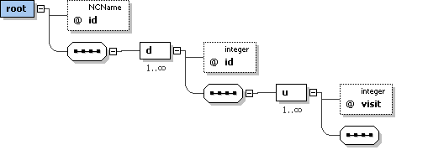

|  |
| --- |
| <?xml version="1.0" encoding="UTF-8"?> <xs:schema xmlns:xs="http://www.w3.org/2001/XMLSchema" elementFormDefault="qualified">  <xs:element name="root">  <xs:complexType>  <xs:sequence>  <xs:element maxOccurs="unbounded" ref="d"/>  </xs:sequence>  <xs:attribute name="id" use="required" type="xs:NCName"/>  </xs:complexType>  </xs:element>  <xs:element name="d">  <xs:complexType>  <xs:sequence>  <xs:element maxOccurs="unbounded" ref="u"/>  </xs:sequence>  <xs:attribute name="id" use="required" type="xs:integer"/>  </xs:complexType>  </xs:element>  <xs:element name="u">  <xs:complexType mixed="true">  <xs:attribute name="visit" use="required" type="xs:integer"/>  </xs:complexType>  </xs:element> </xs:schema> |

The Perl script *dailyRawStats.pl* is implemented to execute this task.

This *dailyRawStats.pl* script is called in the *analyzeLogs.pl* script, in a similar way it calls *awstats.pl* script.

This *dailyRawStats.pl* script:

* reads and analyzes the awstats configuration file content, to get LogFormat, LogSeparator OnlyFile,... as awstats do it.
* reads each line of the log file
  + determines whether the line is approved according to selection criteria (as as awstats do it). If not approved , the line is ignored
  + transforms the date/time of the log data into a ‘day’ date : e.g. “Fri Jul 26 20:16:26 2013” is translate to “20130826”. The function to translate has a time period parameter, currently this parameter is set to ‘day’, but it could be change by configuration to have ‘hour’ or ??? statistics.
  + do incremental statistics (count) by IP/DNS and login (if exists)
* save statistics in an XML files according to the XSD schema

#### Merging statistics into a single Excel file

This process is used to

* build summary statistics (grouping, counting, …)
* merge each individual built statistics into a single Excel file: merge each Excel sheet into a single Excel workbook.

The full description of this configuration file is located in the document [DA 8]. The XML schema is *mergeXmlConfig.xsd*.

The XSD (XML schema) is:

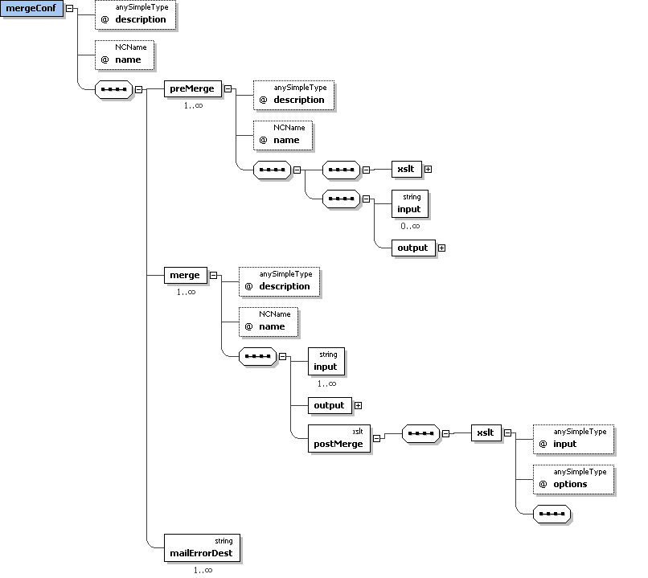

|  |
| --- |
| <?xml version="1.0" encoding="UTF-8"?> <xs:schema xmlns:xs="http://www.w3.org/2001/XMLSchema" elementFormDefault="qualified">  <xs:element name="mergeConf">  <xs:complexType>  <xs:sequence>  <xs:element maxOccurs="unbounded" ref="preMerge"/>  <xs:element maxOccurs="unbounded" ref="merge"/>  <xs:element maxOccurs="unbounded" ref="mailErrorDest"/>  </xs:sequence>  <xs:attribute name="description" use="required"/>  <xs:attribute name="name" use="required" type="xs:NCName"/>  </xs:complexType>  </xs:element>  <xs:element name="preMerge">  <xs:annotation>  <xs:documentation>  Allow defining XSL transformations to run before merge   </xs:documentation>   </xs:annotation>     <xs:complexType>  <xs:complexContent>  <xs:extension base="xslt">  <xs:sequence>  <xs:element minOccurs="0" maxOccurs="unbounded" ref="input">  <xs:annotation>  <xs:documentation>  The input files of the XSLT . If there is only one input, the 'input' attribute of the xslt element can be used instead.  </xs:documentation>   </xs:annotation>     </xs:element>  <xs:element ref="output">  <xs:annotation>  <xs:documentation>  The ouput file of the XSL transformation.  </xs:documentation>   </xs:annotation>   </xs:element>  </xs:sequence>  <xs:attribute name="description" use="required"/>  <xs:attribute name="name" use="required" type="xs:NCName"/>  </xs:extension>  </xs:complexContent>  </xs:complexType>  </xs:element>  <xs:element name="merge">  <xs:annotation>  <xs:documentation>  Allow configuring merge step (merge input Excel sheets into a single Excel workbook)   </xs:documentation>   </xs:annotation>     <xs:complexType>  <xs:sequence>  <xs:element maxOccurs="unbounded" ref="input">  <xs:annotation>  <xs:documentation>  Input Excel sheets (Excel files) to be merged   </xs:documentation>   </xs:annotation>     </xs:element>  <xs:element ref="output">  <xs:annotation>  <xs:documentation>  Output Excel workbook   </xs:documentation>   </xs:annotation>     </xs:element>  <xs:element ref="postMerge">  <xs:annotation>  <xs:documentation>  Allow defining XSL transformations on the output of the merge step   </xs:documentation>   </xs:annotation>     </xs:element>  </xs:sequence>  <xs:attribute name="description" use="required"/>  <xs:attribute name="name" use="required" type="xs:NCName"/>  </xs:complexType>  </xs:element>  <xs:element name="postMerge" type="xslt"/>  <xs:element name="mailErrorDest" type="xs:string"/>  <xs:complexType name="xslt">  <xs:sequence>  <xs:element ref="xslt"/>  </xs:sequence>  </xs:complexType>  <xs:element name="xslt">  <xs:annotation>  <xs:documentation>  The XSLT to process  </xs:documentation>   </xs:annotation>   <xs:complexType mixed="true">  <xs:attribute name="input">  <xs:annotation>  <xs:documentation>  The input file of the XSLT . If there are more than one input, the 'input' element must be used..  </xs:documentation>   </xs:annotation>     </xs:attribute>  <xs:attribute name="options">  <xs:annotation>  <xs:documentation>  xsltproc command -line option..  </xs:documentation>   </xs:annotation>     </xs:attribute>  </xs:complexType>  </xs:element>  <xs:element name="input" type="xs:string"/>   <xs:element name="output">   <xs:complexType mixed="true">  <xs:attribute name="send" type="xs:boolean" default="false">  <xs:annotation>  <xs:documentation>  Flag specifying if the result of the XSL transformation must be sent or not the recipient. Default value is ‘false’ (don’t send)  </xs:documentation>   </xs:annotation>     </xs:attribute>  </xs:complexType>  </xs:element> </xs:schema> |

##### Merging MyOcean Web Portal statistics

This aim is to merge MyOcean Web Portal individual statistics (see section “5.1.7.6 The “raw” XSL transformation”, page 156) into a single Excel workbook.

The XML merge configuration file is:

|  |
| --- |
| <?xml version="1.0" standalone="no"?> <!DOCTYPE skipHostConfig [ <!ENTITY maildest SYSTEM './logMailDestMyOceanWebPortalFinal.xml'> ]> <mergeConf name="MergeStatMyOceanWebPortal" description="Merge MyOcean Web Portal statistics">    <merge name="MergeStatCLSSample" description="CLSSample statistics">  <input>/data2/atoll/awstats/logs/report/MyOcean/%YYYY-0%MM-0/MyOceanWebPortal/logsMyOceanWebPortalPages%YYYY-0%MM-0.xls</input>  <input>/data2/atoll/awstats/logs/report/MyOcean/%YYYY-0%MM-0/MyOceanWebPortal/logsMyOceanWebPortalUsers%YYYY-0%MM-0.xls</input>  <input>/data2/atoll/awstats/logs/report/MyOcean/%YYYY-0%MM-0/MyOceanWebPortal/logsMyOceanWebPortalOrgs%YYYY-0%MM-0.xls</input>  <input>/data2/atoll/awstats/logs/report/MyOcean/%YYYY-0%MM-0/MyOceanWebPortal/logsMyOceanWebPortalTopOrgs%YYYY-0%MM-0.xls</input>  <input>/data2/atoll/awstats/logs/report/MyOcean/%YYYY-0%MM-0/MyOceanWebPortal/logsMyOceanWebPortalCountries%YYYY-0%MM-0.xls</input>  <output send="true">/data2/atoll/awstats/logs/report/MyOcean/%YYYY-0%MM-0/MyOceanWebPortalStat%YYYY-0%MM-0.xls</output>  <postMerge>  <xslt>/data2/atoll/awstats/logs/xslt/distinctExcel.xslt</xslt>  </postMerge>  </merge>    &maildest;   </mergeConf> |

The XML merge configuration file is not generated. It must be built manually.

The merge configuration file is the input of the *mergeXml.pl* Perl script.

The example above is MyOcean V3. It should be adapted for MyOcean V4 (add ***preMerge* steps** ? merge input file…).

##### Merging Dissemination Unit statistics

This aim is to merge Dissemination Unit individual statistics (see section “5.1.7.6 The “raw” XSL transformation”, page 156) into a single Excel workbook.

The process is run for each Dissemination Unit and the “virtual” dissemination unit “AllDU” (all Dissemination Units mixed up).

The merge configuration file is generated by the *mergeMyOceanXml.pl* Perl script. This script is similar with *mergeXml.pl* Perl script. Before emerging, it generates the merge configuration file: e.g. (for a DU named DUCLS):

|  |
| --- |
| <?xml version="1.0" standalone="no"?> <!DOCTYPE skipHostConfig [ <!ENTITY maildest SYSTEM './logMailDestDUCLSFinal.xml'> ]> <mergeConf name="MergeStatDUCLS" description="Merge DUCLS statistics">    <merge name="MergeStatDUCLS" description="DUCLS statistics">  <input>/data2/atoll/awstats/logs/report/MyOcean/%YYYY-0%MM-0/DUCLSFtp/logsFtpDUCLSProduits%YYYY-0%MM-0.xls</input>  <input>/data2/atoll/awstats/logs/report/MyOcean/%YYYY-0%MM-0/DUCLSFtp/logsFtpDUCLSLogins%YYYY-0%MM-0.xls</input>  <input>/data2/atoll/awstats/logs/report/MyOcean/%YYYY-0%MM-0/DUCLSFtp/logsFtpDUCLSUsers%YYYY-0%MM-0.xls</input>  <input>/data2/atoll/awstats/logs/report/MyOcean/%YYYY-0%MM-0/DUCLSFtp/logsFtpDUCLSOrgs%YYYY-0%MM-0.xls</input>  <input>/data2/atoll/awstats/logs/report/MyOcean/%YYYY-0%MM-0/DUCLSFtp/logsFtpDUCLSTopOrgs%YYYY-0%MM-0.xls</input>  <input>/data2/atoll/awstats/logs/report/MyOcean/%YYYY-0%MM-0/DUCLSFtp/logsFtpDUCLSCountries%YYYY-0%MM-0.xls</input>  <input>/data2/atoll/awstats/logs/report/MyOcean/%YYYY-0%MM-0/DUCLSWms/logsWmsDUCLSProduits%YYYY-0%MM-0.xls</input>  <input>/data2/atoll/awstats/logs/report/MyOcean/%YYYY-0%MM-0/DUCLSWms/logsWmsDUCLSUsers%YYYY-0%MM-0.xls</input>  <input>/data2/atoll/awstats/logs/report/MyOcean/%YYYY-0%MM-0/DUCLSWms/logsWmsDUCLSOrgs%YYYY-0%MM-0.xls</input>  <input>/data2/atoll/awstats/logs/report/MyOcean/%YYYY-0%MM-0/DUCLSWms/logsWmsDUCLSTopOrgs%YYYY-0%MM-0.xls</input>  <input>/data2/atoll/awstats/logs/report/MyOcean/%YYYY-0%MM-0/DUCLSWms/logsWmsDUCLSCountries%YYYY-0%MM-0.xls</input>  <output send="true">/data2/atoll/awstats/logs/report/MyOcean/%YYYY-0%MM-0/DUCLSStat%YYYY-0%MM-0.xls</output>  <postMerge>  <xslt>/data2/atoll/awstats/logs/xslt/distinctExcel.xslt</xslt>  </postMerge>  </merge>    &maildest;   </mergeConf> |

The input file of the *mergeMyOceanXml.pl* Perl script is the process configuration file (see section “The process configuration file (A)”, page 148 ).

It must be run twice:

* with the process configuration file (A) by Dissemination Unit (see section “The process configuration file (A) by Dissemination Unit and MyOcean Web Portal”, page 148).

Note: for MyOcean Web Portal statistics the attribute **ignoreBuildprodconf** must be set to *true* (see example above), so MyOcean Web Portal statistics are not concerned by this process, but that section “5.1.7.8.1 Merging MyOcean Web Portal statistics”, page 165

* with the process configuration file (A) for all Dissemination Units mixed up as input (see section “The process configuration file (A) - All Dissemination Units mixed up”, page 151

The example above is MyOcean V3. It should be adapted for MyOcean V4 (add ***preMerge*** **steps** ? merge input file…) : adapt the *mergeMyOceanXml.pl* Perl script / function buildMergeConf (see section “5.1.7.11.5 Dissemination Unit mixed up statistics for all media mixed up”, page 197).

#### Export the LDAP users database

To be able to display user’s information in the statistical reports, an XML file containing users’ information is needed.

##### Create an XML users database

A new Perl script has to be implemented. This Perl script could use the Perl Net:LDAP module (see <http://search.cpan.org/~gbarr/perl-ldap/> and <http://ldap.perl.org/> ).

The XML schema could be:

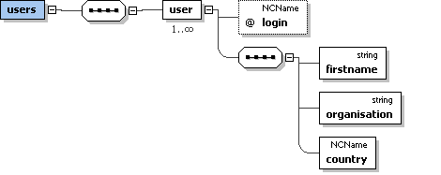

|  |
| --- |
| <?xml version="1.0" encoding="UTF-8"?> <xs:schema xmlns:xs="http://www.w3.org/2001/XMLSchema" elementFormDefault="qualified">  <xs:element name="users">  <xs:complexType>  <xs:sequence>  <xs:element maxOccurs="unbounded" ref="user"/>  </xs:sequence>  </xs:complexType>  </xs:element>  <xs:element name="user">  <xs:complexType>  <xs:sequence>  <xs:element ref="firstname"/>  <xs:element ref="organisation"/>  <xs:element ref="country"/>  </xs:sequence>  <xs:attribute name="login" use="required" type="xs:NCName"/>  </xs:complexType>  </xs:element>  <xs:element name="firstname" type="xs:string"/>  <xs:element name="organisation" type="xs:string"/>  <xs:element name="country" type="xs:NCName"/> </xs:schema> |

##### Use of XML users database

In order to be able to display the users information in reports :

* Adapt the criteria configuration file (B)
  + Create a new attribute ‘xmlLdapUsers’ in the ‘logProductConfig’ element (such as the CRM Aviso users: xmlCrmUsers attribute), e.g.:

xmlLdapUsers="/opt/atoll/loganalyzer/xml/MyOcean/ldapUsers.xml"

* + Adapt the XLST files to get and display the users information in reports (such as the CRM Aviso users: xmlCrmUsers attribute)

#### Sequence of commands

This section describes the commands to run for analysis achievement.

1. Export the MyOcean LDAP users database

This process allows exporting the users’ database to an XML file.

This command has to be implemented in MyOcean V4 (see section “5.1.7.9 Export the LDAP users database”, page 167).

1. Retrieve the log file from the Dissemination Units and MyOcean Web Portal, build criteria configuration file.

This process retrieves the log files configured in each log configuration file from each Dissemination Unit and for MyOcean Web Portal.

The process copies the log files on the local machine (the machine where the CIS transaction Accounting tool is installed).

The process builds (generates) also the criteria configuration files.

|  |
| --- |
| * perl /data2/atoll/awstats/logs/perl/logProcess.pl -conf /data2/atoll/awstats/logs/xml/MyOcean/**logProcessMyOceanDU.xml** -force 1 -step scp,merge,buildprodconf $MONTH_SETTING $YEAR_SETTING |

Always use “-force 1 -step scp,merge,buildprodconf” option.

**-conf *log_conf_file***: specifies the process configuration file to use. Here *logProcessMyOceanDU.xml* (see section “The process configuration file (A) by Dissemination Unit and MyOcean Web Portal”, page 148).

**-force 1** force to get log files(s) from remote host regardless the fromRemote and mergeLogs settings of the log configuration file.

**-step scp,merge,buildprodconf**: allow to only handle specific steps of the process. If no step is set, all treatments are performed ":

**scp**: get the log file(s) from the remote host (see section “The log configuration file (C)”, page 140).

**merge**: merge log file(s) of the previous month and the next month by keeping only the lines whose date (month / year) match the desired analysis (because log file are not always cut exactly at the end and the beginning of the month).

**buildprodconf**: create the criteria configuration file (B) (see section sections “5.1.7.4 Generate criteria configuration file for WMS and Subsetters media”, page 152 and “5.1.7.5 Generate criteria configuration file for VSFTPD media”, page 156).

**$YEAR_SETTING** can be empty or contain **-year *YYYY****:* this is the year of the log to process. If empty, the default is: year of the month preceding the current month

**$MONTH_SETTING** can be empty or contain **-month *MM***: this is the month of the log to process. If empty, the default is: previous month the current month)

$YEAR_SETTING, $MONTH_SETTING are usually empty, unless we want to replay the analysis for a specific period.

1. Analyze log files and compute raw statistics for each Dissemination Unit and media, and for MyOcean Web Portal.

This process configures the Awstats processes.

The process runs Awstats to compute raw statistics and saves them as XML files (Awstats format).

This process run the XSL transformation configured in the criteria configuration files.

|  |
| --- |
| * perl /data2/atoll/awstats/logs/perl/logProcess.pl -conf /data2/atoll/awstats/logs/xml/MyOcean/**logProcessMyOceanDU.xml** $MONTH_SETTING $YEAR_SETTING |

1. Analyze log files and compute raw statistics for all Dissemination Units mixed up and media.

The process runs Awstats to compute raw statistics and saves them as XML files (Awstats XML format).

Log files have already been retrieved in step 1. It is not needed to copy them from each DU

This process runs also the XSL transformation configured in the criteria configuration files.

|  |
| --- |
| * perl /data2/atoll/awstats/logs/perl/logProcess.pl -conf /data2/atoll/awstats/logs/xml/MyOcean/**logProcessMyOceanDUMixedUp.xml** $MONTH_SETTING $YEAR_SETTING |

1. Finalize and merge statistics for each Dissemination Unit and media.

This process merges each Dissemination Unit individual statistics (Excel sheets) into a single Excel workbook (see section “5.1.7.8.2 Merging Dissemination Unit statistics”, page 166).

Note: MyOcean Web Portal statistics are excluded from this process.

|  |
| --- |
| * perl /data2/atoll/awstats/logs/perl/mergeMyOceanXml.pl -conf /data2/atoll/awstats/logs/xml/MyOcean/**logProcessMyOceanDU.xml** $MONTH_SETTING $YEAR_SETTING |

1. Finalize and merge statistics for all Dissemination Units mixed up and media.

This process merges all Dissemination Unit mixed up individual statistics (Excel sheets) into a single Excel workbook (see section “5.1.7.8.2 Merging Dissemination Unit statistics”, page 166).

Note: MyOcean Web Portal statistics are excluded from this process.

|  |
| --- |
| * perl /data2/atoll/awstats/logs/perl/**mergeMyOceanXml.pl** -conf /data2/atoll/awstats/logs/xml/MyOcean/**logProcessMyOceanDUMixedUp.xml** $MONTH_SETTING $YEAR_SETTING |

1. Finalize and merge statistics for MyOcean Web Portal.

This process merges MyOcean Web Portal individual statistics (Excel sheets) into a single Excel workbook (see section “5.1.7.8.1 Merging MyOcean Web Portal statistics”, page 165).

|  |
| --- |
| * perl /data2/atoll/awstats/logs/perl/mergeXml.pl -mergeConf /data2/atoll/awstats/logs/xml/MyOcean/**MyOceanWebPortalMergeXmlConfig.xml** $MONTH_SETTING $YEAR_SETTING |

#### Statistics reports in detail

This section describes the final desired statistics reports and how to obtain them.

Note: The graphics are for illustrative purposes. They are not generated by the CIS Transaction Accounting tool. They will be made “manually” from the Excel outputs files provided by the CIS Transaction Accounting.

##### MyOcean Web Portal statistics

###### Report by visited pages

Implemented in MyOcean V3.

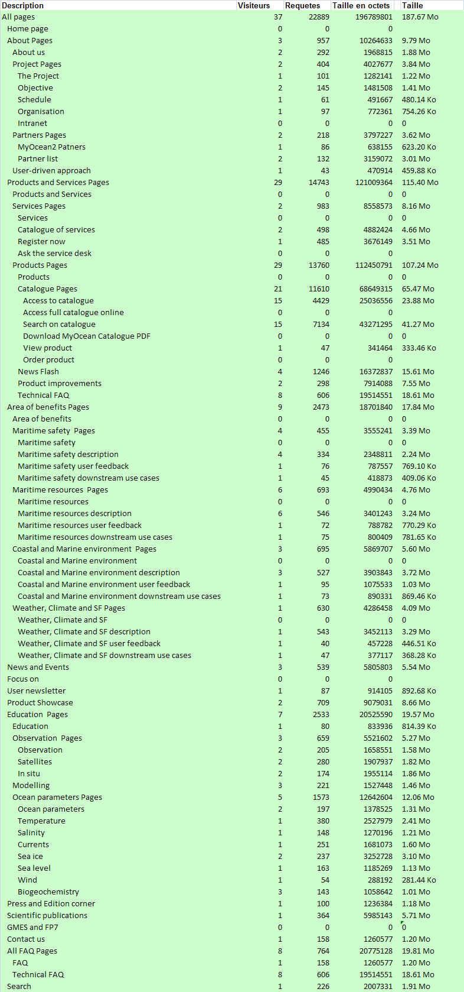

Report built with the **logsProduits.xslt XSL transformation**

###### Report by users and the pages they visited

Implemented in MyOcean V3.

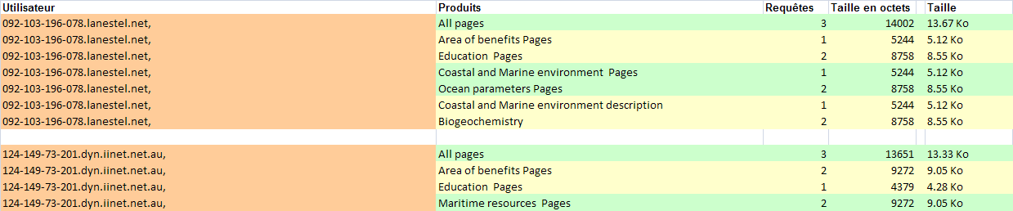

Report built with the **logsUsers.xslt XSL transformation**

###### Report by organization and the pages they visited

Implemented in MyOcean V3.

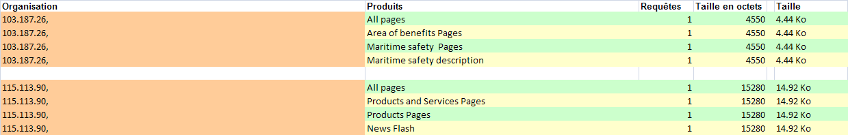

Report built with the **logsOrganisations.xslt XSL transformation**

###### Report by country and the pages they visited

Implemented in MyOcean V3.

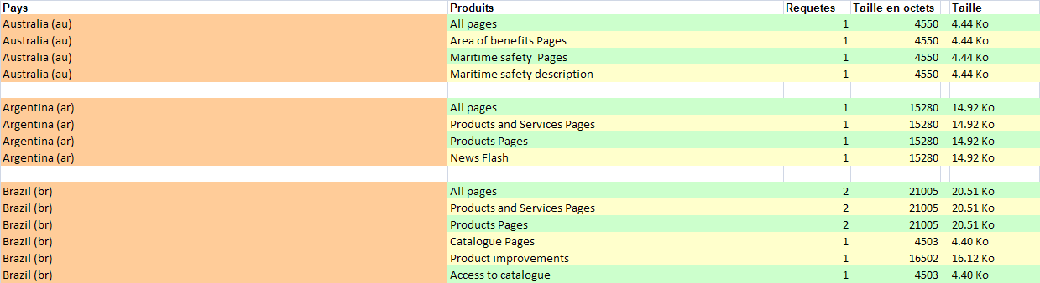

Report built with the **logsCountries.xslt XSL transformation**

###### Report for the Top n organizations

Implemented in MyOcean V3.

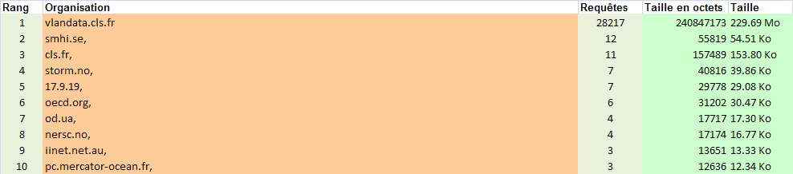

Report built with the **logsTopOrganisations.xslt XSL transformation**

##### Dissemination Unit statistics by media

The following reports are built for each DU statistics by media.

Note: The XLST of this section must be included in the *xslt* element (the parent element is *logXsltConfig* element) of the criteria configuration.

###### Report by products

Implemented in MyOcean V3 – to be adapted in MyOcean V4.

VSFTPD:

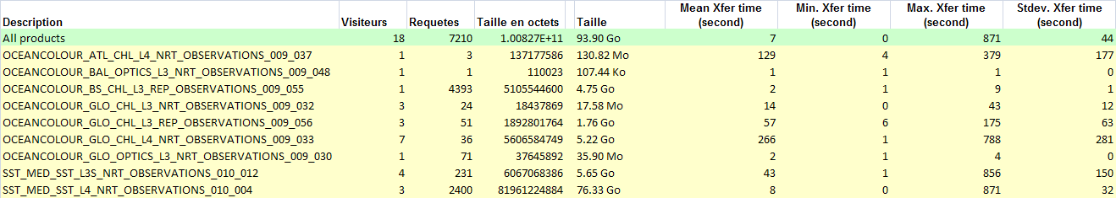

WMS or Motu or… and All DU mixed up:

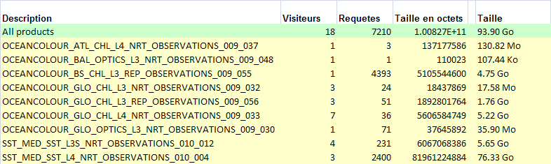

Report built with the **logsProduits.xslt XSL transformation**

###### Report by users and the products they downloaded

Implemented in MyOcean V3.

Same as MyOcean Web Portal but products instead HTML pages

Report built with the **logsUsers.xslt XSL transformation**

###### Report by organization and the products they downloaded

Implemented in MyOcean V3.

Same as MyOcean Web Portal but products instead HTML pages

Report built with the **logsOrganisations.xslt XSL transformation**

###### Report by country and the downloaded products

Implemented in MyOcean V3.

Same as MyOcean Web Portal but products instead HTML pages

Report built with the **logsCountries.xslt XSL transformation**

###### Report for the Top n organizations

Implemented in MyOcean V3.

Same as MyOcean Web Portal but products instead HTML pages

Report built with the **logsTopOrganisations.xslt XSL transformation**

###### Report by login (VSFTPD only)

Partially implemented in MyOcean V3 – to be adapted in MyOcean V4):

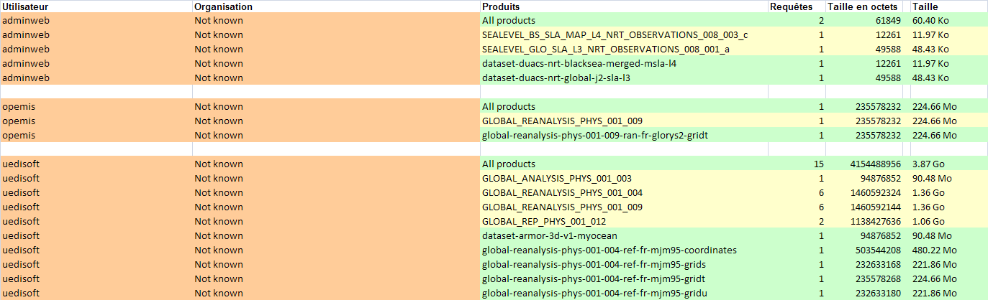

Report built with the **logsLogins.xslt XSL transformation**

The Organization is ‘not known’ in the example above, because the User database has to be linked to be able to report the organization of the user (MyOcean V4).

###### Report “number of users per number of products they have taken”

To be implemented in MyOcean V4.

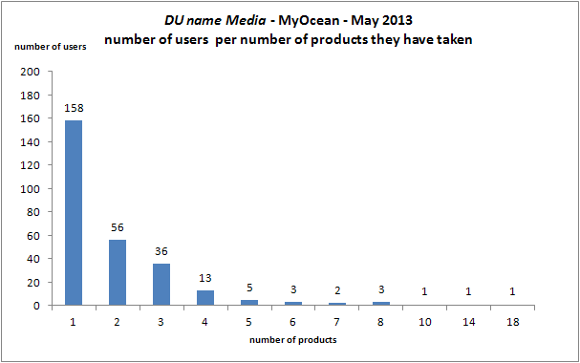

The above graphic will be build manually from the following Excel sheet produced by the CIS Transaction Accounting tool:

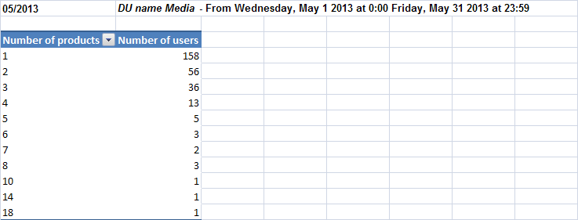

In order to build these statistics, the process (XSL transformation) might be as follows:

1. Create a XLST that uses as input the output of the **logsUsersPrepare.xslt** (see section “5.1.7.6 The “raw” XSL transformation”, page 156)

The XML schema of the output of the the **logsUsersPrepare.xslt** is:

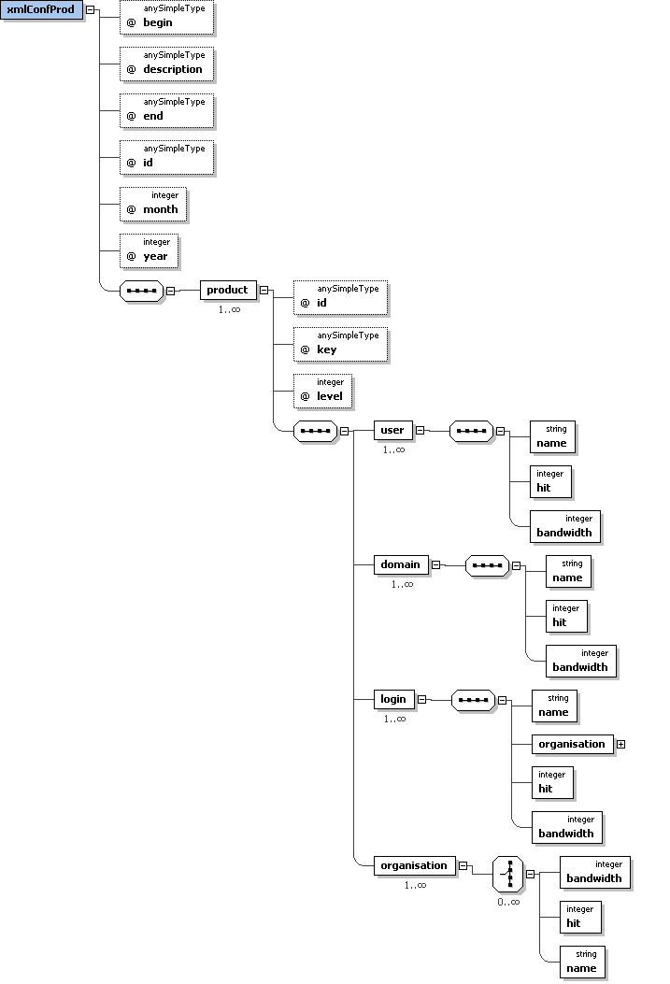

|  |
| --- |
| <?xml version="1.0" encoding="UTF-8"?> <xs:schema xmlns:xs="http://www.w3.org/2001/XMLSchema" elementFormDefault="qualified">  <xs:element name="xmlConfProd">  <xs:complexType>  <xs:sequence>  <xs:element maxOccurs="unbounded" ref="product"/>  </xs:sequence>  <xs:attribute name="begin" use="required"/>  <xs:attribute name="description" use="required"/>  <xs:attribute name="end" use="required"/>  <xs:attribute name="id" use="required"/>  <xs:attribute name="month" use="required" type="xs:integer"/>  <xs:attribute name="year" use="required" type="xs:integer"/>  </xs:complexType>  </xs:element>  <xs:element name="product">  <xs:complexType>  <xs:sequence>  <xs:element maxOccurs="unbounded" ref="user"/>  <xs:element maxOccurs="unbounded" ref="domain"/>  <xs:element maxOccurs="unbounded" ref="login"/>  <xs:element maxOccurs="unbounded" ref="organisation"/>  </xs:sequence>  <xs:attribute name="id" use="required"/>  <xs:attribute name="key" use="required"/>  <xs:attribute name="level" use="required" type="xs:integer"/>  </xs:complexType>  </xs:element>  <xs:element name="user">  <xs:complexType>  <xs:sequence>  <xs:element ref="name"/>  <xs:element ref="hit"/>  <xs:element ref="bandwidth"/>  </xs:sequence>  </xs:complexType>  </xs:element>  <xs:element name="domain">  <xs:complexType>  <xs:sequence>  <xs:element ref="name"/>  <xs:element ref="hit"/>  <xs:element ref="bandwidth"/>  </xs:sequence>  </xs:complexType>  </xs:element>  <xs:element name="login">  <xs:complexType>  <xs:sequence>  <xs:element ref="name"/>  <xs:element ref="organisation"/>  <xs:element ref="hit"/>  <xs:element ref="bandwidth"/>  </xs:sequence>  </xs:complexType>  </xs:element>  <xs:element name="name" type="xs:string"/>  <xs:element name="hit" type="xs:integer"/>  <xs:element name="bandwidth" type="xs:integer"/>  <xs:element name="organisation">  <xs:complexType mixed="true">  <xs:choice minOccurs="0" maxOccurs="unbounded">  <xs:element ref="bandwidth"/>  <xs:element ref="hit"/>  <xs:element ref="name"/>  </xs:choice>  </xs:complexType>  </xs:element> </xs:schema> |

Example:

|  |
| --- |
| <xmlConfProd id="/data2/atoll/awstats/logs/xml/MyOcean/logProductDUCNRVsftpExtendConfig.xml" month="05" year="2013" begin="mercredi 1 mai 2013 0 h 00" end="vendredi 31 mai 2013 23 h 59" description="DUCNR Ftp">  <product id="All products" level="0" key="AllFtp">  <user>  <name>109.99.128.120</name>  <hit>4393</hit>  <bandwidth>5105544600</bandwidth>  </user>  <user>  <name>firewall.regione.emilia-romagna.it</name>  <hit>2497</hit>  <bandwidth>82290251128</bandwidth>  </user>  <user>  <name>host126-233-static.51-88-b.business.telecomitalia.it</name>  <hit>105</hit>  <bandwidth>977797246</bandwidth>  </user> … </product>  <product id="OCEANCOLOUR_GLO_CHL_L3_NRT_OBSERVATIONS_009_032" level="1" key="AllFtp/OCEANCOLOUR_GLO_CHL_L3_NRT_OBSERVATIONS_009_032">  <user>  <name>103.16.223.3</name>  <hit>22</hit>  <bandwidth>17596827</bandwidth>  </user>  <user>  <name>180.243.95.104</name>  <hit>1</hit>  <bandwidth>627064</bandwidth>  </user>  <user>  <name>bl10-234-204.dsl.telepac.pt</name>  <hit>1</hit>  <bandwidth>213978</bandwidth>  </user> …  </product>  <product id="SST_MED_SST_L3S_NRT_OBSERVATIONS_010_012" level="1" key="AllFtp/SST_MED_SST_L3S_NRT_OBSERVATIONS_010_012">  <user>  <name>firewall.regione.emilia-romagna.it</name>  <hit>146</hit>  <bandwidth>1064082640</bandwidth>  </user>  <user>  <name>host126-233-static.51-88-b.business.telecomitalia.it</name>  <hit>70</hit>  <bandwidth>496726818</bandwidth>  </user>  <user>  <name>host226-102-static.99-5-b.business.telecomitalia.it</name>  <hit>12</hit>  <bandwidth>4484394196</bandwidth>  </user> …  </product> |

The XSLT must select only the <product> with attribute *level* = “1” (Level 1 is Product specification, Level 0 is all products mixed up, there is no level greater than 1 because we don’t want statistics for datasets).

The XSLT must write each user regardless the product, as an XML file. E.g. (theoretical):

<users>  
 <user>User A</user>  
 <user>User B</user>  
 <user>User C</user>  
 <user>User A</user>  
 <user>User A</user>  
 <user>User B</user>  
 <user>User B</user>  
 <user>User C</user>  
</users>

1. Create a XLST that uses the previous XLST output and counts the number of each distinct user (write as an XML file); e.g. (theoretical):

<users>  
 <user count ="3">User A</user>  
 <user count ="3">User B</user>  
 <user count ="2">User C</user>  
</users>

1. Create a XLST that uses the previous XLST output that counts the number of user who have the same “count” attribute

<products>  
 <product num ="3" users="2"/>  
 <product num ="2" users="1"/>  
</products>

The example above means:

* 2 users have taken 3 products
* 1 user has taken 1 product

1. Create a XLST that formats an Excel XML Sheet (Workbook, Cell, Row, Data... - see logUsers.xslt as example).

###### Report by products and users

To be implemented in MyOcean V4.

The following Excel sheet will be produced by the CIS Transaction Accounting tool:

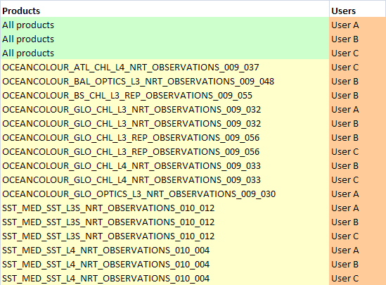

In order to build these statistics, the process (XSL transformation) might be as follows:

1. Create a XLST that uses as input the output of the **logsUsersPrepare.xslt** (see section “5.1.7.6 The “raw” XSL transformation”, page 156) and that formats as output an Excel XML Sheet (Workbook, Cell, Row, Data...).

###### Report “number of products taken by users, by type of products”

To be implemented in MyOcean V4.

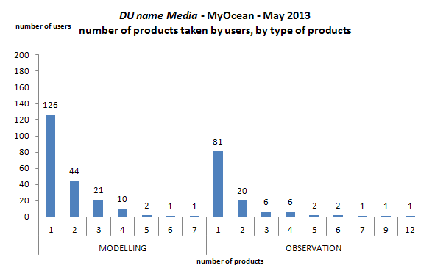

The above graphic will be build manually from the following Excel sheet produced by the CIS Transaction Accounting tool:

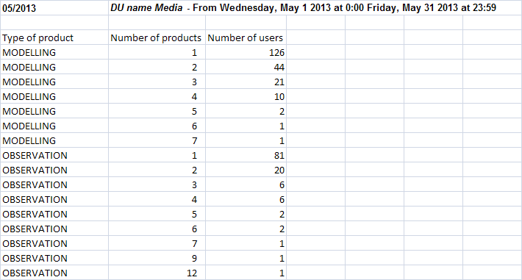

In order to build these statistics, the process (XSL transformation) might be as follows:

1. Create a XLST that uses as input the output of the **logsUsersPrepare.xslt** (see section “5.1.7.6 The “raw” XSL transformation”, page 156)

The XSLT must select only the <product> with attribute *level* = “1”.

The XSLT must have the path of the MyOcean XML EPST file as parameter (see section “5.1.7.2 MyOcean XML Product Specification (EPST) file”, page 134), to be able to get the type of the product.

The XSLT must write (as an XML file) each user regardless the product, but by reporting the type of the product. E.g. (theoretical):

<users>  
 <user ptype="type 1">User A</user>  
 <user ptype="type 1">User B</user>  
 <user ptype="type 2">User C</user>  
 <user ptype="type 2">User A</user>  
 <user ptype="type 2">User A</user>  
 <user ptype="type 1">User B</user>  
 <user ptype="type 2">User B</user>  
 <user ptype="type 1">User C</user>  
</users>

1. Create a XLST that uses the previous XLST output and counts the number of each distinct user per type of product (write as an XML file); e.g. (theoretical):

<users>  
 <user ptype="type 1" count ="1">User A</user>  
 <user ptype="type 2" count ="2">User A</user>  
 <user ptype="type 1" count ="2">User B</user>  
 <user ptype="type 2" count ="1">User B</user>  
 <user ptype="type 1" count ="1">User C</user>  
 <user ptype="type 2" count ="1">User C</user>  
</users>

1. Create a XLST that uses the previous XLST output that counts, per type of product, the number of user who have the same “count” attribute

<products>  
 <product ptype="type 1" num ="1" users="2"/>  
 <product ptype="type 1" num ="2" users="1"/>  
 <product ptype="type 2" num ="1" users="2"/>  
 <product ptype="type 2" num ="2" users="1"/>  
</products>

The example above means:

* 2 users have taken 1 product of type 1
* 1 user has taken 2 products of type 1
* 2 users have taken 1 product of type 2
* 1 user has taken 2 products of type 2

1. Create a XLST that formats an Excel XML Sheet (Workbook, Cell, Row, Data...).

###### Report “number of users per region”

To be implemented in MyOcean V4.

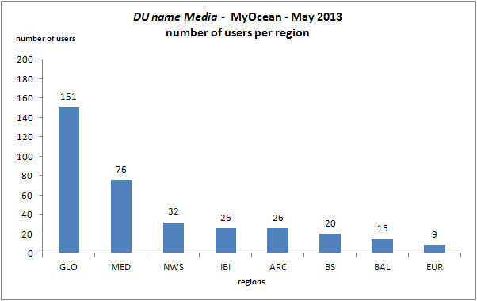

The above graphic will be build manually from the following Excel sheet produced by the CIS Transaction Accounting tool:

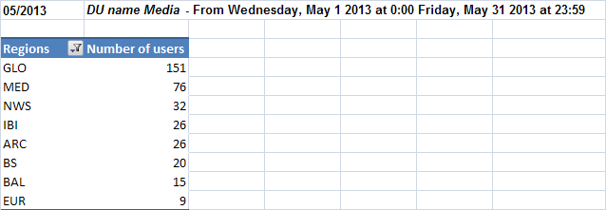

In order to build these statistics, the process (XSL transformation) might be as follows:

1. Create a XLST that uses as input the output of the **logsUsersPrepare.xslt** (see section “5.1.7.6 The “raw” XSL transformation”, page 156)

The XSLT must select only the <product> with attribute *level* = “1”.

The XSLT must have the path of the MyOcean XML EPST file as parameter (see section “5.1.7.2 MyOcean XML Product Specification (EPST) file”, page 134), to be able to get the region of the product.

The XSLT must write (as an XML file) each user regardless the product, but by reporting the region of the product. E.g. (theoretical):

<users>  
 <user region="BS">User A</user>  
 <user region ="BS">User B</user>  
 <user region ="ARC”>User C</user>  
 <user region ="ARC">User A</user>  
 <user region ="ARC">User A</user>  
 <user region ="BS">User B</user>  
 <user region ="ARC">User B</user>  
 <user region ="BS">User C</user>  
</users>

1. Create a XLST that uses the previous XLST output and counts the number of each distinct user per region (write as an XML file); e.g. (theoretical):

<users>  
 <user region ="BS" count ="1">User A</user>  
 <user region ="ARC" count ="2">User A</user>  
 <user region ="BS" count ="2">User B</user>  
 <user region ="ARC" count ="1">User B</user>  
 <user region ="BS" count ="1">User C</user>  
 <user region ="ARC" count ="1">User C</user>  
</users>

1. Create a XLST that uses the previous XLST output that counts, per region, the number of user who have the same “count” attribute

<products>  
 <product region ="BS" num ="1" users="2"/>  
 <product region ="BS" num ="2" users="1"/>  
 <product region ="ARC" num ="1" users="2"/>  
 <product region ="ARC" num ="2" users="1"/>  
</products>

The example above means:

* 2 users have taken 1 product of region BS
* 1 user has taken 2 products of region BS
* 2 users have taken 1 product of region ARC
* 1 user has taken 2 products of region ARC

1. Create a XLST that formats an Excel XML Sheet (Workbook, Cell, Row, Data...).

###### Report “number of products taken by users, per product type and region”

To be implemented in MyOcean V4.



The above graphic will be build manually from the following Excel sheet produced by the CIS Transaction Accounting tool:

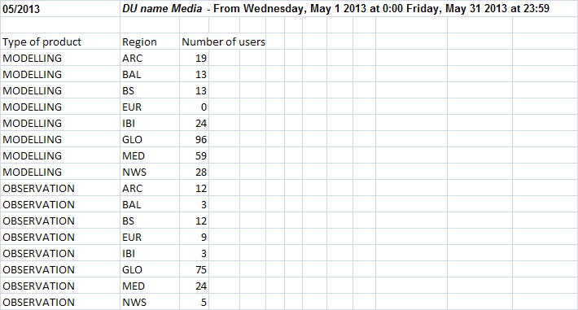

In order to build these statistics, the process (XSL transformation) might be as follows:

1. Create a XLST that uses as input the output of the **logsUsersPrepare.xslt** (see section “5.1.7.6 The “raw” XSL transformation”, page 156)

The XSLT must select only the <product> with attribute *level* = “1”.

The XSLT must have the path of the MyOcean XML EPST file as parameter (see section “5.1.7.2 MyOcean XML Product Specification (EPST) file”, page 134), to be able to get the type of the product and its region.

The XSLT must write (as an XML file) each user regardless the product, but by reporting the type of the product and its region. E.g. (theoretical):

<users>  
 <user ptype="type 1" region ="BS">User A</user>  
 <user ptype="type 1" region ="BS">User B</user>  
 <user ptype="type 2" region ="ARC">User C</user>  
 <user ptype="type 2" region ="ARC">User A</user>  
 <user ptype="type 2" region ="ARC">User A</user>  
 <user ptype="type 1" region ="BS">User B</user>  
 <user ptype="type 2" region ="ARC">User B</user>  
 <user ptype="type 1" region ="BS">User C</user>  
</users>

1. Create a XLST that uses the previous XLST output and counts the number of each distinct user per type of product and region (write as an XML file); e.g. (theoretical):

<users>  
 <user ptype="type 1" region ="BS" count="1">User A</user>  
 <user ptype="type 2" region ="ARC" count="2">User A</user>  
 <user ptype="type 1" region ="BS" count="2">User B</user>  
 <user ptype="type 2" region ="ARC" count="1">User B</user>  
 <user ptype="type 1" region ="BS" count="1">User C</user>  
 <user ptype="type 2" region ="ARC" count="1">User C</user>  
</users>

1. Create a XLST that uses the previous XLST output that counts, per type of product and region, the number of user who have the same “count” attribute

<products>  
 <product ptype="type 1" region ="BS" num ="1" users="2"/>  
 <product ptype="type 1" region ="BS" num ="2" users="1"/>  
 <product ptype="type 2" region ="ARC" num ="1" users="2"/>  
 <product ptype="type 2" region ="ARC" num ="2" users="1"/>  
</products>

The example above means:

* 2 users have taken 1 product of type 1 and region BS
* 1 user has taken 2 products of type 1 and region ARC
* 2 users have taken 1 product of type 2 and region BS
* 1 user has taken 2 products of type 2 and region ARC

1. Create a XLST that formats an Excel XML Sheet (Workbook, Cell, Row, Data...).

###### Report “number of users per TAC-MFC”

To be implemented in MyOcean V4.

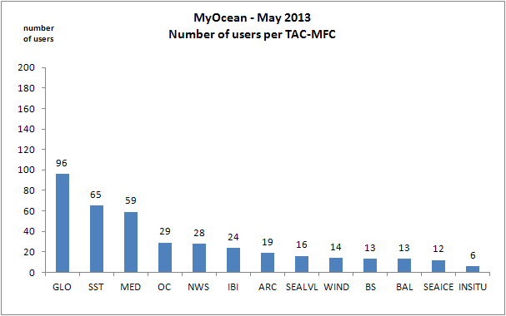

The above graphic will be build manually from the following Excel sheet produced by the CIS Transaction Accounting tool:

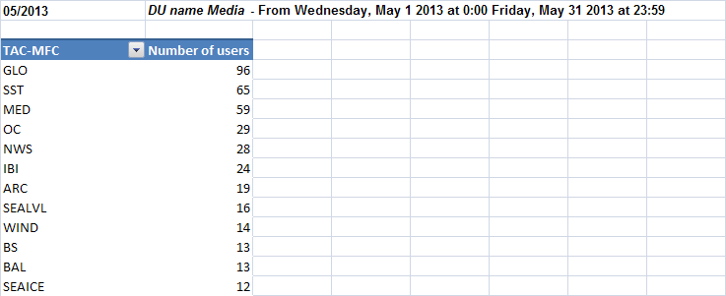

In order to build these statistics, the process (XSL transformation) might be as follows:

1. Create a XLST that uses as input the output of the **logsUsersPrepare.xslt** (see section “5.1.7.6 The “raw” XSL transformation”, page 156)

The XSLT must select only the <product> with attribute *level* = “1”.

The XSLT must have the path of the MyOcean XML EPST file as parameter (see section “5.1.7.2 MyOcean XML Product Specification (EPST) file”, page 134), to be able to get the TAC-MFC of the product.

The XSLT must write (as an XML file) each user regardless the product, but by reporting the TAC-MFC of the product. E.g. (theoretical):

<users>  
 <user tacmfc="SST">User A</user>  
 <user tacmfc="SST">User B</user>  
 <user tacmfc="OC">User C</user>  
 <user tacmfc="OC">User A</user>  
 <user tacmfc="OC">User A</user>  
 <user tacmfc="SST">User B</user>  
 <user tacmfc="OC">User B</user>  
 <user tacmfc="SST">User C</user>  
</users>

1. Create a XLST that uses the previous XLST output and counts the number of each distinct user per TAC-MFC (write as an XML file); e.g. (theoretical):

<users>  
 <user tacmfc ="SST" count ="1">User A</user>  
 <user tacmfc ="OC" count ="2">User A</user>  
 <user tacmfc ="SST" count ="2">User B</user>  
 <user tacmfc ="OC" count ="1">User B</user>  
 <user tacmfc ="SST" count ="1">User C</user>  
 <user tacmfc ="OC" count ="1">User C</user>  
</users>

1. Create a XLST that uses the previous XLST output that counts, per TAC-MFC, the number of user who have the same “count” attribute

<products>  
 <product tacmfc ="SST" num ="1" users="2"/>  
 <product tacmfc ="SST" num ="2" users="1"/>  
 <product tacmfc ="OC" num ="1" users="2"/>  
 <product tacmfc ="OC" num ="2" users="1"/>  
</products>

The example above means:

* 2 users have taken 1 product of TAC-MFC SST
* 1 user has taken 2 products of TAC-MFC SST
* 2 users have taken 1 product of TAC-MFC OC
* 1 user has taken 2 products of TAC-MFC OC

1. Create a XLST that formats an Excel XML Sheet (Workbook, Cell, Row, Data...).

###### Report “users per day”

To be implemented in MyOcean V4.

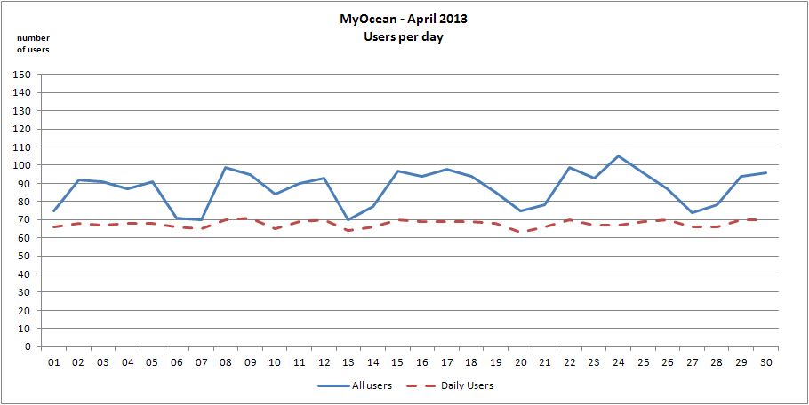

The above graphic will be build manually from the following Excel sheet produced by the CIS Transaction Accounting tool:

This report must be built for ‘IP/DSN’ users and ‘login’ users if login information exists in the log (see section “5.1.7.7 Per number of days raw statistics”, page 159).

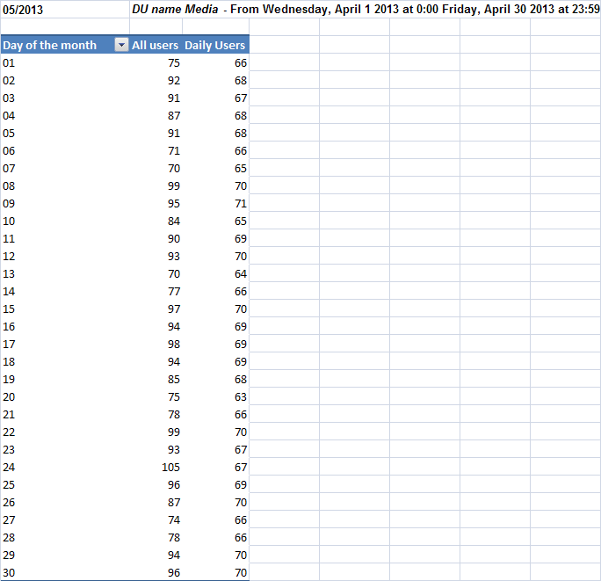

The CIS Transaction Accounting will also produce the list of the “daily users”:

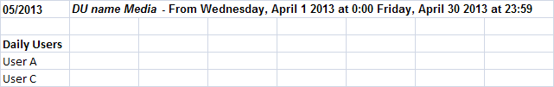

The statistics relate only on “products” whose “dailyStats” attribute is set to true in the criteria configuration file (see “Criteria configuration file” in the [DA 8] document). We don’ need to compute them for each product. The Perl script involved is *transform.pl*. By default if there is no input file attribute in the *xslt* element (*logXsltConfig* element), the input files are the awstats statistics files. In the case of “users per day” report, it shall be the “Per number of days” XML file. The Perl script *transform.pl* has been adapted.

For VFSFTP and WMS, the criteria configuration files are generated: the Perl scripts *buildConfFromVsftp.pl* and *buildConfFromWms.pl* must changed to generate the dailyStats” attribute

In order to build these statistics, the process (XSL transformation) is as follows:

1. **logsCountByDays.xslt**: computes the number of users per date (day). Create a XLST that uses as input the “Per number of days” XML file (see section “5.1.7.7 Per number of days raw statistics”, page 159).

We consider a user is a “daily user” if the number of days he access the product is greater than (>=) a number of days (default value is. 20). This value is a setting of the xslt script.

The XSLT must count the number of users per date (day). E.g. (theoretical):

<days product="NRT-ADT-ABO-C2-CF">  
 <day id="20130501">25</day>  
 <day id="20130502">32</day>  
 <day id="20130509">18</day>  
</days>

1. **logsCountDailiesPrepare.xslt**: computes the number of “daily users” per date. Create a XLST that uses as input the “Per number of days” XML file (see section “5.1.7.7 Per number of days raw statistics”, page 159)

The XSLT must count for each distinct user the number of occurrences he appears in the month (all dates). If the number occurrences for a user greater than 20, the XSLT count the user as a daily user and reported in output

E.g. (theoretical):

<root id="NRT-ADT-ABO-C2-CF">  
 <d id="20130501">  
 <u>setou</u>  
...  
 </d>  
 <d id="20130502">  
 <u>setou</u>  
 <u>bonjean</u>  
 <u>ipsl_ramage</u>  
...  
 </d>  
 <d id="20130509">  
 <u>setou</u>  
 <u>ipsl_ramage</u>  
...  
 </d>  
</root>

1. **logsCountDailies.xslt**: computes the number of “daily users” per date. Create a XLST that uses as input the output of the previous step: **logsCountDailiesPrepare.xslt**

The XSLT must count the number of “daily users” per date (day). E.g. (theoretical):

<dailies product="NRT-ADT-ABO-C2-CF">  
 <day id="20130501">20</day>  
 <day id="20130502">29</day>  
 <day id="20130509">18</day>  
</dailies>

1. **logsGetDailies.xslt**: gets the “daily users” per date. Create a XLST that uses as input the output of the previous step: **logsCountDailiesPrepare.xslt**
2. .

The user value is

* the user’s IP address / DSN
* or the user’s login if the login information exists (currently only for VSFTPD)

The XSLT must list the “daily users. E.g. (theoretical):

E.g. (theoretical):

<dailyUsers product="NRT-ADT-ABO-C2-CF">  
 <dailyUser>User A</dailyUser>  
 <dailyUser>User C</dailyUser>  
</dailyUsers>

1. Create a XLST that merge the 3 previous XML and add missing days of the month with value 0. E.g. (theoretical):

<root product="NRT-ADT-ABO-C2-CF">  
 <days>  
 <day id="20130501">25</day>  
 <day id="20130502">32</day>  
 <day id="20130503">0</day>  
…  
 <day id="20130508">0</day>  
 <day id="20130509">18</day>  
 <day id="20130510">0</day>  
…  
 <day id="20130531">0</day>  
 </days>  
 <dailies>  
 <day id="20130501">20</day>  
 <day id="20130502">29</day>  
 <day id="20130503">0</day>  
…  
 <day id="20130508">0</day>  
 <day id="20130509">18</day>  
 <day id="20130510">0</day>  
…  
 <day id="20130531">0</day>  
 </dailies>  
 <dailyUsers>  
 <dailyUser>User A</dailyUser>  
 <dailyUser>User C</dailyUser>  
 </dailyUsers>  
</root>

1. Create a XLST that formats an Excel XML Sheet (Workbook, Cell, Row, Data...) for the daily statistics
2. Create a XLST that formats an Excel XML Sheet (Workbook, Cell, Row, Data...) for the list of daily users.

The user value is

* the IP address / DSN
* or login if the login information exists (currently only for VSFTPD) and there is no “export LDAP users database (see section “5.1.7.9 Export the LDAP users database”, page 167)
* or the user name (first name, last name) retrieved from the export of the LDAP database if the login information exists (currently only for VSFTPD) and there is an “export LDAP users database (see section “5.1.7.9 Export the LDAP users database”, page 167).

###### Report “number of users per number of days when they came”

To be implemented in MyOcean V4.

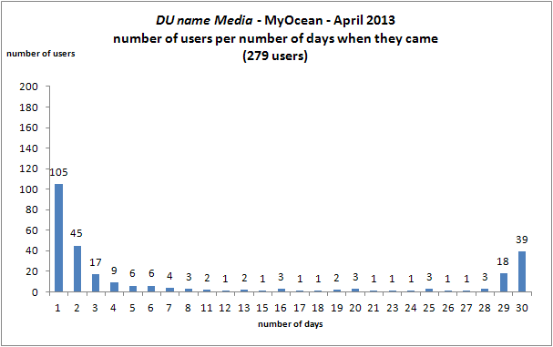

The above graphic will be build manually from the following Excel sheet produced by the CIS Transaction Accounting tool:

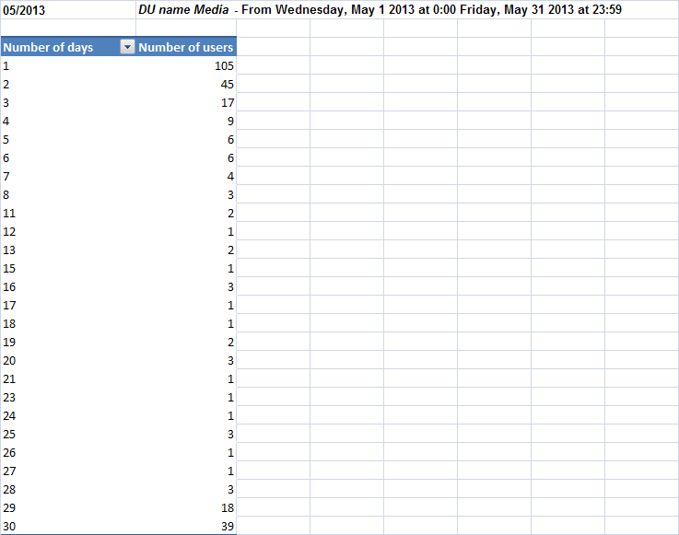

In order to build these statistics, the process (XSL transformation) might be as follows:

1. Get the users and the number of days they came. Create a XLST that uses as input the “Per number of days” XML file (see section “5.1.7.7 Per number of days raw statistics”, page 159).

The statistics relate only on “all products” (high level *products* element) of the criteria configuration file). We don’ need to compute them for each product. The Perl script involved is *transform.pl*. By default if there is no input file attribute in the *xslt* element (*logXsltConfig* element), the input files are the awstats statistics files. In the case of “users per day” report, it shall be the “Per number of days” XML file. The Perl script *transform.pl* has to be adapted.

The XSLT must count the number of users per number of days. E.g. (theoretical):

<users>  
 <user numDays="2">User A</user>  
 <user numDays="2">User B</user>  
 <user numDays="1">User C</user>  
 <user numDays="9">User F</user>  
 <user numDays="21">User M</user>  
 <user numDays="9">User T</user>  
</users>

1. Create a XLST that uses the previous XLST output and count the numbers of users per numbers of days and add missing number of days with value 0

<users>  
 <user numDays="1">1</user>  
 <user numDays="2">2</user>  
 <user numDays="3">0</user>  
 <user numDays="4">0</user>  
…  
 <user numDays="8">0</user>  
 <user numDays="9">2</user>  
 <user numDays="10">0</user>  
…  
 <user numDays="20">0</user>  
 <user numDays="21">1</user>  
 <user numDays="22">0</user>  
…  
</users>

The example above means:

* 1 user came 1 day
* 2 users came 2 days
* 0 users came 3 days
* ...
* 0 user came 8 days
* 2 users came 9 days
* 0 user came 10 days
* ...
* 0 user came 20 days
* 1 user came 21 days
* 0 user came 22 days
* ...

##### Dissemination Unit mixed up statistics by media

The reports of this section are same as those in section “5.1.7.11.2 Dissemination Unit statistics by media”, page 173, but they apply to all DU mixed up by media (virtual DU “AllDU”).

##### Dissemination Unit statistics for all media mixed up

The following reports are built for each DU statistics for all media mixed up (regardless the media).

Note: The XLST of this section MUST NOT be included in the *xslt* element (the parent element is *logXsltConfig* element) of the criteria configuration. They MUST be included in *preMerge* element of the merging statistics configuration file and this configuration file is automatically generated;the *buildMergeConf* of the *mergeMyOceanXml.pl* Perl script has to be adapted (see section “5.1.7.8 Merging statistics into a single Excel file”, page 162).

###### Merge products and users

The **indexUsersProducts.xslt**, **distinctIndexProducts.xslt**, **mergeUsersPrepare.xslt** and **mergeUsers.xslt** XSLTs produce this merge.

The above XLSTs already exist (they are used for Aviso project).

The inputs are the outputs of each **logsUsersPrepare.xslt** (see section “5.1.7.6 The “raw” XSL transformation”, page 156).

Example: (GLO-CLS-TOULOUSE-FR is the Dissemination Unit name)

|  |
| --- |
| <!-- Build and merge products/users for all media -->  <preMerge name="indexUsers" description="index products/users GLO-CLS-TOULOUSE-FR">  <xslt>/data2/atoll/awstats/logs/xslt/indexUsersProducts.xslt</xslt>  <input>/data2/atoll/awstats/logs/tmp/logsFtpGLO-CLS-TOULOUSE-FRUsersPrepare%YYYY-0%MM-0.xml</input>  <input>/data2/atoll/awstats/logs/tmp/logsWmsGLO-CLS-TOULOUSE-FRUsersPrepare%YYYY-0%MM-0.xml</input>  <input>/data2/atoll/awstats/logs/tmp/logsMotuGLO-CLS-TOULOUSE-FRUsersPrepare%YYYY-0%MM-0.xml</input>  <output>/data2/atoll/awstats/logs/tmp/indexGLO-CLS-TOULOUSE-FRUsersPrepare%YYYY-0%MM-0.xml</output> </preMerge>  <!-- build products/users index (distinct products, no duplicated produts) --> <preMerge name="indexDistinct" description="index distinct products GLO-CLS-TOULOUSE-FR">  <xslt input="/data2/atoll/awstats/logs/tmp/indexGLO-CLS-TOULOUSE-FRUsersPrepare%YYYY-0%MM-0.xml">/data2/atoll/awstats/logs/xslt/distinctIndexProducts.xslt</xslt>  <output>/data2/atoll/awstats/logs/tmp/indexDistinctGLO-CLS-TOULOUSE-FRUsersPrepare%YYYY-0%MM-0.xml</output> </preMerge>  <!-- prepare merge of users, organizations and countries --> <preMerge name="mergeUserPrepare" description="prepare merge all media GLO-CLS-TOULOUSE-FR">  <xslt input="/data2/atoll/awstats/logs/tmp/indexDistinctGLO-CLS-TOULOUSE-FRUsersPrepare%YYYY-0%MM-0.xml">/data2/atoll/awstats/logs/xslt/mergeUsersPrepare.xslt</xslt>  <output>/data2/atoll/awstats/logs/tmp/mergeGLO-CLS-TOULOUSE-FRUsersPrepare%YYYY-0%MM-0.xml</output> </preMerge>  <!-- merge (sum) of users, organisations and countries --> <preMerge name="mergeUser" description="merge all medias GLO-CLS-TOULOUSE-FR">  <xslt input="/data2/atoll/awstats/logs/tmp/mergeGLO-CLS-TOULOUSE-FRUsersPrepare%YYYY-0%MM-0.xml">/data2/atoll/awstats/logs/xslt/**mergeUsers.xslt**</xslt>  <output>/data2/atoll/awstats/logs/tmp/mergeGLO-CLS-TOULOUSE-FRUsers%YYYY-0%MM-0.xml</output> </preMerge> |

The XML schema of the **mergeUsers.xslt** ouput is same as **logsUsersPrepare.xslt** ouput (see section “Report “number of users per number of products they have taken””, page 175).

Warning: a specific merge has to be processed for the report “users per day” (see “Report “users per day””, page 187): merge the “Per number of days” XML files (see section “5.1.7.7 Per number of days raw statistics”, page 159).

###### Build and finalize reports

The reports are similar to those described in section “5.1.7.11.2 Dissemination Unit statistics by media”, page 173.

The same XLST have to be integrated in *preMerge* elements.

Example: (GLO-CLS-TOULOUSE-FR is the Dissemination Unit name)

|  |
| --- |
| <!-- Build xml Excel - Statistics by user - All media --> <preMerge name="sumUser" description="Statistics sum - GLO-CLS-TOULOUSE-FR by user">  <xslt options="--stringparam titre 'GLO-CLS-TOULOUSE-FR Total Users' --stringparam tabColorIndex '40'" input="/data2/atoll/awstats/logs/tmp/mergeGLO-CLS-TOULOUSE-FRUsers%YYYY-0%MM-0.xml">/data2/atoll/awstats/logs/xslt/logsUsers.xslt</xslt>  <output>/data2/atoll/awstats/logs/tmp/sumGLO-CLS-TOULOUSE-FRUsers%YYYY-0%MM-0.xls</output> </preMerge>  <!-- Build xml Excel - Statistics by organization - All media --> <preMerge name="sumUser" description="Somme des statistiques GLO-CLS-TOULOUSE-FR by organization">  <xslt options="--stringparam titre 'GLO-CLS-TOULOUSE-FR Total Organizations' --stringparam tabColorIndex '40'" input="/data2/atoll/awstats/logs/tmp/mergeGLO-CLS-TOULOUSE-FRUsers%YYYY-0%MM-0.xml">/data2/atoll/awstats/logs/xslt/logsOrganisations.xslt</xslt>  <output>/data2/atoll/awstats/logs/tmp/sumGLO-CLS-TOULOUSE-FROrgs%YYYY-0%MM-0.xls</output> </preMerge>  <!-- Build xml Excel - Statistics by country - All media --> <preMerge name="sumOrg" description="Statistics sum GLO-CLS-TOULOUSE-FR by country">  <xslt options="--stringparam titre 'GLO-CLS-TOULOUSE-FR Total Pays' --stringparam tabColorIndex '40'" input="/data2/atoll/awstats/logs/tmp/mergeGLO-CLS-TOULOUSE-FRUsers%YYYY-0%MM-0.xml">/data2/atoll/awstats/logs/xslt/logsCountries.xslt</xslt>  <output>/data2/atoll/awstats/logs/tmp/sumGLO-CLS-TOULOUSE-FRCountries%YYYY-0%MM-0.xls</output> </preMerge>  <!-- Build xml Excel - Statistics by login (VSFTPD only) - All media --> <preMerge name="sumLogin" description="Statistics sum GLO-CLS-TOULOUSE-FR by login">  <xslt options="--stringparam titre 'GLO-CLS-TOULOUSE-FR Total Login' --stringparam tabColorIndex '40'" input="/data2/atoll/awstats/logs/tmp/mergeGLO-CLS-TOULOUSE-FRUsers%YYYY-0%MM-0.xml">/data2/atoll/awstats/logs/xslt/logsLogins.xslt</xslt>  <output>/data2/atoll/awstats/logs/tmp/sumGLO-CLS-TOULOUSE-FRLogins%YYYY-0%MM-0.xls</output> </preMerge>   <preMerge name="indexProduct" description="index products - GLO-CLS-TOULOUSE-FR">  <xslt input="/data2/atoll/awstats/logs/xml/logProductGLO-CLS-TOULOUSE-FRFtpConfig.xml">/data2/atoll/awstats/logs/xslt/logsIndexProducts.xslt</xslt>  <output>/data2/atoll/awstats/logs/tmp/logsGLO-CLS-TOULOUSE-FRIndexProducts%YYYY-0%MM-0.xml</output> </preMerge>  <preMerge name="countStatsProduct" description="count statistics by product (all media) - GLO-CLS-TOULOUSE-FR">  <xslt options="--stringparam statsfile '/data2/atoll/awstats/logs/tmp/mergeGLO-CLS-TOULOUSE-FRUsers%YYYY-0%MM-0.xml'" input="/data2/atoll/awstats/logs/tmp/logsGLO-CLS-TOULOUSE-FRIndexProducts%YYYY-0%MM-0.xml">/data2/atoll/awstats/logs/xslt/logsAllProductsCount.xslt</xslt>  <output>/data2/atoll/awstats/logs/tmp/logsGLO-CLS-TOULOUSE-FRAllProductsCount%YYYY-0%MM-0.xml</output> </preMerge>  <preMerge name="allStatsGLO-CLS-TOULOUSE-FRProducts" description="Statisitics all media - GLO-CLS-TOULOUSE-FR">  <xslt options="--stringparam titre 'GLO-CLS-TOULOUSE-FR Total Products'" input="/data2/atoll/awstats/logs/tmp/logsGLO-CLS-TOULOUSE-FRAllProductsCount%YYYY-0%MM-0.xml">/data2/atoll/awstats/logs/xslt/logsAllProducts.xslt</xslt>  <output>/data2/atoll/awstats/logs/tmp/sumGLO-CLS-TOULOUSE-FRProducts%YYYY-0%MM-0.xls</output> </preMerge>  Add here *preMerge* for the other reports |

The **logsIndexProducts.xslt**, **logsAllProductsCount.xslt** and **logsAllProducts.xslt** XSLTs above already exist (they are used for Aviso project).

###### Add the XML Excel Sheet into the final reports

The “all media” statistics have to be included in the final Excel Workbook. Add them into the ***merge*** element:

##### Dissemination Unit mixed up statistics for all media mixed up

The reports of this section are same as those in section “5.1.7.11.4 Dissemination Unit statistics for all media mixed up”, page 194, but they apply to all DU mixed up by media (virtual DU “AllDU”).

#### CIS Transaction accounting physical view

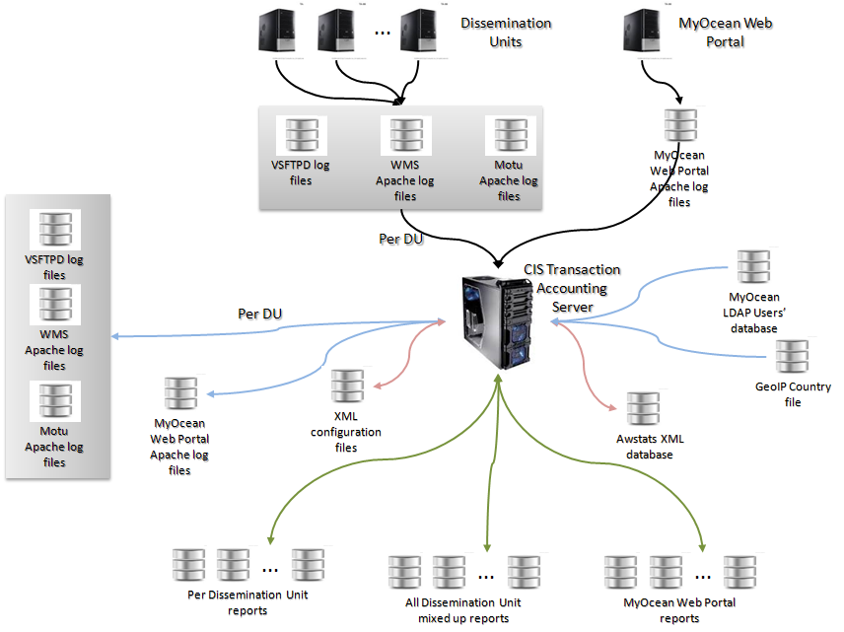

Figure 45 - CIS Transaction accounting physical architecture

#### Interfaces

Table

|  |  |  |  |  |
| --- | --- | --- | --- | --- |
| Name | Description | Interface provided / use an external interface | Format | Protocol |
| EI_MIS_TA_MONITORING<APACHE> | Transaction monitoring interface at CIS that retrieve **Apache** logs. | External |  |  |
| EI_MIS_TA_MONITORING<VSFTPD> | Transaction monitoring interface at CIS that retrieve **VSFTPD** logs. | External |  |  |
| EI_MIS_TA_REPORTS | This interface is used by Service Desk or Service Managers to have access to the reports. | Provided |  |  |

Figure

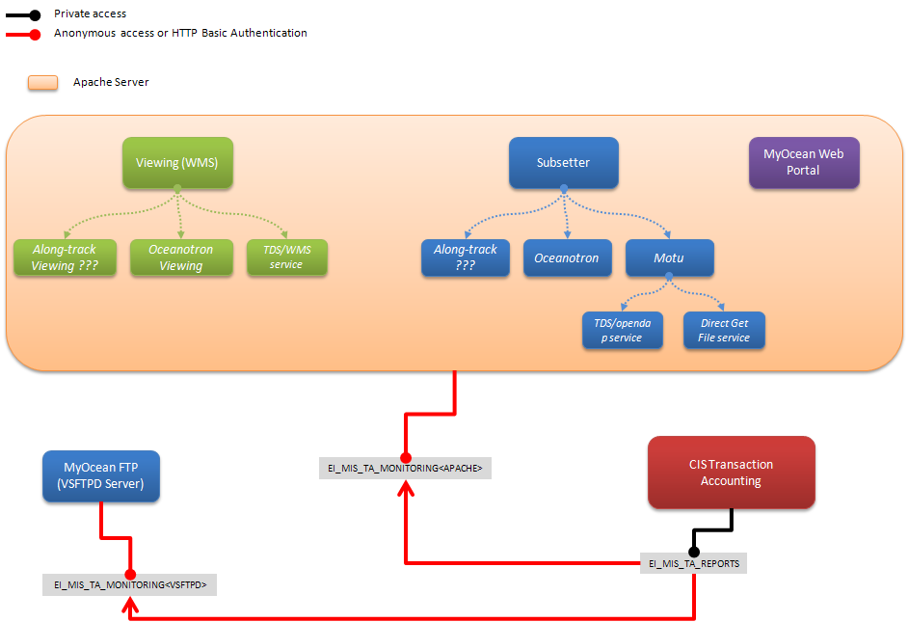

Figure 46 – CIS Transaction Accounting interfaces diagram

Detailed description of interfaces

##### EI_MIS_TA_MONITORING<APACHE>

This interface allows retrieving Apache logs files from a remote HTTP server.

The HTTP access is either anonymous or HTTP Basic Authentication

See also the EI_DISS_GW_TA_MONITORING<APACHE> in the [DA 7] document.

The input is the “The log configuration file (C)”, see page 140.

The output is the retrieved Apache logs file

##### EI_MIS_TA_MONITORING<VSFTPD>

This interface allows retrieving VSFTPD logs files from a remote HTTP server.

See also the EI_DISS_GW_TA_MONITORING<VSFTPD> in the [DA 7] document.

The input is the “The log configuration file (C)”, see page 140.

The output is the retrieved VSFTPD logs file.

##### EI_MIS_TA_REPORTS

This interface allows building final statistical reports and sends them to the final recipients (Service Desk, Dissemination Unit manager…).

The inputs are the retrieved logs file and the configuration files (see section “The configuration files”, page139.

The outputs are the reports described in section section: “5.1.7.11 Statistics reports in detail” page 171.

#### (UC) Log Users requests done on the CIS

Identification

(UC) Log Users requests done on the CIS

Description

This use case describes the gathering of requests done on the CIS.

Preconditions

A request occurs on the CIS: Subsetters (Motu, ...), VSFTPD, MyOcean WebPortal.

Inputs

|  |  |
| --- | --- |
| Variables | Mandatory / Optional |
|  |  |

Post conditions

Logs are made up on the appropriate server: Subsetters (Motu, ...), VSFTPD, MyOcean Web Portal.

Outputs

|  |  |
| --- | --- |
| Variables | Mandatory / Optional |
|  |  |

Normal flow

The recorded requests come from:

* the Web Portal
* the Download Transaction (Motu, VSFTPD download,...)
* the View Transaction (WMS)

Download transaction logs and View transaction logs are collected from the Dissemination Units. Other logs are collected from the CIS.

The logs files are copied from the CIS and from each Dissemination Unit to the CIS Transaction Accounting Server. The protocol is HTTP. Theses copies (local) are then the inputs of the CIS Transaction Accounting.

Alternative flows

Precise description of alternative flows (if relevant)

Exceptions

Any processing error must be notified and sent by email to the administrator in order to inform him about the problem

#### (UC) Compute raw statistics data

Identification

(UC) Compute raw statistics data

Description

This use case describes the creation of raw statistics from requests logs, according to the following topics

* Web Portal
* Download Transaction
* View Transaction

The criteria configuration files (inputs of the process) are generated automatically

Preconditions

To provide raw statistics data based on MyOcean Products, the MyOcean Catalogue should be used initially. In MyOcean V4, an export of the Product Specification File (EPST) is used instead.

Inputs

|  |  |
| --- | --- |
| Variables | Mandatory / Optional |
|  |  |

Post conditions

The logs are processed to provide raw statistics data as an XML Awstats database.

Outputs

|  |  |
| --- | --- |
| Variables | Mandatory / Optional |
|  |  |

Normal flow

The logs data will be summarised to provide statistical data, such as:

- Number of visits, and number of unique visitors (anonymous visitors and authenticated users),

- Visits duration and last visits,

- Authenticated users, and last visits,

- Days of week and rush hours,

- Countries of visitors/users,

- Most viewed pages, specific viewed pages (e.g, FAQ, News Flash ...)

- Keyphrases and keywords used to access the CIS,

- Errors (Page Not Found ...),

- Amount of downloaded data,

Regarding to the Download Transaction and the View Transaction activities, the statistical data will be derived according to the products catalogue structure and content. This means statistical data will be provided for

- all products (global statistics)

- each product (statistics on each product)

- each dataset (statistics on each dataset belonging to a product)

This monitoring depends on the products’ Catalogue. Changing the contents of the Catalogue will result in a change in statistical analysis.

The system should allow recalculating statistical data of previous months in order to obtain a consistent analysis on a calendar year.

The raw statistics data should be stored as widely used (standard) format (e.g. xml).

The range date of raw statistics data should be monthly: from the first day of the month to the last day of the month].

As raw logs, all raw statistics must be backed-up during at least a calendar year (sliding backup). Raw statistics older than one year could be deleted.

Alternative flows

Precise description of alternative flows (if relevant)

Exceptions

Any processing error must be notified and sent by email to the administrator in order to inform him about the problem.

#### (UC) Build statistical/analysis reports

Identification

(UC) Build predefined statistical/analysis reports from raw statistics data

Description

This use case describes the creation of statistical/analysis reports from raw statistics data, according to the reports described in the previous section: “5.1.7.11 Statistics reports in detail” page 171.

Preconditions

The raw statistics data have been computed.

Inputs

|  |  |
| --- | --- |
| Variables | Mandatory / Optional |
|  |  |

Post conditions

The final statistical/analysis’ reports are:

- stored in the system,

- sent by email from a predefined list to the Service Desk, Service Manager

Outputs

|  |  |
| --- | --- |
| Variables | Mandatory / Optional |
|  |  |

Normal flow

The analysis shall enable to report information described in section: “5.1.7.11 Statistics reports in detail” page 171.

Alternative flows

Precise description of alternative flows (if relevant)

Exceptions

Any processing error must be notified and sent by email to the administrator in order to inform him about the problem.

#### (UC) Visualize statistical/analysis reports (TODO)

Identification

(UC) Visualize statistical/analysis reports

Description

Preconditions

List of preconditions (is atoll IS up, LDAP well configured, etc…)

Inputs

|  |  |
| --- | --- |
| Variables | Mandatory / Optional |
|  |  |

Post conditions

List of post conditions

Outputs

|  |  |
| --- | --- |
| Variables | Mandatory / Optional |
|  |  |

Normal flow

Precise description of the flow

Alternative flows

Precise description of alternative flows (if relevant)

Exceptions

Exception cases (loss of network, time out, etc…)

### Production and System monitoring configuration

The Production and System monitoring configuration component goal is to deliver to the System and Production Monitoring tool a configuration file built on Catalogue data. If an entry of the Catalogue changes, the component shall deliver an up-to date configuration to avoid manual errors.

#### Software used

Table

|  |  |  |  |  |
| --- | --- | --- | --- | --- |
| **Components** | **label** | **operator** | **support** | **Developer / maintainer** |
| ? | ? | ? | ? | ? |

Description

#### Interfaces

#### Interfaces

Table

|  |  |  |  |  |
| --- | --- | --- | --- | --- |
| Name | Description | Interface provided / use an external interface | Format | Protocol |
| II_MIS_CONF_SYS_MONITORING | Interface that provides monitoring configuration files. | Provided |  |  |

Figure

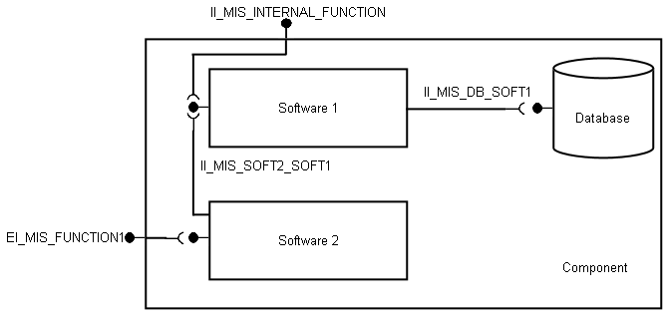

Figure 47 – Example

Detailed description of interfaces

##### II_MIS_CONF_SYS_MONITORING: configuration of the system monitoring engine

###### Scope

This interface gives access to configuration files which are ready to use for the any NAGIOS monitoring engine having internet connection, wherever it is operated.

The configuration provided enables to monitor the availability and performance of the access services provided by Dissemination Unit and the central services provided by MIS and Web Portal.

###### Maturity

The interface is basic as the configuration is accessed as a whole.

###### Protocol

The configuration files can be accessed through HTTP protocol.

#### (UC) Export monitoring configuration

Identification

(UC) Export monitoring configuration

Description

Preconditions

List of preconditions (is atoll IS up, LDAP well configured, etc…)

Inputs

|  |  |
| --- | --- |
| Variables | Mandatory / Optional |
|  |  |

Post conditions

List of post conditions

Outputs

|  |  |
| --- | --- |
| Variables | Mandatory / Optional |
|  |  |

Normal flow

Precise description of the flow

Alternative flows

Precise description of alternative flows (if relevant)

Exceptions

Exception cases (loss of network, time out, etc…)

### System and Production Monitoring

The system monitoring goal is to monitor dissemination units and CIS sub-system health (availability and performances).

The production monitoring shall be able to compute the availability and timeliness of datasets.

It shall also store the results of the measurements so that Service Level Agreement and Operational Level Agreement can be checked. Alerts must be sent when a component status has changed.

Dashboards shall display the results of the monitoring.

#### Software used

Table

|  |  |  |  |  |
| --- | --- | --- | --- | --- |
| **Components** | **label** | **operator** | **support** | **Developer / maintainer** |
| NAGIOS | Monitoring engine / sub-system availability database | CLS | CLS | CLS |

Description

##### Monitoring with Nagios

Nagios documentation is available online at: <http://labs.nagios.com/>

###### Functions provided, requirements

The Nagios component is available on the shelf, available with open source license.

It enables to test on a real time basis (every 30 minutes) the central services operated by MIS and the access services operated by the Dissemination Units.

The tests are doing real requests depending on services: MOTU, OPeNDAP, FTP/NetCDF, Web pages and returns status which are among OK, Warning, Failure, Unknown.

The results can be displayed in real time dashboards in a web browser.

The results are archived with references to the access services id and product specification id which are tested.

###### Architecture context

The monitoring engine uses the monitoring engine configuration provider to be configured.

The monitoring engine host must use the time synchronization interface so that the monitoring results done by distributed monitoring engine are synchronized.

The monitoring engine used the configuration of the system monitoring engine to be automatically configured.

The monitoring engine provides email alerts, on-line dashboard and availability and performance archive for the monitored services.

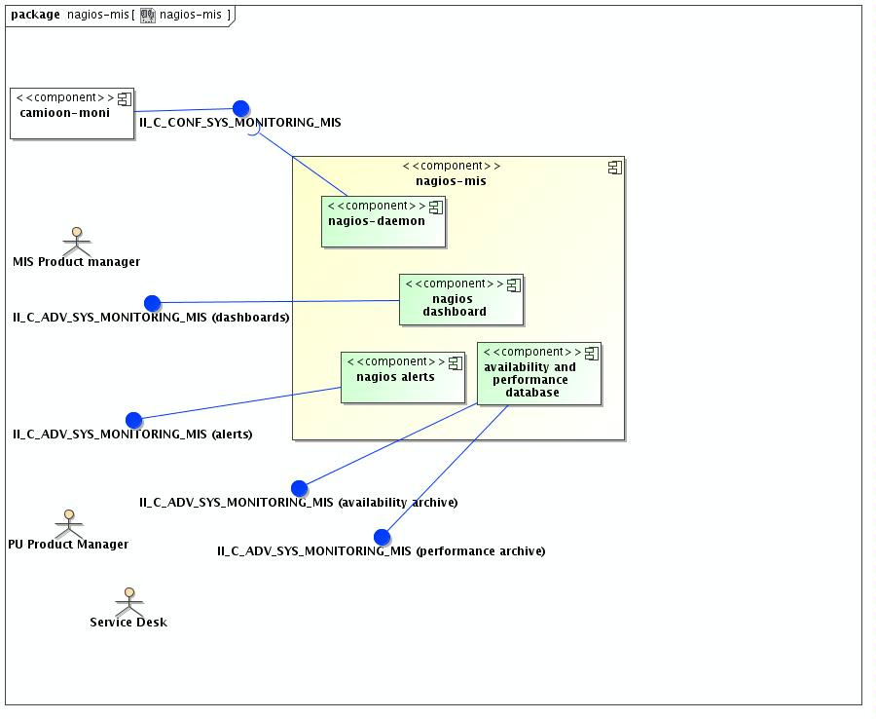

Figure 48: NAGIOS architecture context

###### Software

The software used as monitoring engine is NAGIOS 3.X

Specific plugins are developed in Python to test the access services (OPeNDAP, FTP, MOTU …).

###### Software Infrastructure required

Apache 2 server with PHP module (for dashboard).

Python interpreter (for the MyOcean specific test plugin)

Perl interpreter (for NAGIOS native tests)

Mail command for alerts.

OS Linux (the monitoring engine runs as a daemon on the system).

#### Interfaces

Table

|  |  |  |  |  |
| --- | --- | --- | --- | --- |
| Name | Description | Interface provided / use an external interface | Format | Protocol |
| EI_MIS_PROD_MONITORING | Production monitoring interface used to measure datasets availability and timeliness. | External |  |  |
| EI_MIS_PROD_MONITORING_GUI | This interface is used by Service Desk or Service Managers to access the reports. | Provided |  |  |
| II_MIS_CONF_SYS_MONITORING | Interface that provides monitoring configuration files. | external |  |  |
| EI_MIS_SYSTEM_MONITORING | System monitoring interface used to measure CIS sub systems and dissemination units availability. | External |  |  |
| EI_MIS_SYSTEM_MONITORING_GUI | This interface is used by Service Desk or Service Managers to access the reports. | Provided |  |  |

Figure



Figure 49 – Example

Detailed description of interfaces

##### II_C_ADV_SYS_MONITORING_MIS (alerts) : system monitoring alerts

###### Scope

When the status of an access service or a central service changes (from OK to failure or from failure to OK) an alert is send to the operator of the service and to support managers.

###### Maturity

The interface is basic as the alerts are sent as-is to the operator or support manager.

###### Protocol

The protocol used for sending alerts is a mail protocol which is SMTP.

###### Operations

The only operation allowed is “receive an alert (email)”.

The email has roughly the format given below.

It tells which product and with access services is monitored.

|  |
| --- |
| ***** Nagios *****  Notification Type: PROBLEM  Service: mercatorPsy3v1R1v_ind_mean_best_estimate  Host: OPENDAP.MERCATOR-OCEAN.FR  Address: 80.245.34.1  State: CRITICAL  Date/Time: Thu Apr 16 00:06:21 CEST 2009  Additional Info:  Critical: Unable to open dataset. |

##### II_C_ADV_SYS_MONITORING_MIS (dashboard): system monitoring dashboards

###### Scope

The system monitoring dashboard is a web graphical interface: EyesOfNetwork

EyesOfNetwork (“EON”) is the Open Source solution combining a pragmatic usage of ITIL processes and a technological interface allowing their workaday application. EyesOfNetwork Supervision is the first brick of a range of products targeting to assist IT management and governance. EyesOfNetwork Supervision provides event management, availability, problems and capacity

###### Maturity

We are using EyesOfNetwork V3 for global monitoring on CLS servers. It is a tool we are used to, and we know the tools it can provide.

###### Protocol

The “bundle” EyesOfNetwork is composed of a minimalist operating system including an integrated set of applications that meet the different requirement for complete IT monitoring:

GED (Generic Event Dispatcher) : Event handler secured and multi-sites,

NAGIOS : managing incidents and problems,

THRUK : multi backend monitoring web interface,

NAGVIS : customizable mapping of the availability,

NAGIOSBP : management of the application criticality,

CACTI : Performance Management,

WEATHERMAP : Mapping bandwidth,

BACKUP MANAGER : Online tool backup of the solution,

EONWEB : Unified Web interface of the solution,

EZGRAPH : Framework used for graphical rendering,

SNMPTT : SNMP traps translation,

GLPI / OCS / FUSION: Asset management and inventory.

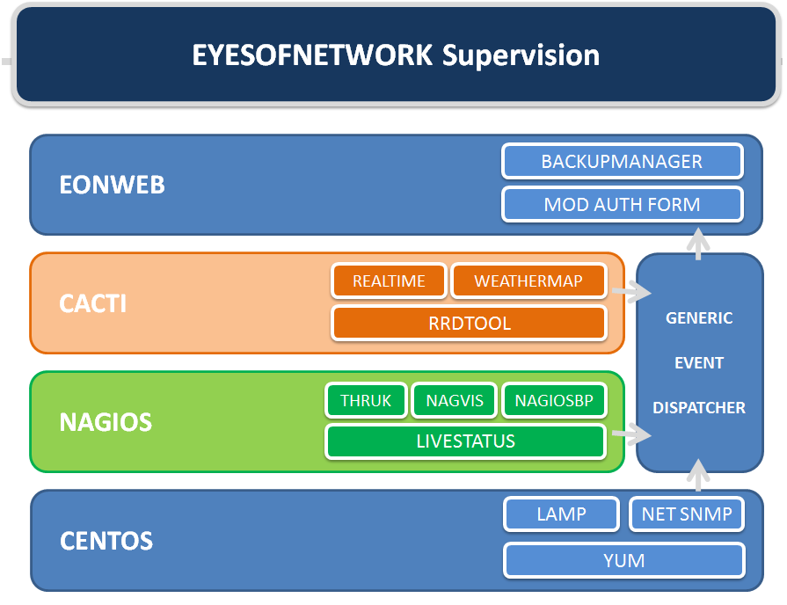

Figure 50: EyesOfNetwork architecture

###### Operations

This interface provides an overview of the system, details of the system, graphics, and some administration tasks.

Get all information from the official website: <http://www.eyesofnetwork.com/>

##### II_C_ADV_SYS_MONITORING_MIS (availability): availability status archive TBD

###### Scope

Nagios data are stored in a MySQL database. The data archives are available for reporting.

###### Maturity

TBD

###### Protocol

TBD

###### Operations

TBD

##### II_C_ADV_SYS_MONITORING_MIS (performance): performance status archive TBD

###### Scope

The performance monitoring is ensured by a EyesOfNetwork component: CACTI.

This component gives graphical views on the monitored system about performance.

###### Maturity

TBD

###### Protocol

Cacti is made with php/mySQL technologies.

It can get information from any script or external command.

###### Operations

TBD

##### II_C_BASIC_PUSH_MONITORING_<DU> TBD

Generic dataset inventory (provided by MIS gateway) TBD

##### II_C_BASIC_PUSH_MONITORING_INSITU_<DU> TBD

Different than not in-situ products.

#### (UC) Monitor CIS sub systems

Identification

(UC) Monitor CIS sub systems

Description

Preconditions

List of preconditions (is atoll IS up, LDAP well configured, etc…)

Inputs

|  |  |
| --- | --- |
| Variables | Mandatory / Optional |
|  |  |

Post conditions

List of post conditions

Outputs

|  |  |
| --- | --- |
| Variables | Mandatory / Optional |
|  |  |

Normal flow

Precise description of the flow

Alternative flows

Precise description of alternative flows (if relevant)

Exceptions

Exception cases (loss of network, time out, etc…)

#### (UC) Record dissemination units availability and performance

Identification

(UC) Record dissemination units availability and performance

Description

Preconditions

List of preconditions (is atoll IS up, LDAP well configured, etc…)

Inputs

|  |  |
| --- | --- |
| Variables | Mandatory / Optional |
|  |  |

Post conditions

List of post conditions

Outputs

|  |  |
| --- | --- |
| Variables | Mandatory / Optional |
|  |  |

Normal flow

Precise description of the flow

Alternative flows

Precise description of alternative flows (if relevant)

Exceptions

Exception cases (loss of network, time out, etc…)

#### (UC) Compute availability and timeliness

Identification

(UC) Compute availability and timeliness

Description

Preconditions

List of preconditions (is atoll IS up, LDAP well configured, etc…)

Inputs

|  |  |
| --- | --- |
| Variables | Mandatory / Optional |
|  |  |

Post conditions

List of post conditions

Outputs

|  |  |
| --- | --- |
| Variables | Mandatory / Optional |
|  |  |

Normal flow

Precise description of the flow

Alternative flows

Precise description of alternative flows (if relevant)

Exceptions

Exception cases (loss of network, time out, etc…)

#### (UC) Record dataset availability

Identification

(UC) Record dataset availability

Description

Preconditions

List of preconditions (is atoll IS up, LDAP well configured, etc…)

Inputs

|  |  |
| --- | --- |
| Variables | Mandatory / Optional |
|  |  |

Post conditions

List of post conditions

Outputs

|  |  |
| --- | --- |
| Variables | Mandatory / Optional |
|  |  |

Normal flow

Precise description of the flow

Alternative flows

Precise description of alternative flows (if relevant)

Exceptions

Exception cases (loss of network, time out, etc…)

#### (UC) Visualize production monitoring dashboard

Identification

(UC) Visualize production monitoring dashboard

Description

Preconditions

List of preconditions (is atoll IS up, LDAP well configured, etc…)

Inputs

|  |  |
| --- | --- |
| Variables | Mandatory / Optional |
|  |  |

Post conditions

List of post conditions

Outputs

|  |  |
| --- | --- |
| Variables | Mandatory / Optional |
|  |  |

Normal flow

Precise description of the flow

Alternative flows

Precise description of alternative flows (if relevant)

Exceptions

Exception cases (loss of network, time out, etc…)

## Deployment architecture

### Introduction

The MIS architecture is distributed at different locations which are:

* Core MIS: Monitoring, user administration, metadata and centralized identification system. The Coremis itself is made of several components.
* Dissemination Units: These are independent units installed on each product centre that want to include their data in the MyOcean catalogue. This part will not be developed in this document as a specific document will be written to describe the dissemination gateways.

The Dissemination Units operates MIS software so that the topology of the architecture avoids a central bottle neck at MIS for circulation of voluminous ocean data.

This architecture topology eases the scalability of the MyOcean system in case of an increase of Dissemination Unit number and dataset volumes.

The core MIS is distributed in 2 locations which are CLS/CNES at Toulouse, France and IFREMER at Brest, France.

* MIS-CLS is in charge of operation coordination and management of reference services (authentication…) and monitoring consolidation (production, transaction …).
* MIS-IFREMER is in charge of the management of the metadata of product and access services. (GEONETWORK)

The distribution of activities has been driven by expertise of the teams to ease the deployment and maintenance of the used software. Basically, the central facilities are operated where the related software has been developed.

The distribution of the MIS is a strength for the system as, in the future, the more mature components and the most strategic (authentication, system monitoring, catalogue…) ones could be redundant to increase the reliability of the provided service.

### Overview

MyOcean V4 will be fully hosted and managed at CLS. The full redundancy is ensured by the CNES servers. These systems shall ensure 365/24/7 availability and physical or logical break monitoring and fixing.

### Development, testing and integration

Three live hosting environments are used:

A medium specification server used for live development and testing

A high specification server for preproduction validation.

A high specification server for the live web portal.

Modules and other code will be developed on an offline desktop machine then deployed to the TEST environment (or QT) for testing. When a candidate new release of the web portal is ready, code on the development server will be transferred in the pre-operational environment (or QO) and frozen for testing. Then the new version will be transferred to the production server once tested.



Figure 51: Environments description

#### TEST environment (QT) overview

The test environment is simpler than the pre production and production environments. It will be opened to the external users so the tests can be run out of CLS. However, the redundancy is less important than for other environments.

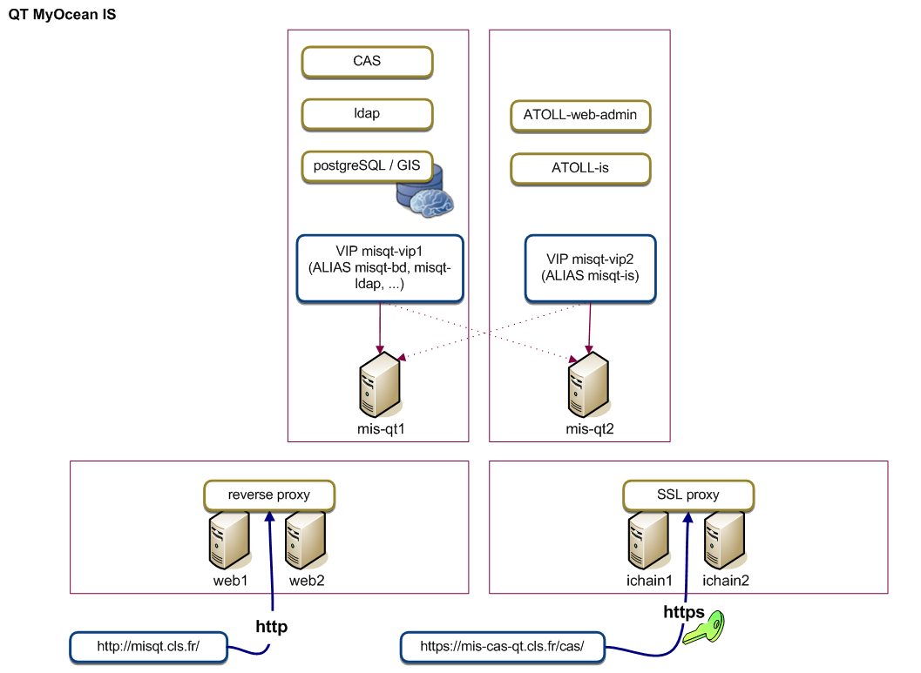

Figure 52: MyOcean QT environment

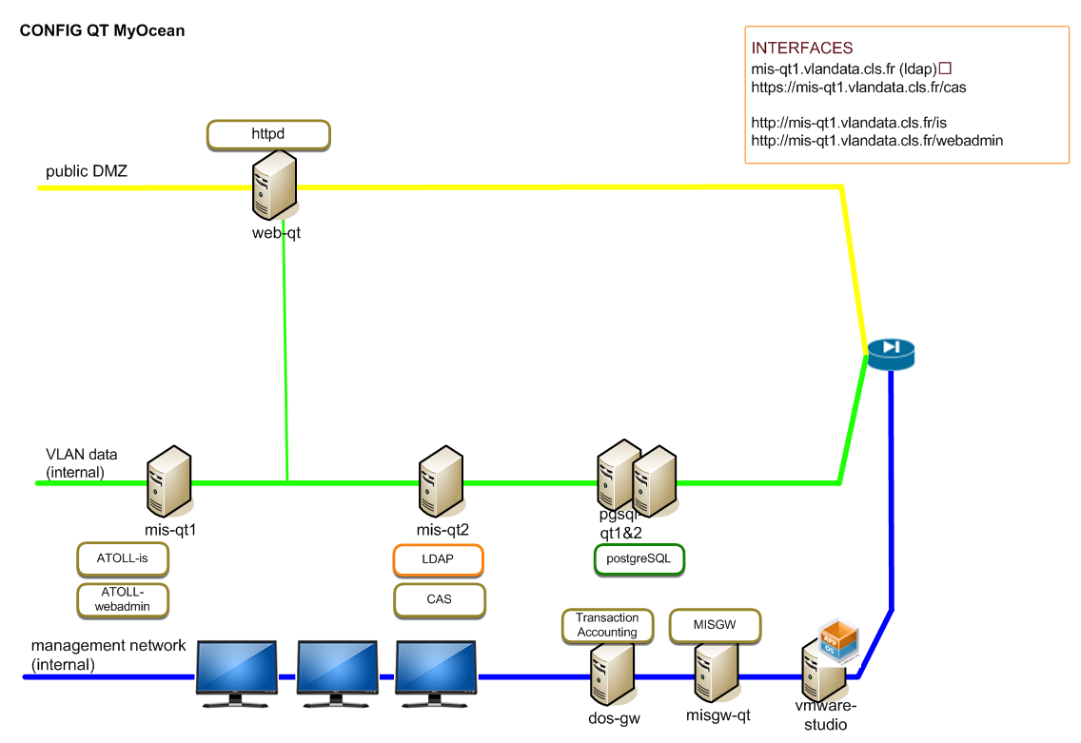

Figure 53: MyOcean QT Network

#### PRE-OPER environment (QO) overview

This pre-operational environment aims to be a reference environment for operational testing. It has to be the replica of the production environment in order to check every technical issue that could happen. As MyOcean is a distributed application, issues can come from multiple sources such as servers, communication between components, authorizations etc.

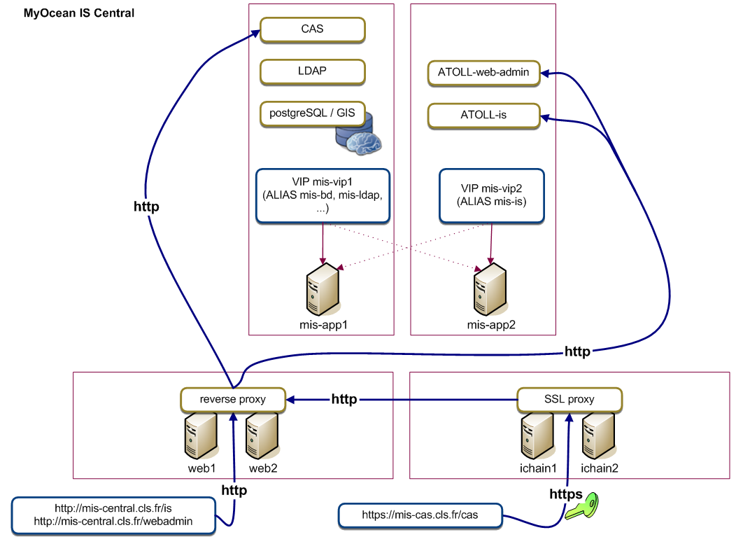

Figure 54: MyOcean QO environment

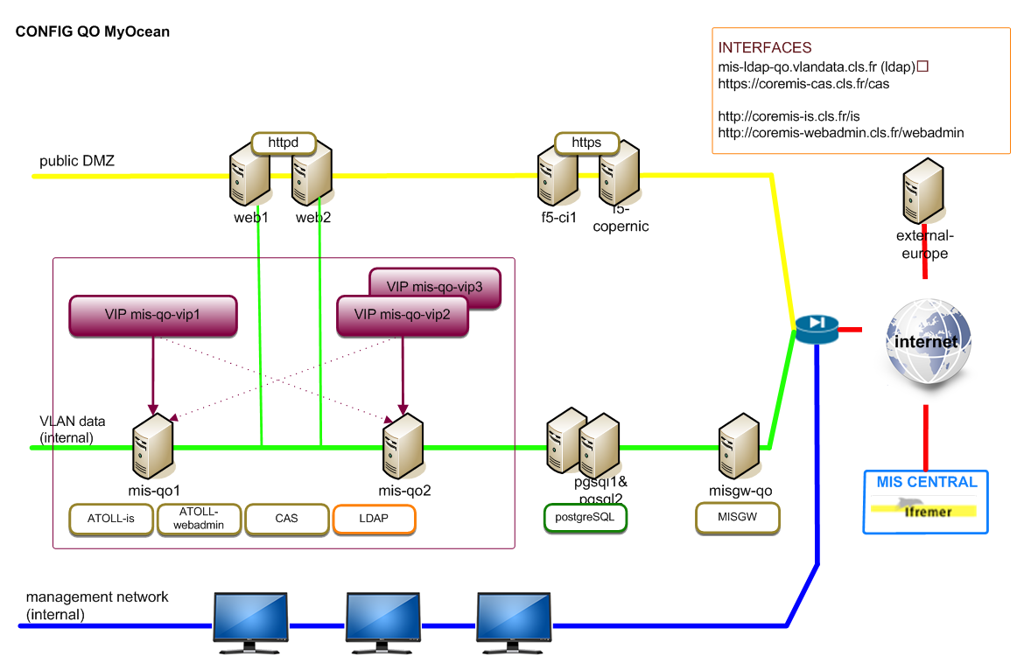

Figure 55: MyOcean QO Network

#### Production environment overview

The production environment is similar to the PRE-OPER environment. Every component is duplicated on the CNES servers.

In the following schema you can see CLS servers (1) and CNES servers (2). Even the dissemination units are duplicated.

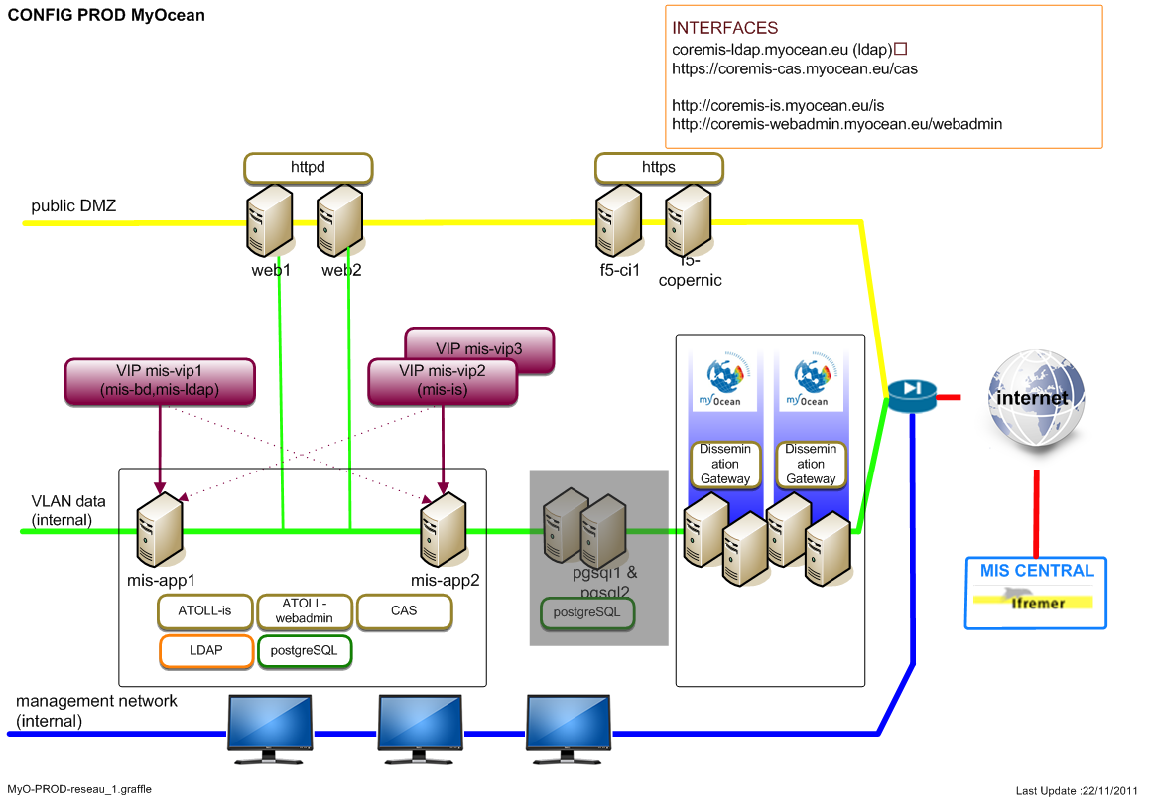

Figure 56: MyOcean production Network

### Physical architecture deployed at IFREMER

At Ifremer the Information Technology infrastructure is managed with the ITIL practices for several years and is now achieving the ISO 20000 certification (on-going procedure).

Thanks to that, the reliability and security of the service is now achieved thanks to redundant infrastructures (power supply, clusters) and distributed facility (archives) and will be later enhanced with Business Continuity and Disaster Recovery Planning.

#### Component List

GEONETWORK

GEONETWORK-RO

NAGIOS-CIS-IFR

#### Details of implementation

The Ifremer infrastructure is composed with the following nodes:

Reverse proxy (apache) and internet connection

Tomcat server

Batch system

PostgreSQL RDBMS server

Monitoring engine server.

In addition, to that, an email server may be used by the monitoring engine component to send alerts.

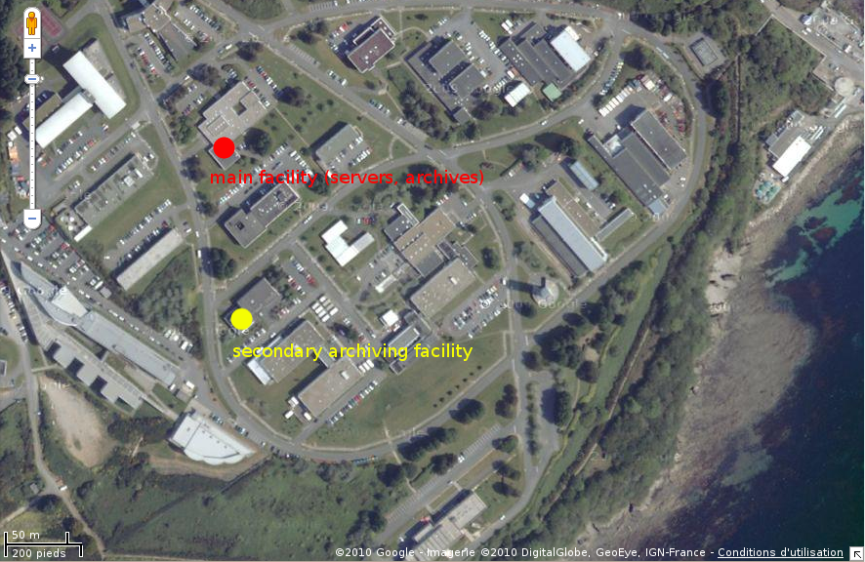

Figure 57: location of the Ifremer IT facilities

The full Ifremer infrastructure power supply is redundant.

The archive system is redundant as well and distributed in different buildings.

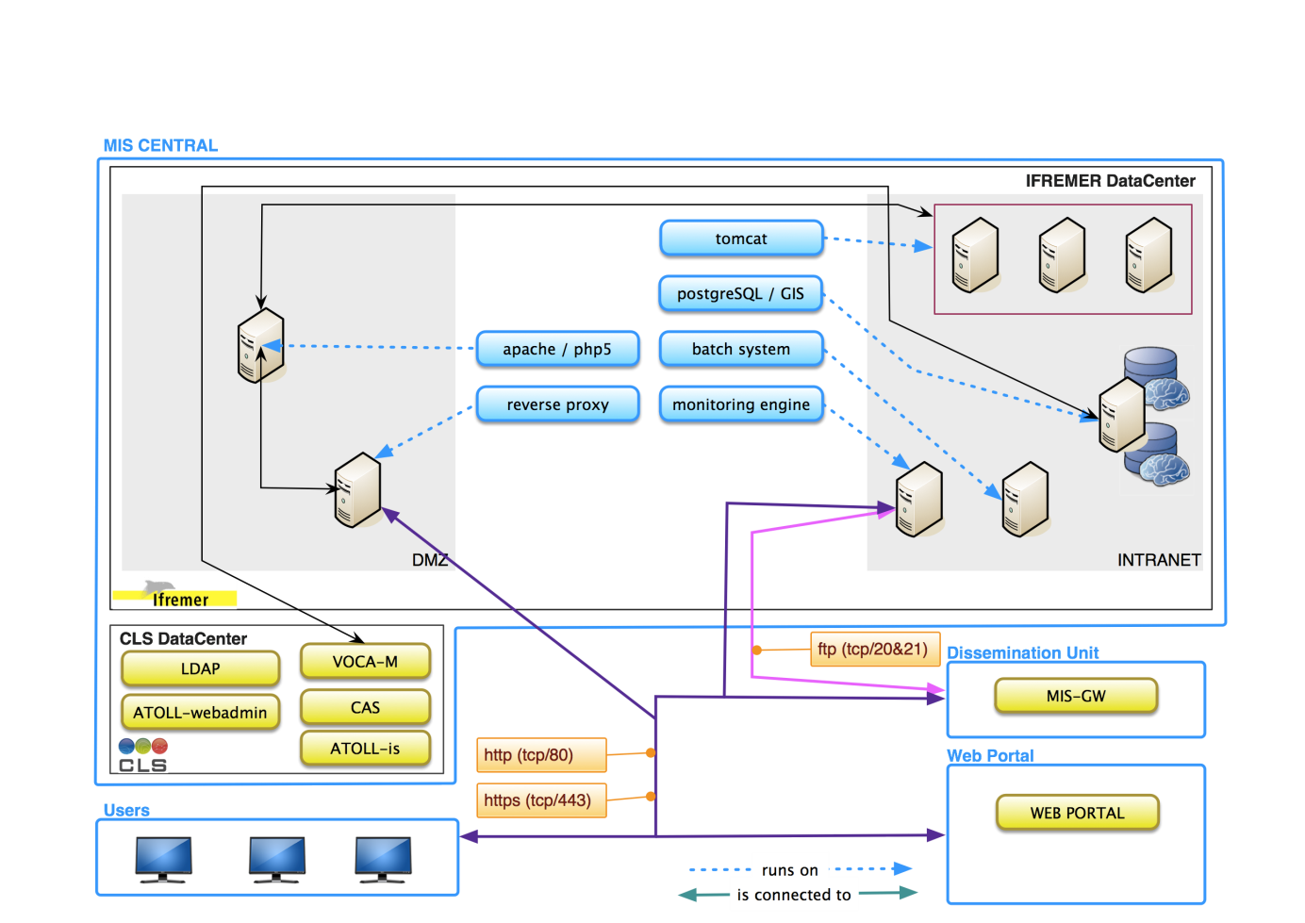

Figure 58 : Ifremer infrastructure (nodes) and interaction with external components

##### Reverse proxy and internet connection

Ifremer is connected to Internet through the RENATER network.

A gateway to the internet is provided by a Sun Solaris Server. The server hosts an apache server which is used as a reverse proxy to enable the management of different DNS names such as the “catalogue.myocean.eu.org”.

##### Tomcat server

The tomcat server is hosted by a cluster of nodes.

The cluster is managed by VMWARE ESX 3.5 software.

It enables VMWARE HA, so that, when one node has an unexpected device failure, a web application can be quickly restored on another node of the cluster.

It also enables VMOTION which allows full continuity of service when one of the nodes requires maintenance.

The cluster is composed with 3 servers hosting Debian operating systems.

The scalability of the system can be managed by adding nodes to the cluster.

##### Apache server

The apache server is hosted by a Debian operating system which is dedicated to this usage.

##### Batch system

The batch system is a Debian server which is dedicated to this usage.

##### postgreSQL RDBMS server

The postgreSQL server is hosted by a Sun Solaris system.

It hosts 2 postgreSQL servers in version 9.

One is used for transactions (ie CRUDL interactions with data).

The other is used until workflow is fully implemented on metadata edition. It contains the latest validated version of the catalogue dedicated to Read Only access for information dissemination.

##### Monitoring engine server

The monitoring engine is hosted by a Debian system.

Perl and Python interpreters are installer on the system.

It also hosts an apache server.

The server is specifically configured so that it does not rely on external resources (e.g. mount remote NFS disk) and is not sensible to external failures.

#### Details of deployment

##### GEONETWORK: product and access service metadata management

The deployment of the GEONETWORK components’ elements is as follow:

|  |  |  |  |
| --- | --- | --- | --- |
| **Element** | **Node** | **Comment** | |
| Geonetwork Web application (harvesting of DU, edition/administration of product and service database) | tomcat |  | |
|  |  | |
| Internet connexion | Reverse proxy |  | |

##### GEONETWORK-RO

The deployment of the GEONETWORK-RO components’ elements is as follow:

|  |  |  |
| --- | --- | --- |
| **Element** | **Node** | **Comment** |
| Geonetwork Web application (harvesting of latest validated catalogue, CSW dissemination) | tomcat |  |
| Database | postgreSQL | On the R/O instance of the RDBMS server, used for references. |
| Internet connexion | Reverse proxy |  |

The little number of deployed elements and the usage of the cluster of node for tomcat enhance the reliability of the component.

The little number of nodes which is required for the deployment of the component eases multiple deployments, for redundancy and scalability of the component in case of an increase of the number of users (with load balancing on top of it).

##### NAGIOS-CIS-IFR: system monitoring engine

The deployment of the GEONETWORK-MONI components’ elements is as follow:

|  |  |  |
| --- | --- | --- |
| **Element** | **Node** | **Comment** |
| Nagios daemon | Monitoring engine |  |
| Nagios dashboard | Monitoring engine |  |
| Nagios alerts | Email server |  |
| Availability and performance database | Reverse proxy | Availability and performance results are disseminated through a file server. |

### Physical architecture deployed at CLS

#### Component List

ATOLL-WEBADMIN

ATOLL-IS

LDAP

CAS

#### Details of implementation

In order to reach Non Functional Requirements (in term of performance and availability), the following architecture was chosen to deploy MIS CENTRAL at CLS:

2 processing servers, which can run ATOLL-webadmin and ATOLL-is. Depending on operational constraints and performance, components can be started on only one server (failover mode only) or on the two servers (load balancing mode).

One database server

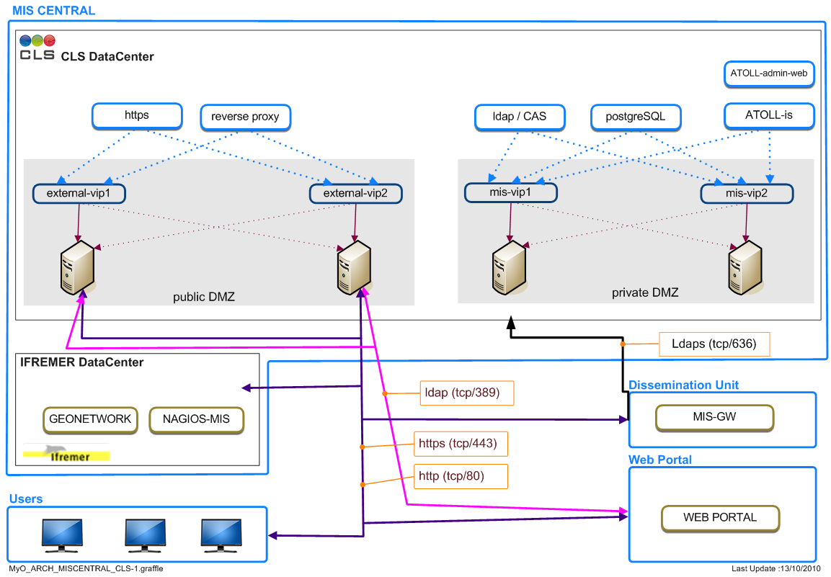

Figure 59: Physical Architecture of MIS CENTRAL deployed at CLS

Additional servers can be easily installed and added inside this configuration in order to extend redundancy or performance, thanks to virtualization (see later) and extensive usage of virtual IP addresses (VIPs) and DNS aliases (particularly in configuration files).

Virtual IPs allows a smooth transition from one server to another for any reason (in case of a failure on a server, or for a planned maintenance).

This first or Nominal Configuration, located in the Primary Data Centre (CLS Ramonville) is in charge of MIS CENTRAL operation in routine mode.

A second or Disaster Recovery Configuration is located at the Secondary Data Centre (CLS-CNES Toulouse). It is identical to the Nominal Configuration (same servers, identical configuration, and similar storage capacity) so that all services can be taken over in case of a software problem on the Nominal Configuration, a planned downtime in Primary Data Centre or in the event of disaster.

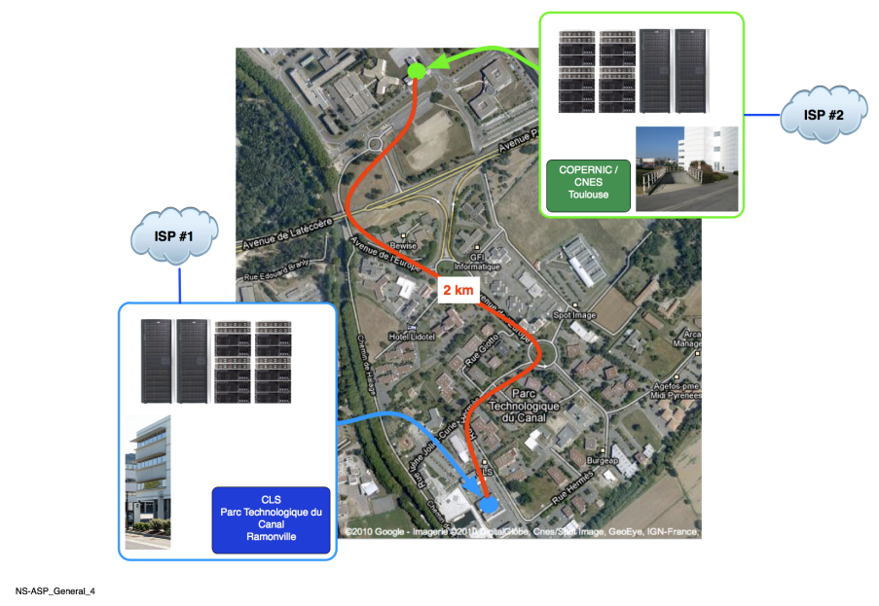

Figure 60 : Physical location of CLS Computer Centers

Both configurations (Nominal and Disaster Recovery) are hosted on dedicated VMware servers in CLS data centers. CLS already uses VMware configurations for a large number of operational services. Some twenty VMWare servers currently execute about 200 VMware instances (operational processing servers, DNS, directory servers, validation servers, database servers, CRM/ERP, etc.).

A virtual machine (VM) is a software implementation of a real machine. On a physical point of view, a virtual machine is a group of files which contains a complete and independent system. These files can be located on local disks, SAN storage bay… VMware virtualization works by inserting a thin layer of software (the “hypervisor”) directly on the computer hardware or on a host operating system. The hypervisor allocates hardware resources dynamically and transparently, which allow several VMs to run concurrently on a single physical computer and share hardware resources (CPU, memory, network devices) with each other.

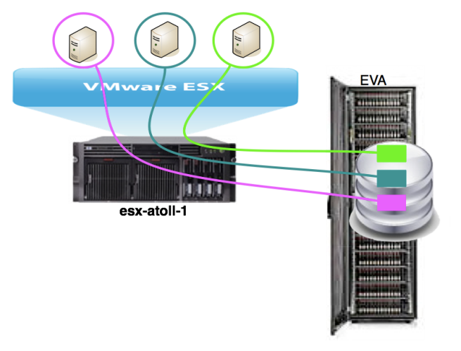 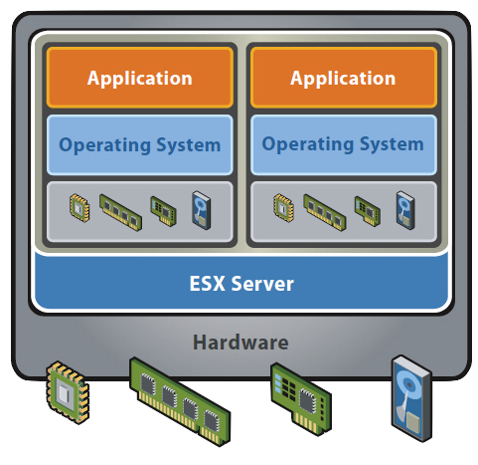

Figure 61 : Virtualization Concepts

Data will be stored on 2 storage bay HP EVA6100, an enterprise-class virtual storage array, which offers embedded virtualization (improves capacity and simplifies management), easy upgrade, repair and replacement of components without the need for a service call and high availability for planned uptime. One EVA is hosted at the Primary Data Centre and will contain data related to Nominal Configuration, while the other will be hosted at the Secondary Data Centre (for Disaster Recovery Configuration data). Data synchronization and replication is possible between these 2 storage bays, allowing a high level of security.

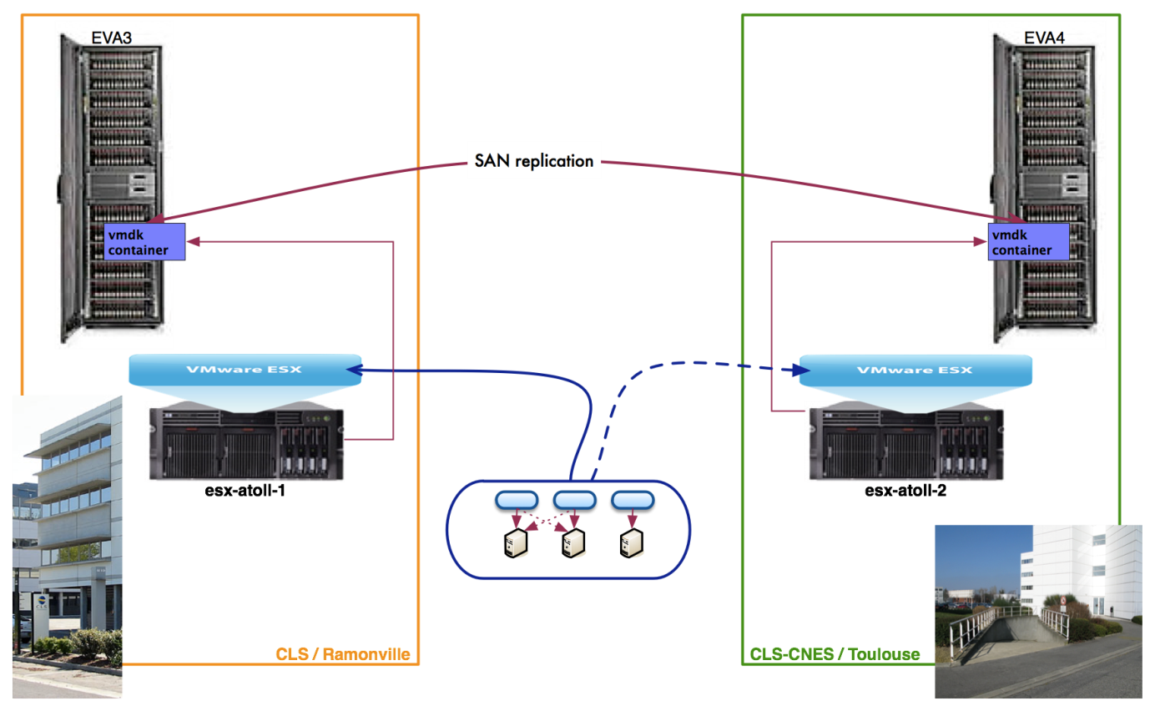

Figure 62 : How secure is the physical implementation of MIS CENTRAL components in CLS premises

In terms of network connectivity, CLS is connected to two Internet Service Providers (COGENT & OLEANE, Tier-1 backbones). Thanks to Border Gateway Protocol (BGP, the core routing protocol of the Internet) and the availability of dark fibers between the two sites, this dual connection allows 24-hour, 7-day-a-week internet access. The MIS CENTRAL will benefit from this dual ISP connection.

All network traffic is secured by a cluster of firewalls which applies typical security rules, filters incoming traffic and restricts connection from LAN to the Internet. Some specific rules will be written to secure MIS CENTRAL.

#### Backup and redundancy

Backups are managed by CLS and CNES internal system and system backups. The RAID 5 system gives a first security in case of physical break on a hard drive. The external backup is ensured by the full system redundancy at CNES infrastructure.

Passive redundancy is provided by these backups. In the unlikely event that the production hosting environment fails for a significant period of time, a reduced functionality service can be provided by the development server.

A deployable web server image will be created so that it will be easy to deploy a new instance of the web server to a new hosting environment if required.

Active redundancy is provided for the following key components:

LDAP server, which will be required for all MyOcean authentications, is replicated by MIS. The Web Portal LDAP server will act as the master directory.

NAGIOS monitoring is replicated by MIS to improve system monitoring information.

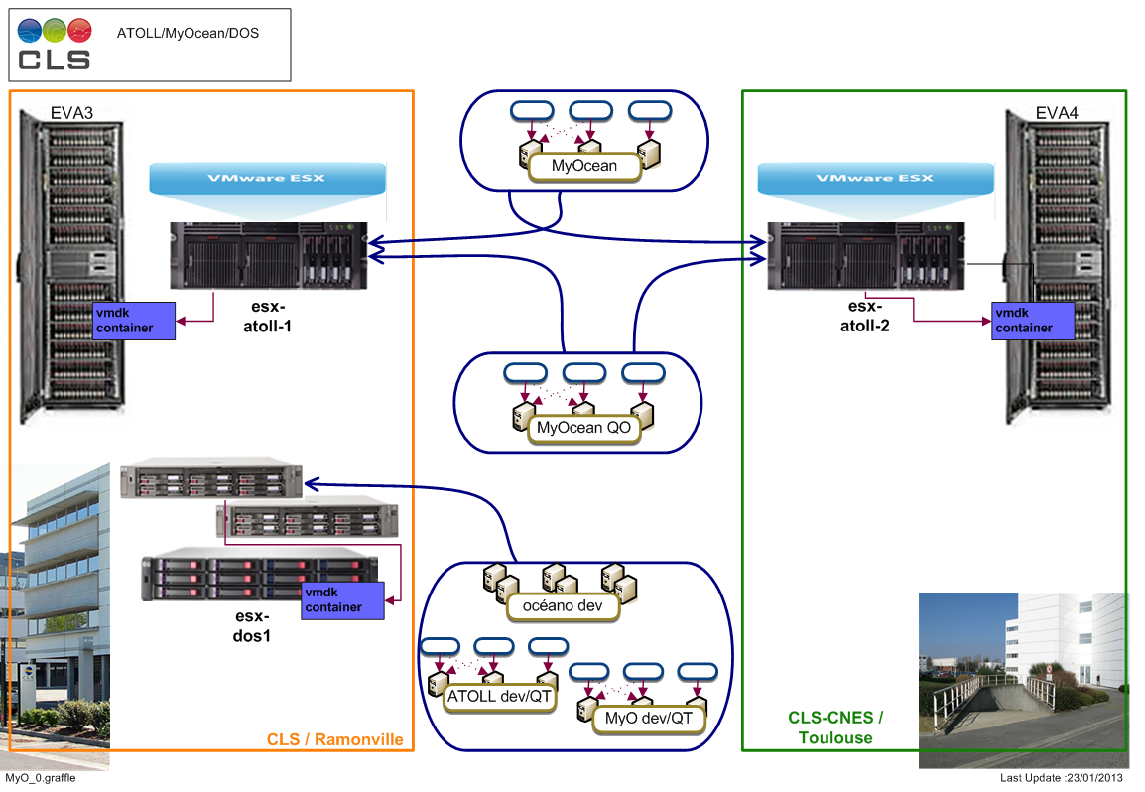

Figure 63: Disaster Recovery architecture

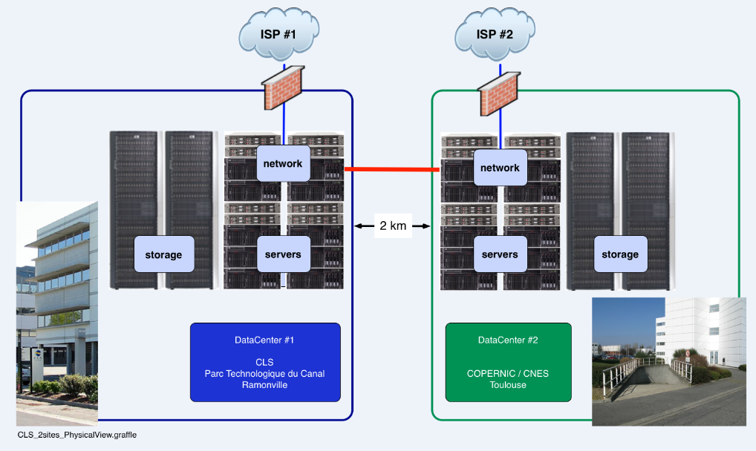

Figure 64: CLS and Copernic redundancy

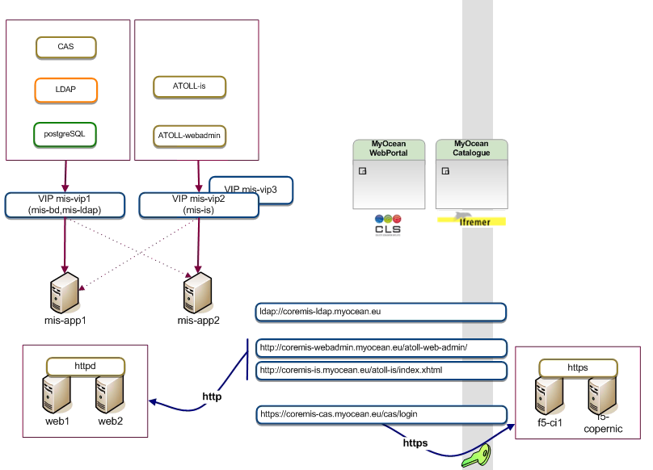

Figure 65 : MIS central view

#### Production environment hardware and operating system TBU

The following dedicated server hardware specification is proposed (MyOcean WP V1 specifications):

Dell R710 server provided by Rackspace

Processor: Dual Quad Core Xeon L5520 (2.26GHz)

Memory: 24 GB

HDD: 4 x 146 GB 15K SAS RAID 5

This specification is expected to provide ample capacity for the MyOcean web portal – to be confirmed by service monitoring.

Scalability is provided by the addition of extra servers and a load balancer if required (resources permitting).

The operating system is Red Hat Enterprise Linux (currently v 5.4), security patches for this and the Apache web server are applied by the hosting company.

# Concept of operations, using the architecture components

Reuse Operational Scenarios and others (suggested by the Review Panel for instance) to explain how architectural physical components and interfaces contribute to their satisfaction.

ADDITIONAL scenarios to exercise the reliability and robustness of the physical and execution architectures.

Failure scenarios :

the case of a particular system element involved in the CIS not being available under conditions compliant with availability guarantees and service level agreements

the case of partial or total failure of default servers on which key data are stored or key routing and status information is maintained

the case of partial or total failure of the default communications infrastructure supporting exchange of data between CIS components.

# System Design Objectives

This paragraph intends to match MyOcean overall answers to design objectives into design requirements applicable to the sub system.

Design for Value

Many of MIS sub-system components are adaptation of existing software according to requirement given in SRD documentation.

Design for usability

The MIS sub-system components are designed according to the System Requirement Documentation.

Design for interoperability

The MIS sub-system components implement interfaces which are interoperable with the oceanography community and geographic community when the scope of the required interfaces meets requirements for this community (e.g. metadata discovery: OGC/CS-W protocol and ISO19139 profile which is compliant with INSPIRE).

Design for portability

The MIS sub-system components are developed with technologies which are widely available, free and open source which eases the deployment of the application in any context.

In addition the technologies (J2EE, PHP, PYTHON …) themselves are technically portable on different operating systems (Linux, Windows …) and hardware systems (PC, Sun …) which guaranty a long term availability of platforms for these software.

Design for growth and expansion

The MIS sub-system is designed to enable the growth of the system (more datasets to manage, more Production Units) or the growth of the system usage (more user requests).

The growth of the system is supported because the topology of the architecture is designed so that the MIS Core component is not a bottle neck for dataset circulation. Only ancillary information are centralized at MIS and their growth can be handled with usual IT infrastructures.

The growth of the system usage can be handled with Advanced Operating System handling cluster of hardware. In addition the most demanding components (authentication server, catalogue dissemination) are designed to be as simple as possible and as easy as possible to deploy.

Design for reliability

Standard well support operating system and software deployed on commodity hardware. Hosting environment backed by a strong service level agreement and full 24/7/365 support. Hosting environment has multiple redundant internet backbone connections.

Design for availability

A monitoring tool shall be used in order to ensure the availability of the services. The test environment will continuously check the functional availability and avoid bugs.

Design for effectiveness

CLS and CNES servers’ architecture will ensure the effectiveness of the web application

Design for reconfigurability

The components must be configured using centralized configuration files.

Each atoll component configuration are in separate configuration projects. To change the configuration related to the target environment, the configuration project just needs to be replaced.

The transaction accounting is configured using an xml configuration file to define the source logs, filters and data processing.

Design for integration, test and evaluation

The development can be done on a local developer’s machine. A procedure to help a developer to work on it has been written.

Two distinct and independent test environments are defined: Technical qualification tests environment (QT) and operational qualification tests environment (QO) which is a copy of the production environment (same system architecture).

The integration and tests are run manually by different teams from the implementation team.

Design for verification

In addition with the monitoring system, the transaction accounting will analyse the logs and give statistics on the components.

Tests are defined for the different project phases in order to check the integration, specifications, etc…

Monitoring tools will be available in the final environment:

System monitoring

NAGIOS monitoring (more details will be given in this document)

Design for maintainability

As MyOcean is a modular application each module can be updated separately. The technologies used in the MIS are widely known (JAVA, Python, Shell, Javascript)

Deployment documents and development environment documentations are available on the internal WIKI and on a dedicated Forge.

Design for security and protection

Data servers are protected by the CLS and CNES security

Personal data are encrypted in the MIS Database.

The administration module is an authenticated module using the centralized identification system: CAS.

# Appendices

## Requirements traceability and allocations

TBU

## Issues (currently in discussion)

## Materials, check list (answers & coverage)

These materials are the *real an abridged expectations* of EC reviewers towards the MyOcean project to pass the PDRs and CDKP (please replace "CSF" by "MyOcean", "CSFRD" by "top level SRD").

### Guidance on the Scope and Content of the ADD (SRR report, Review Panel)

For V0, V1 and V2:

A detailed functional (logical) architecture that illustrates how the input data is transformed into the products and services identified in the FTSS. In particular this architecture should describe the:

Hierarchy of functions;

Associated data flows.

Design Requirements for Sub Systems

This architecture shall be independent of the physical implementation.

The description of the functional architecture shall follow a structured methodology consistent with accepted industry standards (IDEF0 has been identified in the DoW).

A description of software architecture and its relationship to the functional architecture. In particular it should be possible to identify the main software components that will be used to implement the various functions.

A description of the physical architecture showing the main hardware components, their geographical location and any associated communications links.

A mapping of the software architecture onto the hardware architecture.

A characterisation of the main interfaces and associated data flows. This shall include an explicit description of the output dataset from each TAC and MFC.

The proposed redundancy concept which identifies how products and services can continue to be provided in the event of failures. This concept should contain an identification of the backup system or product, a specification of any differences between the back-up option and the default system, a characterisation of the impact of the identified outage on the service chain performance and a characterisation of the consequences for the user organisations. This should include consideration of at least the following cases:

the case of a particular product not being available under conditions compliant with availability guarantees and service level agreements

the case of an input data set or TAC output not being available under conditions compliant with availability guarantees and service level agreements

the case of a particular system element involved in the generation of TAC or MFC outputs not being available under conditions compliant with availability guarantees and service level agreements

the case of a distributed data base holding input data, TAC output or MFC output products not being available under conditions compliant with availability guarantees and service level agreements

the case of partial or total failure of default servers on which key data sets are stored or key routing and status information is maintained

the case of partial or total failure of the default communications infrastructure supporting exchange of data products between partners or delivery of output products to users

An availability analysis showing how the proposed redundancy concept is consistent with the defined availability commitments provided with the FTSS.

### The "GMES Guideline"

#### System Architectural Design Phase

To further develop architectural design of the service provision infrastructure, initially elaborated at the proposal stage, through for instance the elaboration of a high-level physical model of the CSF system that identifies main components of the system (software and hardware) together with their interfaces that establishes the overall design framework for the subsequent development. The design framework should be adaptable (easy to modify and maintain), efficient (make best use of available resources) and understandable (can be built, operated and maintained). All design decisions should be recorded and justified. The decomposition of the system into its main components should be to a level of definition that is sufficient to allow small groups to work in parallel on their subsequent detailed design and implementation.

To define the components and the exchanges between them,

To further consolidate the external interfaces,

To perform prototyping as necessary to justify the design,

To define how the system will be integrated and tested,

And to further define how the system will be operated.

In the case where the CSF is built from existing building blocks, the design phase will concentrate on the overall system consistency, the newly developed items and the interconnection between elements.

#### ADD

The Architectural design document describes how the requirements defined in the SRD will be implemented. The ADD should describe at least:

the functional (logical) architecture (apportionment of requirement between components);

the software architecture proposed for realising the functional architecture (with traceability to the functional architecture);

the hardware architecture;

the mapping of the software architecture onto the hardware architecture;

traceability of the proposed Design for the CIS SRD.

The ADD is substantiated by the necessary trade-offs, gathered in a design justification file. Prototyping may be necessary to validate a certain number of concepts and to propose an adequate Human Machine Interface.